Humanity United Geospatial Dashboard:

Technical Description

The proposed Humanity United Geospatial Dashboard would be a platform to explore the relationships between human rights in Africa and related social variables including international aid, population, poverty, and conflict. The dashboard would serve three purposes:

1) Allow users to easily overlay geospatial data about aid, human rights abuses, actions by human rights organizations, population, poverty, and conflict.

2) Display pop-up windows for aid and conflict events with further details about those events.

3) Provide hyperlinks to event details such as participating organizations, dates, aid project funding, and severity of conflicts.

The dashboard could use Open Street Map (<http://www.openstreetmap.org/>) as a baselayer. This means that roads, railroads, dams, lakes, national and subnational boundaries, national parks, cities, hospitals, and schools among other features would all appear beneath the other layers in the dashboard for reference.

Layers other than the baselayer would include some or all of the following:

**Aid Layers**

**Population Layers**

**Poverty Layers**

**Conflict Layers**

**Human Rights Layers**

**Baselayers**

Users could interactively choose to display one or more of these layers on top of the baselayer. A pop-up window could appear if the user hovers the mouse over any country, sub-national district, or event point depending on the layers selected by the user. This window would retrieve the most important statistics and display graphs of relevant data for that spatial feature. These pop-up windows would also display descriptive text for aid and conflict events along with hyperlinks to further detail from the appropriate source, such as AidData, ACLED, or SCAD.

See the Appendix below for screenshots of possible sources for these layers.

**Appendix:**

Details on potential dashboard layers are below:

**Aid Layers**

Aid layers could include AidData’s work on Chinese aid to African recipients (china.aiddata.org) and data on aid in the rest of the world.

*AidData geocoded international aid project locations*

**Population Layers**

Example population layer:

Afripop: <http://www.clas.ufl.edu/users/atatem/index_files/Data.htm>

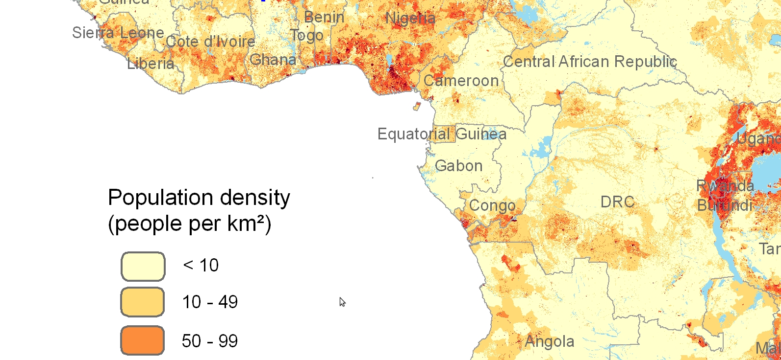

*Map of African population density from Afripop*

**Poverty Layers**

Example poverty layer:

# The HarvestChoice Sub-national Poverty and Extreme Poverty Prevalence

: <http://harvestchoice.org/maps/sub-national-poverty-and-extreme-poverty-prevalence>

*Poverty headcount ratio - below '05 PPP $1.25/day*

**Conflict Layers**

Example conflict layers:

SCAD and ACLED are two complementary sources of conflict information.

ACLED (<http://www.acleddata.com/>) provides data on armed conflict.

SCAD (<https://www.strausscenter.org/scad.html>) provides data on social conflict.

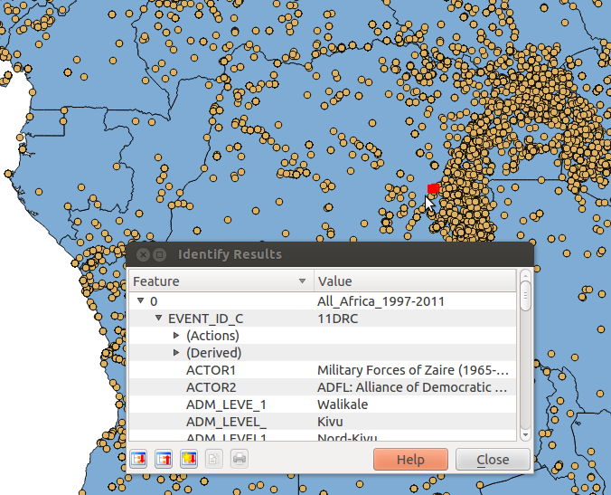

*Example ACLED conflicts*

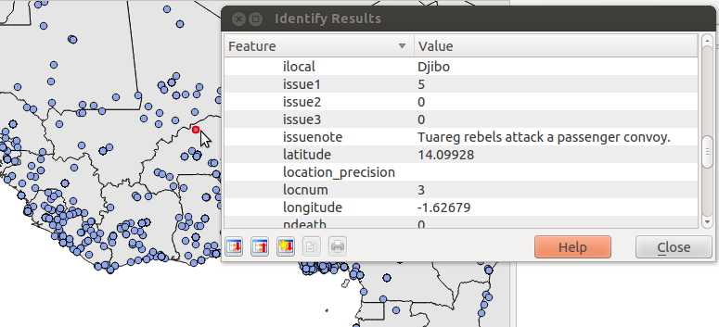

*Example SCAD geocoded data*

**Human Rights Layers**

Example human rights layers:

GDELT- Global Data on Events, Location and Tone ( made by University of Illinois, Penn State, and University of Texas at Dallas )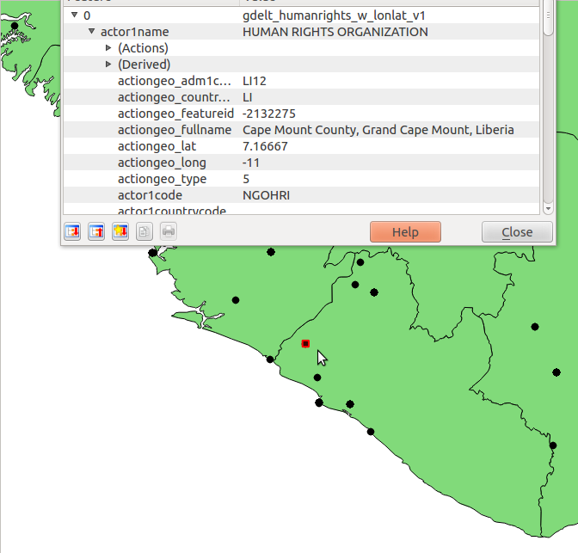

*Example of GDELT human rights related events in Liberia*

**Baselayers**

Available baselayers would include maps of roads, major infrastructure such as airports, and public parks, hospitals, rivers, lakes, and national and sub-national boundaries.

One possible source of this data could be Open Street Map, as seen below:

<http://www.openstreetmap.org/#map=14/9.5458/31.6669>

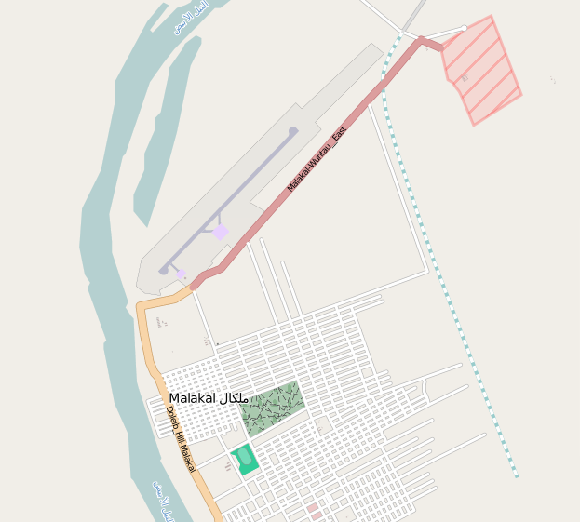

*City of Malakal, South Sudan, as seen in Open Street Map*