**Flowchart for Migration Process:**

1. **Start**: Initiate the migration project.
2. **Assess Polymer Application**: Understand existing features and setup.
3. **Set Up Angular Environment**: Prepare the development environment for Angular.
4. **Migrate Components**: Sequentially migrate components, starting with least complex.
5. **API Integration**:
   * Convert **iron-ajax** calls to **HttpClient** methods.
   * Ensure all endpoints are secured and data flow is optimized.
6. **Testing**: Unit, Integration, and E2E tests.
7. **Deployment**: Phased rollout.
8. **Feedback and Iteration**: Post-deployment monitoring and adjustments.
9. **End**: Project closure.

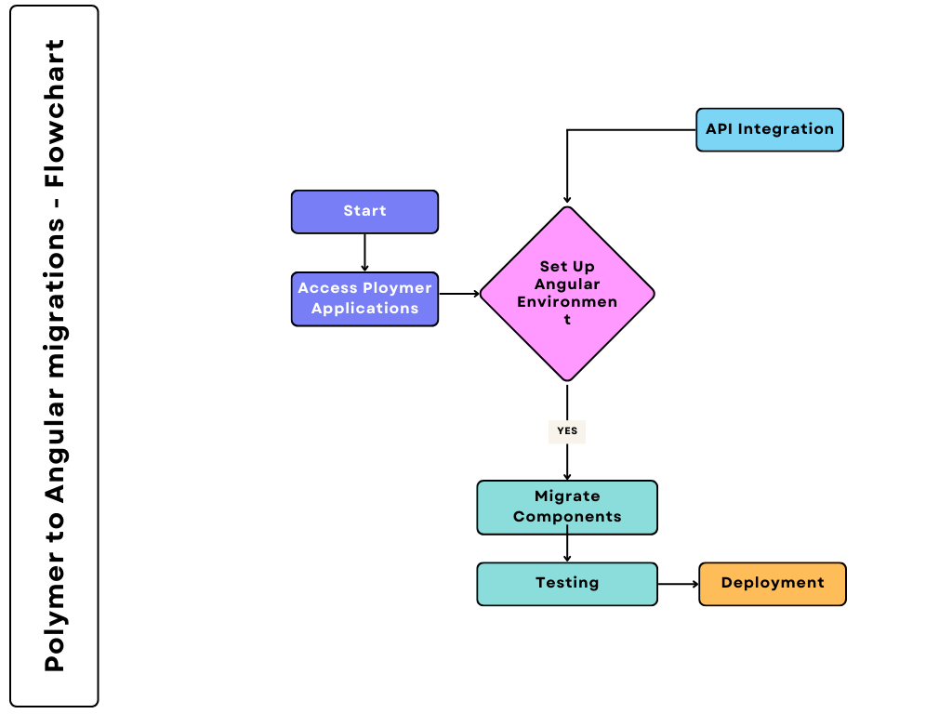

**Example Code Snippet for API Integration:**

**Detailed Code Snippets:**

**Converting Polymer Data Bindings to Angular:**

**Polymer(Old)**

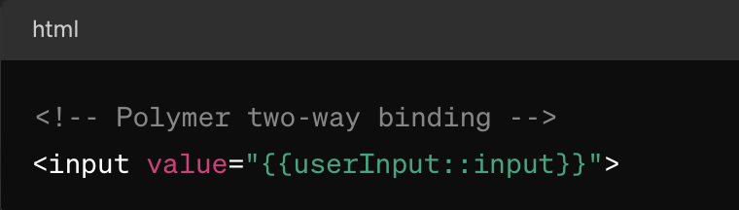

**Angular (New)**

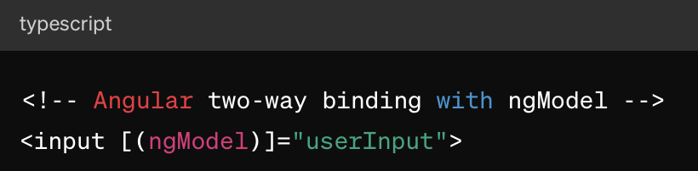

**Handling Events from DOM to Angular:**

**Polymer (Old)**

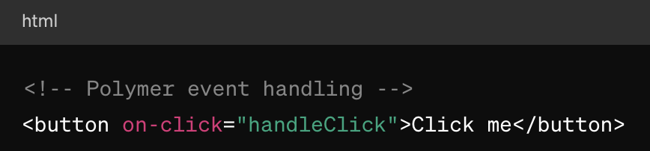

**Angular (New)**

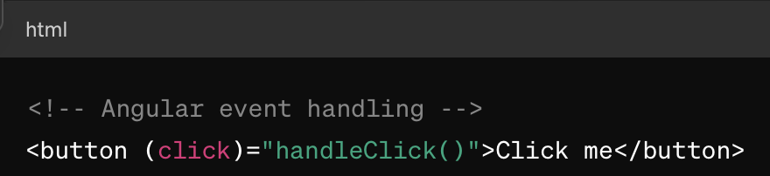

**Migrating Polymer Computed Properties to Angular**:

**Polymer(Old)**

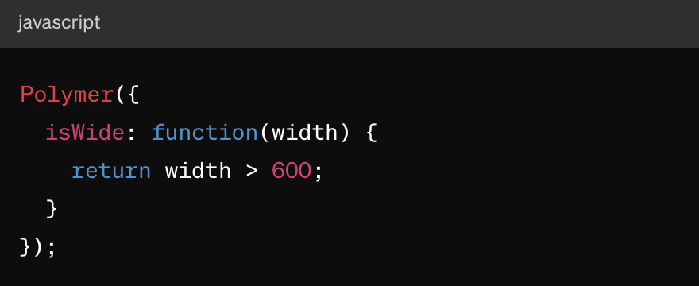

**Angular (New)**

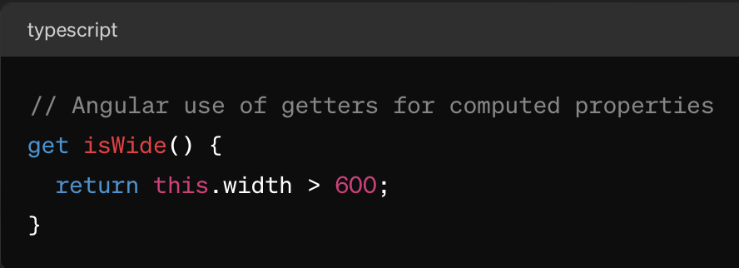

**Replacing Polymer’s iron-ajax with Angular HttpClient**:

Polymer (Old):



Angular (New):

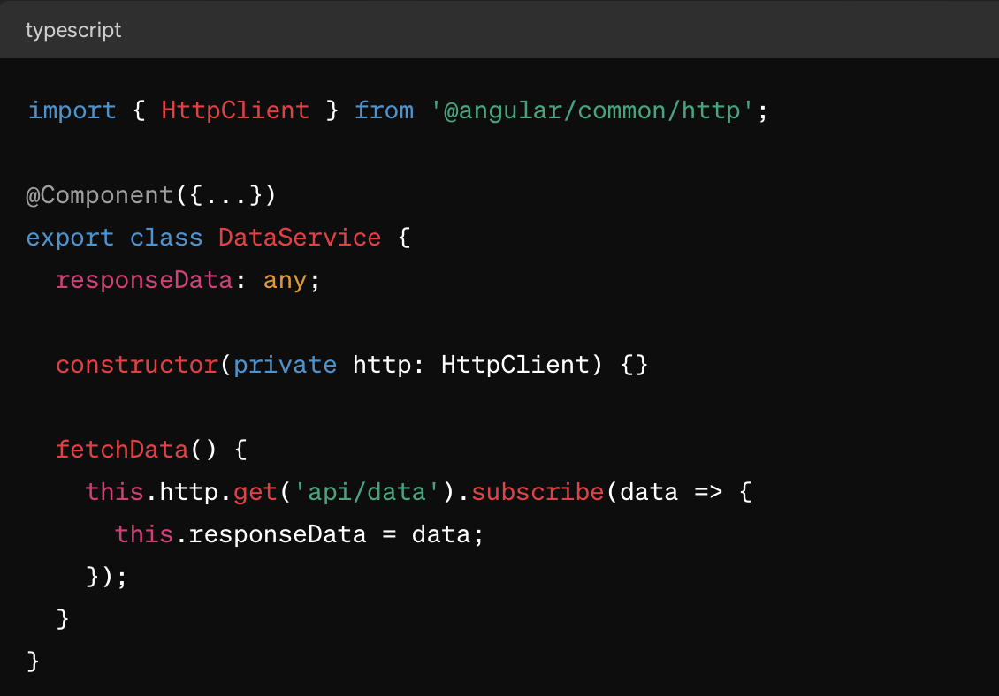

**Technical Considerations:**

1. **State Management**:
   * Migrate from Polymer’s simplistic property observation to more robust state management solutions in Angular like NgRx or Akita, which provide a Redux-inspired architecture for managing state changes predictably.
2. **Modularization**:
   * Break down the application into feature modules in Angular to optimize code reusability and lazy loading capabilities. This helps in loading features on demand, improving the application’s performance and scalability.
3. **Component Lifecycle Management**:
   * Understand and effectively use Angular lifecycle hooks (**OnInit**, **OnChanges**, **OnDestroy**) to manage component lifecycle better than Polymer’s observers for property changes, which can lead to performance issues if not handled properly.
4. **Optimized Change Detection**:
   * Utilize Angular’s **ChangeDetectionStrategy.OnPush** to improve performance by minimizing the checks Angular performs to detect changes in the data model. This is particularly beneficial in applications with complex UIs and large data bindings.
5. **Dependency Injection**:
   * Leverage Angular’s powerful dependency injection system for managing dependencies across components and services, which is more sophisticated and configurable compared to Polymer's approach.
6. **Routing and Lazy Loading**:
   * Implement Angular’s Router to manage navigation and view organization. Use route guards to protect routes and lazy loading to load modules only when needed, which significantly reduces the initial load time.
7. **Testing Strategy**:
   * Develop a comprehensive testing strategy using Angular’s testing utilities. This includes Jasmine for writing unit tests, and Protractor for end-to-end testing, ensuring all components and services function correctly both individually and when integrated.
8. **Security Enhancements**:
   * Apply Angular’s built-in security features such as DOM sanitization to protect against XSS vulnerabilities, and use HTTPS methods in **HttpClient** for secure data transmission.