**Money Doesn’t Make the World Go Round: Currency Priming Replication Study**

Alex K. Mitchell

Department of Psychology, University of Texas at Arlington

**Abstract**

Through an assessment of participants' responses to a series of questions about free-market capitalism, system justification, and social dominance orientation, this study sought to understand peoples' attitudes about social inequality. The original literature that provided the results for the same variables and ultimately served as the basis for this study is replicated in this study. The participants' beliefs regarding system justification and capitalism were examined in one experiment, and their attitudes toward social dominance were measured in the other. The first hypothesis was that in experiment one, exposure to money would increase support for social inequalities. The second hypothesis was that in experiment two, exposure to money would lead to an increase in the oppression of the disadvantaged. Both experiments were subjected to an independent sample t-test, and the findings showed that neither of the two hypotheses was supported. Participants' support for social injustices and social dominance orientation didn’t increase as a result of being exposed to money. Despite the fact that the results didn’t confirm the theories, the data can still be applied to the entire population. Participants' attitudes and responses to political and social beliefs remain unchanged whether or not they are exposed to money.

*Keywords:* Capitalism, system justification, inequality, social dominance, money

**Money Doesn’t Make the World Go Round: Currency Priming Replication Study**

Money is a material good that seems to have an independent mind that controls the opinions, independence, and equality of Americans and foreigners alike. Eugene Caruso and his colleagues strive to examine and explain the basic idea of money; that it’s a strong force that has a hold on people all over the world. According to Christopher J. Boyce and his colleagues' study on money and happiness, there is some truth to the notion that having money might make you happier. Out of 80,000 participants, their findings showed that the average relative rank of income did explain happiness (Boyce, 2010). Caruso predicted that the concept of money would bolster endorsements of existing social hierarchies and inequality (Caruso, 2021, p. 301). My team and I plan to duplicate Caruso's research to further address the issues associated with the concept of money.

In his original research, Caruso and his colleagues postulated that participants' support for the social structures in place would rise because of thinking about money. Furthermore, they proposed that thinking about money would significantly boost the belief that advantaged social groupings should be superior to disadvantaged groups (Caruso, 2012, p. 301). According to Richard Easterlin, in all societies more money for the individual typically means more individual happiness (Easterlin, R., 1973). My group anticipates replicating the impact that monetary and non-monetary notions have on the justification of systems (experiment 1) and whether financial attitudes have an influence on social dominance orientation (experiment 3) (Caruso, 2012, p. 302).

Caruso's findings showed that his initial theory was true; participants' support for system justification did increase when they thought about money. Additionally, Caruso's second hypothesis proved accurate; participants did favor advantaged groups being superior to disadvantaged groups more when thinking about money. Replicating these trials is essential since members of the political and economic hierarchy frequently propose legislation and regulations that affect disadvantaged areas in America. It also reveals how different groups are perceived by their members and what distinguishes them from other groups (Sidanius & Pratto,1999). It’s crucial to understand why higher-performing groups think that political and social policies should benefit them and not others, even though lower-performing groups suffer from social inequality.

When an outgroup feels compelled to defend a social and cultural structure with which they are associated, it’s referred to as system justification. Free-market capitalism is one illustration. The foundation of free market capitalism is the rule of supply and demand, yet due to a lack of resources, not all Americans can purchase goods and services (Caruso, 2012, p. 302). Due to the just world order, most disadvantaged groups must still rely on this system, which benefits non-disadvantaged groups more because they can afford everything they choose. According to Karlijn Roex, myths that legitimize inequality in a specific society have an impact on views toward economic disparity (Roex, 2019). Myths like the notion that the wealthy get richer while the poor get poorer have their roots here. While the poor struggle to make ends meet, wealthy individuals can reinvest their money in the system, leading to conformity to a system that doesn’t work for everyone.

The overall contentment of Americans is greatly influenced by their socioeconomic status. But wealth inequality is problematic because it creates a hierarchy that heightens status rivalry and stresses people out, which has detrimental effects on their health and other areas of their lives (Rowlingson, K., 2011). Financially speaking, doctors, lawyers, and legislators are far wealthier than, for example, the ordinary American who works at McDonald's. Most wealthy Americans desire to maintain the natural order of things because they will continue to benefit from it. However, some wealthy Americans are aware of the imbalance among employed citizens. One of the only solutions to this problem is for wealthy Americans to take a significant wage cut and give less fortunate Americans extra compensation. Higher-ups (such as members of Congress) wouldn’t consent to this, as it would be a disadvantage to them and ultimately aggravate the balance in the free market.

Social dominance orientation describes how ingroups perceive themselves to be superior to outgroups. According to Ryan Quist, individuals higher in the social hierarchy "develop and endorse" hierarchy-supporting myths about low-status groups, which often take the form of negative outgroup attitudes and help perpetuate society's existing hierarchical structure (Quist, R & Resendez, M, 2002). A common misconception is that you can rise above your class with hard work and talent. This isn’t necessarily true for lower-income Americans because the majority come from a variety of backgrounds that lack educational resources, financial stability, and safety in an increasingly dangerous world. Even so, socioeconomic status plays a significant role in how lower-income groups perceive themselves.

Although many factors contribute to policies, group orientation, and social inequality, one of the primary causes is income. My research team and I predict that the concept of money will increase participant support for free-market capitalism and system justification. We also predict that thinking about money will increase participants' beliefs about social dominance and social inequality. This experiment will be divided into two parts to reduce participant disengagement during a lengthy survey while also measuring attitudes toward the impoverished. We hypothesize that being exposed to money increases support for social injustices in experiment one. In experiment two, we hypothesize that being exposed to money increases oppression of the disadvantaged.

**Methods**

**Participants**

A minimum of 50 participants will be selected by the research team for this study. The participants will be selected from the general population, but more specifically, those who are employed within the workforce industry. There will be no compensation provided to the participants, nor will there be any accumulated costs during this experiment. The participants must be between the ages of 25 and 60 years old and must hold either a part-time or full-time job. The way we will be controlling for any third variables that may influence the data we are trying to report is by using convenience sampling. All participants will be asked for demographics that include age, ethnicity, and annual salary.

Each research team member will need to recruit at least 10 participants to complete both experiments. Due to time constraints and availability, the 50 participants obtained will be subdivided into four different condition groups, based on the two different experiments. We will be using a within-groups design for convenience and to reduce random noise. This will also control for any participant who wishes to drop out of the study. In addition, deception will be used to divert any questions the participants may have that will cause an internal validity threat.

**Instruments**

The experiment will be conducted in an online format only; no other alternative formats will be used for this study. The website where this study will be taking place is QuestionPro. QuestionPro is a web-based software where its users can create and distribute surveys. Academic institutions, small businesses, and other software companies use QuestionPro, so the reliability of this software is pretty good. For the duration of the surveys, participants can expect to spend a maximum of 5 minutes completing the survey they are assigned to. No risk of any sort will be incurred in the participation of this experiment beyond what the participant would encounter in their daily life.

**Design**

***Experiment 1***

For experiment one, 25 participants will be randomly assigned through QuestionPro to one of two condition groups. The first group will be the manipulated group, and the second group will be the control group. The manipulated group will be shown a clickbait image of a wealthy, YouTube finance enthusiast, and the control group will not be shown an image. This image will appear before every question. Upon taking the survey, the participants will be asked a series of eight-item questions that measure their support for capitalism and system justification. In both groups, demographic questions like age, ethnicity, and income level will be asked in a survey, along with the 8 questions that will assess feelings about system justification and free-market capitalism. The participants will rate each item on a 4-point ordinal scale (1 = strongly disagree; 4 = strongly agree).

***Experiment 2***

For experiment 2, another set of 25 participants will be randomly assigned through QuestionPro to one of two condition groups. The first group will be our manipulation group, and the second group will be our control group. The manipulated group will be shown a clickbait image of scattered money with the caption “500/day”; the control group will not be shown a clickbait image. Both groups will be asked the same demographic questions as in Experiment 1, but the item questions will be different. The participants will complete a series of eight questions that will measure social dominance orientation. The participants will rate each item on the same 4-point ordinal scale as in Experiment 1(1 = strongly disagree; 7 = strongly agree).

After the completion of the experiment, the research team will collect all the data from QuestionPro for statistical analysis. The surveys are completely anonymous, and the privacy of the participants will be protected. If participants wish to drop from the experiment at any point, their data will be withdrawn from this study and will not be used in other future studies. The research team has no intention of sharing the participants’ data; in addition, the study doesn’t involve any components that would affect the health and safety of participants. The research team will also debrief participants about the study's components if participants request it after all the experiments are completed. Although there is no direct compensation for participating in this study, the participant data will help the research team in generalizing the findings back to the public.

**Results**

In experiment one, we asked participants a series of questions regarding system justification and capitalism, and if the money prime group would be influenced by the picture of the Youtuber holding up a stack of money. For the non-prime group, the participants were asked the same series of questions but weren’t shown an image. In experiment two, participants were asked another series of questions regarding social dominance orientation. The prime group were shown an image of scattered money with the caption “500/day”. The non-prime group was asked the same questions but weren’t shown an image.

For experiment 1, we hypothesized that the prime group would show more support for capitalism than the non- prime group. To test this hypothesis, we used an independent sample t-test. Results showed that there wasn’t a significant difference between the prime group (*M* = 2.71; *SD* = .486) and the non-prime group (*M* = 2.56; *SD* = .587), *t*(19) = .658, *p* = .519. Levene’s test indicated equal variances (*F* = .499, *p* = .489). Results didn’t support the hypothesis that the prime group showed more support for capitalism than the non-prime group.

For experiment 2, we hypothesized that being shown money would increase the support for social dominance among participants in the prime group than the non-prime group. To test this hypothesis, we used an independent sample t-test. Results showed that there wasn’t a significant difference between the prime group (*M* = 3.14, *SD* = .283) and the non-primed group (*M* = 2.91, *SD* = .423), *t*(48) = 1.861, *p* = .069. Levene’s test indicated equal variances (*F* = .800, *p* = .376). Results didn’t support the hypothesis that the prime group would show more support for social dominance than the non-prime group.

**Discussion**

By evaluating participants' attitudes toward free-market capitalism, social dominance orientation, and system justification, this study sought to ascertain people’s ideas regarding social inequality. According to our first hypothesis, the money prime group would support the free market and the justification of the current economic system more than the non-money prime group. The initial statistical analysis revealed no significant difference between the two groups. Additionally, experiment one's findings don’t match those of Caruso and his colleagues' literature; they reported that their money condition group strongly favored system justification more than the condition group did (Caruso, 2012).

Our second hypothesis, we predicted that the money prime group would have more support for system justification than the non-money prime group. The secondary statistical analysis performed indicated no significant difference between the two groups. A two-tailed p-value of .069 nevertheless shows some difference between the money prime group and the non-money prime group, even if our results weren’t statistically significant. Although Caruso and his colleagues stated that their money condition group showed a higher social dominance orientation than that of the condition group, the results of experiment two don’t match with their literature (Caruso, 2012).

**Limitations**

In our study, some limitations did have an impact. For what we were looking for, the number of participants in the experiment was relatively low. We had 21 participants in experiment one and 50 individuals in experiment two. Finding at least 10 participants was a requirement for each research team member. Some researchers found more participants than others, but overall, they had little time to obtain participants because of the study's time limitations. Although a larger sample size would have been ideal, Beth Morling (2018) once said, “when it comes to the external validity of the sample, it’s *how*, not *how* many” (p. 195).

Furthermore, we gathered our subjects by convenience sampling. The requirements that participants had to fulfill to be included in our study included being between the ages of 25 and 60 and being employed. We believe the parameters we set were reasonable given that we were attempting to evaluate political and social ideologies. However, the survey was carried out online via QuestionPro, which allowed participants to provide false information regarding their age, ethnicity, and employment status. The team deleted the data of those participants who misrepresented their information to control for any outliers in our study.

**Implications and Future Directions**

The findings of our study show that people's beliefs regarding social inequity don’t change when they are exposed to money. Neither of the two hypotheses we tested indicated a significant difference between the groups, but it doesn’t suggest that the data is irrelevant. Participants' thought processes when filling out surveys in both tests, with and without exposure to money, were unaffected. This means that individuals' ideas regarding political and social ideologies aren’t necessarily influenced by money. For future replications, one path it might take is having a longer period to complete the trials and allowing a wide range of candidates to participate in the study. This way, other ethnic backgrounds’ beliefs about money can be accessed as well. For instance, a 2016 study in Russia indicated that young Russians view money as a sign of achievement, the purpose of life, and general well-being (Knyazeva, T., 2016).

According to the Federal Reserve Bank of St. Louis (2021, May 6), a unit of account, a store of value, and a medium of exchange are all definitions of money. Having money has less to do with being wealthy or poor than it does with how individuals use it in their daily lives. According to our research and Caruso's, people would choose to keep their money for themselves if it meant they would gain more from it. Only a few aspects of our economy—healthcare, education, and employment—depend on capital. Although money doesn't have a mind of its own, it may be a formidable tool if utilized improperly. The first step in resolving this problem is for higher political parties and figures to be prepared to share a resource that may provide everyone with limitless opportunities. If America and other nations wish to close the socioeconomic gap in their societies, they must be prepared to meet people's demands and needs.

**References**

Boyce, C. J., Brown, G. D. A., & Moore, S. C. (2010). Money and Happiness: Rank of Income,

Not Income, Affects Life Satisfaction. Psychological Science, 21(4), 471–475.

https://doi.org/10.1177/0956797610362671.

Caruso, E. M., Vohs, K.D., Baxter, B., & Waytz, A. (2012). Mere exposure to money increases

endorsement of free-market systems and social inequality. Journal of Experimental

Psychology: General. 2013, Vol. 142, No. 2, 301–306.

Easterlin, R. A. (1973, Winter). Does Money Buy Happiness? The Public Interest, 30, 3.

https://login.ezproxy.uta.edu/login

Federal Reserve Bank of St. Louis. (2021, May 6). Functions of Money - The Economic

Lowdown Podcast Series. Federal Reserve Bank of St. Louis. Retrieved August 10, 2022,

From https://www.stlouisfed.org/education/economic-lowdown-podcast-series/episode-9

functions-of-money.

Knyazeva, Tatiana, et al. (2016). Semantic Meaning of Money in the Perception of Modern

Russian Youth. International Journal of Environmental and Science Education, 2016,

Vol. 11, No. 15, 7381- 7391.

Morling, B. (2018). Research methods in psychology (4th ed.). WW Norton.

Quist, R. M., & Resendez, M. G. (2002). Social dominance threat: Examining social dominance

theory’s explanation of prejudice as legitimizing myths. Basic and Applied Social

Psychology, 24(4), 287–293. 10.1207/S15324834BASP2404_4

Roex, K. L. A., Huijts, T., & Sieben, I. (2019). Attitudes towards income inequality: ‘Winners’

versus ‘losers’ of the perceived meritocracy. *Acta Sociologica*, *62*(1), 47–63. https://doi.org/10.1177/0001699317748340

Rowlingson, K. (2011). Does income inequality cause health and social problems? Joseph

Rowntree Foundation. www.jrf.org.uk

Sidanius, J., & Pratto, F. (1999). Social dominance: An intergroup theory of social hierarchy and

oppression. New York, NY: Cambridge Uni-versity Press.

**Figure 1**

*Average means for Prime and Non- Prime conditions for Capitalism*

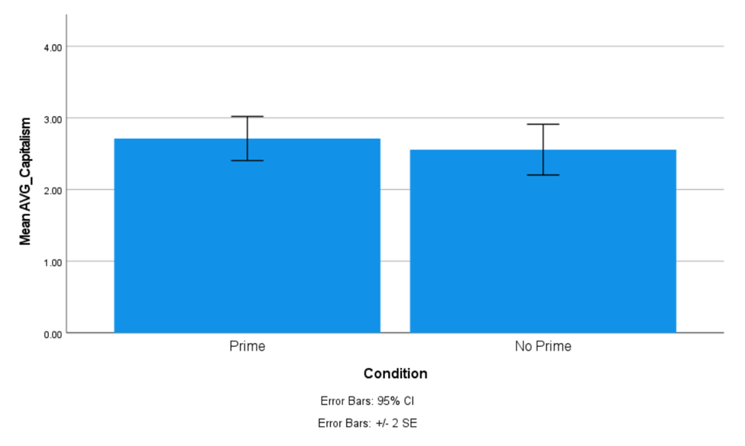

**Figure 2**

*Average means for Prime and Non- Prime conditions for Social Dominance Orientation*

