Template for preparing a final project for 2.719 class
Author^{1,*}
¹Optica Publishing Group, Optica, 2010 Massachusetts Avenue N.W., Washington, D.C. 20036
*Corresponding author: author_three@uni-jena.de
Submitted XX Month XXXX

This is the abstract of your final paper. Describe the background (There’s a photonics problem that’s worthwhile to work on!), what methods you used to gain understanding of or to design a photonic material/structure, what did you learn.

Again, start with a more expanded intro to the problem, its significance, and applications.
Then, describe the methodology, the physics of the observed phenomena, and the numerical results. Discuss how you validated your approach and the code by using the literature data. Show and discuss how different model parameters affect your material/system performance.
Justify the use of material models or the experimental data for the material permittivity or permeability. Mention explicitly how you perform numerical integration, terminate the infinite series solutions, perform root searching, etc. (if applicable). Discuss briefly how your material/structure can be fabricated for practical realization.
Include 3+ figures, including a schematic of the problem geometry and numerical results. Write descriptive captions for your figures.
Do not use headings (apart from “Acknowledgements” and “References”), write letter-style. Do not change the font or the margins. Paper length: min. 4 pages including figures and tables but not counting references (max 10 pages). Submit your codes and slide decks together with this report to Canvas.

Equations. Display equations should be broken and aligned for two-column display unless spanning across two columns is essential. For MathType math, use the Format Equations feature to format all equations as Times + Symbol 10. Apply the Equations style to create appropriate spacing above and below.
(1)
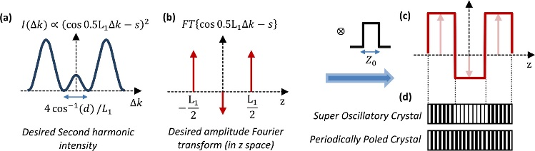
Fig. 1. Caption text with descriptions of (a), (b), and (c).
Figures. As with tables and equations, figures should be set as one column wide if possible unless two-column display is essential. If possible, set the figures in the desired position within the text. Apply the Figure style to the figure and the Caption style to the caption.
Tables. Tables should be set as one column wide if possible and be placed near their first mention in the body.
Table 1. Supplementary Materials Supported in Our Journals
Type | Description
Supplemental Document | PDF document with expanded descriptions or methods
Visualization | 2D image, 3D image, video
Data File | Small data file such as data underlying a plot in a figure
Dataset | Dataset stored in an appropriate external repository
Code | Code or simulation files stored in an appropriate external repository

Acknowledgments. Acknowledgments should be included at the end of the document. The section title should not follow the numbering scheme of the body of the paper. Additional information crediting individuals who contributed to the work being reported, clarifying who received funding from a particular source, or other information that does not fit the criteria for the funding block may also be included; for example, “K. Flockhart thanks the National Science Foundation for help identifying collaborators for this work.”
References
- M. R. E. Lamont, Y. Okawachi, and A. L. Gaeta, “Study about lasers and optics,” Opt. Lett. 38, 3478 (2013).
- A. Cordero-Davila, J. R. Kantun-Montiel, and J. Gonzalez-Garcia, in Imaging and Applied Optics Technical Digest 2012 (Optical Society of America, 2012), p. 13.
- M. Partridge, “Spectra evolution during coating,” figshare, (2019), https://doi.org/10.6084/m9.figshare.1004612.

