Analysis of DH Rule Impact on ERA and Slugging
The introduction of the Designated Hitter (DH) rule in the American League (AL) in 1973 created a notable divergence in statistics compared to the National League (NL). The visualizations clearly show that the AL's league-wide ERA consistently rose above the NL's, as dedicated batters replaced weaker-hitting pitchers in the lineup. Correspondingly, the AL's slugging percentage also saw a sustained increase over the NL.
This statistical gap began to close with the introduction of the universal DH rule, first temporarily in 2020 and then permanently from 2022 onward. In these years, with both leagues operating under the same rules, the differences in both ERA and slugging percentage have narrowed significantly. This demonstrates the DH rule's direct and immediate impact on increasing offensive production in a league.
Comparing League-Wide ERA
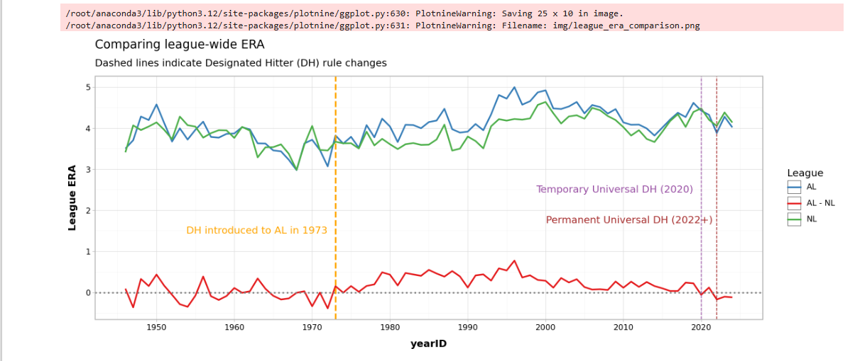
Comparing League-Wide Slugging Percentage
