class04.R
anaka
2026-01-15
title: “Class 04 R Intro”
author: “Ana Karolina Navarro”
date: “January 15th, 2026”
x <- 1:50
plot(x, sin(x))
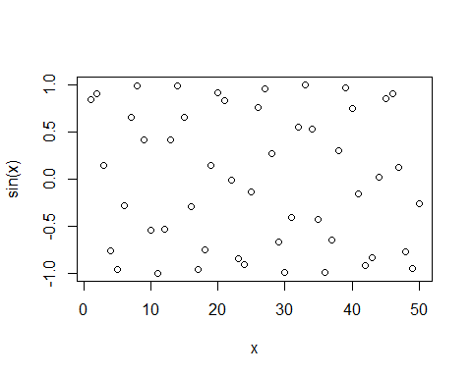
plot(x, sin(x), typ="l", col="pink", lwd=2)
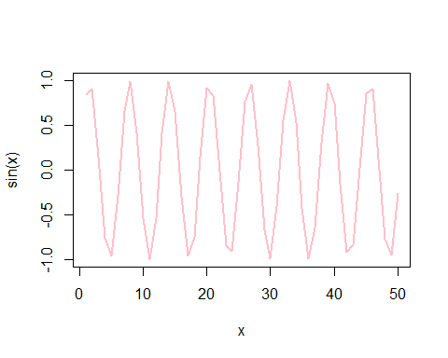
log(10,base=10)
## [1] 1

