The NLP Landscape/Genesis from 1960s to 2026

Natural Language Processing (NLP) has evolved from manually written language rules to large, multimodal AI systems that can reason, retrieve information, and use tools.

1960s–1980s — Rule-Based NLP
Language was processed using manually written grammar rules, dictionaries, and pattern matching. Examples include ELIZA and SHRDLU. These systems worked well in limited domains but were difficult to scale.
ELIZA
ELIZA is the first computer chatbot. Joseph Weizenbaum made it at MIT in 1966. It used simple word matching to act like a therapist. It tricked people into thinking it understood them.
The Doctor Script: The most famous setup made it act like a mental health doctor.
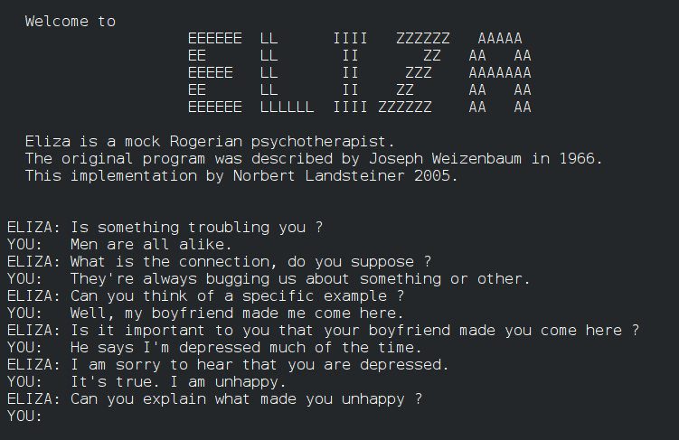
SHRDLU
SHRDLU is a pioneering early natural-language understanding computer program developed by Terry Winograd at MIT (MIT Artificial Intelligence Laboratory) between 1968 and 1970. Users interacted with it via text to command a simulated robot arm moving objects in a virtual "blocks world" of colored shapes.

Late 1980s–2000s — Statistical NLP
NLP began learning patterns from data instead of relying entirely on rules. N-grams, Hidden Markov Models (HMMs), Naive Bayes, and Conditional Random Fields (CRFs) became important.
N-grams:
- N-grams are sequences of N words used to predict the next word based on previous words.
- Example: “I love NLP” → bigrams: “I love”, “love NLP”.
Hidden Markov Models (HMMs):
- HMMs predict hidden states (such as parts of speech) from observed words.
- They use probabilities to model how likely one state is to follow another.
Naive Bayes:
- Naive Bayes is a probabilistic classifier that predicts a category using the probability of the words in the text.
- Speech Recognition, POS Tagging.
- It is commonly used for tasks like spam detection and sentiment classification.

2000–2013 — Machine Learning NLP
Supervised machine learning became common for tasks such as classification, sentiment analysis, and named entity recognition. SVMs, logistic regression, and feature engineering were widely used.

Sentence
↓
Feature Extraction
↓
Machine Learning Model
↓
Prediction
Algorithms
- SVM
- Logistic Regression
- Decision Trees
- Random Forest
- CRF

2013–2017 — Deep Learning
Word embeddings such as Word2Vec and GloVe gave words meaningful vector representations. RNNs, LSTMs, and GRUs improved sequence modeling, translation, and text generation.
Word2Vec (2013)
- Words became vectors.
- Example
Cat → [0.23, -1.4, ...]
Dog → [0.30, -1.2, ...]
- Similar words had nearby vectors
King - Man + Woman ≈ Queen
RNN
- RNNs have a built-in memory (hidden state) that loops past information back into the network, making them ideal for text, speech, and audio
- I -> love -> AI
LSTM
- Solved the vanishing gradient problem.
- The vanishing gradient problem in Recurrent Neural Networks (RNNs) occurs when error gradients shrink exponentially close to zero during backpropagation through time.
- Remembered long-term information.

Applications
- Translation
- Chatbots
- Summarization
- Speech Recognition

2017–2020 — Transformers
The Transformer architecture introduced self-attention and enabled highly parallel training. BERT, GPT, T5, and related models significantly improved language understanding and generation.
- Attention Is All You Need (June 12, 2017)
Self Attention
- Self-attention is an artificial intelligence mechanism that lets a model weigh the importance of different words in a sentence relative to one another, it helps the model understand context.
- Instead of reading one word at a time, transformer reads all words at once.

I love machine learning
↓ ↓ ↓ ↓
└────────────── Self-Attention ──────────────┘

Advantages
- Parallel training
- Better long context
- Higher accuracy
- Faster GPUs

BERT (2018)
- A language model built by Google and released in October 2018.
- It uses stacked layers of bidirectional self-attention to understand the deep context of text
GPT (2018)
- GPT had decoder only architecture which was used for text generation tasks.

2020–2022 — Large Language Models
Models such as GPT-3 demonstrated strong few-shot and zero-shot capabilities. Large-scale pretraining allowed one model to perform many different language tasks.
- Training shifted from task-specific models to massive pretraining.
- GPT-3 (2020)

2022–2024 — ChatGPT and Generative AI
Instruction tuning and RLHF made LLMs much better at following human instructions and having conversations. RAG, embeddings, and vector databases enabled models to use external and private knowledge.
- General-purpose assistants became mainstream.

2024–2026 — Agentic & Multimodal AI
Modern NLP is increasingly part of multimodal and agentic systems. Models can work with text, images, audio, and documents, while using tools, APIs, code execution, retrieval, memory, and multi-step workflows.
- Long Context Models: 100K–1M+ token context windows.
Multimodal Models Understand
- Text
- Images
- Audio
- Video
- Documents

AI Agents
Models can:
- Call APIs
- Search the web
- Execute code
- Access databases
- Use tools
- Plan multi-step workflows

NLP Evolution at a Glance
Period | Main Technology | Key Shift
1960s–1980s | Rules & Grammars | Handwritten language rules
1990s–2000s | Statistics & ML | Learning from language data
2013–2016 | Embeddings & RNNs | Learning semantic representations
2017 | Transformers | Self-attention and parallel training
2020+ | LLMs | General-purpose language models
2022–2026 | RAG, Agents, Multimodal AI | Knowledge retrieval, tools, reasoning, and multiple modalities

The Big Picture
Rules → Statistics → Machine Learning → Deep Learning → Transformers → LLMs → RAG + Agents + Multimodal AI

1960s
│
├── Rule-Based NLP
│ ELIZA
│
1970s
│
├── Grammar
├── Knowledge Representation
│
1980s
│
├── HMM
├── Statistical NLP Begins
│
1990s
│
├── N-Grams
├── CRF
├── Naive Bayes
│
2000s
│
├── SVM
├── Feature Engineering
│
2013
│
├── Word2Vec
├── GloVe
│
2014–2016
│
├── RNN
├── LSTM
├── GRU
│
2017
│
├── Transformer
│
2018
│
├── BERT
├── GPT
│
2020
│
├── GPT-3
├── Large Language Models
│
2022
│
├── ChatGPT
├── RLHF
├── Instruction Tuning
│
2023–2024
│
├── RAG
├── Vector Databases
├── Function Calling
│
2025–2026
│
├── AI Agents
├── Multimodal AI
├── Long Context Models
├── Small Language Models
└── Reasoning-Centric Systems

