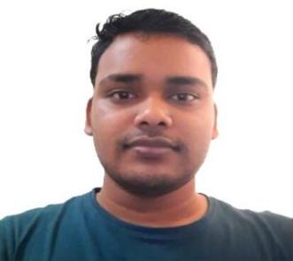

**Asish Kumar Nayak**

**Software Engineer**

**Objective** : As a Software Developer seeking to get Full Stack (MERN) position in an organization, where I Can share & utilize Techno skills and knowledge for organization’s growth as well as learn from others to grow mutually.

**Project**

1. **Location Tracking App (Android Studio, Java)**

* Worked on the Location Tracking Functionality using google API .
* Worked on Firebase DB to Perform CRUD on User’s info.

1. **BLOG (React.js)**

Objective :

1. **Weather web App (React.js)**

* Implemented with Fetching real time Weather data using React.js & Bootstrap.

1. **Process Scheduling (C)**

* Implemented the FCFS Algorithm.
* Implemented Graphics Using C on Console.

1. **Portfolio (React.js)**

**Work Experience**

May 2021- Sept 2022

**ServiceNow Developer |AGS5 | Allianz Technology**

* Developed the Dashboards and Reports using Performance Analytics (PA).
* Worked on Service Catalog and Work Flow Design..

**Web Design Intern**

* Designed Flex-box and it’s functionality by using HTML,CSS,JS &Bootstrap.
* Designed Video , Audio Drag & Drop Uploading functionality Page..

**Achievement**

1. NRTS Scholarship from Govt. Of Odisha.
2. Runner’s Up in Science Exhibition at Block Level.

**Interest**

* Sports : Cricket, Carrom
* Speak : Hindi, English, Oriya
* Others : Pencil Art, Travelling, Cooking

**Certification**

* JavaScript DSA ( FreeCodeCamp )
* CSA - ServiceNow (Pearson)
* Time Management (Soft Skill)

**Education**

**B.Tech (Computer Science and Engineering)**

* Centurion University Of Technology & Management(CUTM),BBSR.

**Intermediate (10+2)**

* Aaryan Gurukul Residential College,Brahmapur.

**Tools & Technologies**

* ServiceNow (ITSM)
* Visual Studio
* Core Java
* JavaScript
* Python
* Html,Css,Bootstrap
* Tailwind CSS
* React.js
* Express.js
* Node.js
* MongoDB
* MySQL
* Version control System (Git & GitHub)

* Adaptability
* Collaboration
* Time Management

**Personal Information**

**Email : [akndipu96@gmail.com](https://www.gmail.com)**

**Phone :** (+91) 8908512995

**Address** : Block Road,College Square,Bellaguntha ,Ganjam,

Odisha(761119).

**LinkedIn :<https://www.linkedin.com/in/asish-kumar-nayak-3126a1152/>**

**GitHub :**

**Skills**