**Introduction to HTML/CSS**

**Date 09/feb/2021**

**1.How are inline and block elements different from each other?**

1) Block level elements always start from a new line whereas inline elements don’t start from a new line.

2) Block level elements take up all the width (left and right) available whereas inline elements take only that amount of width which is necessary for the content.

3) Block elements has margin on both top and bottom whereas inline elements don’t.

**Inline element Example Block elements example**

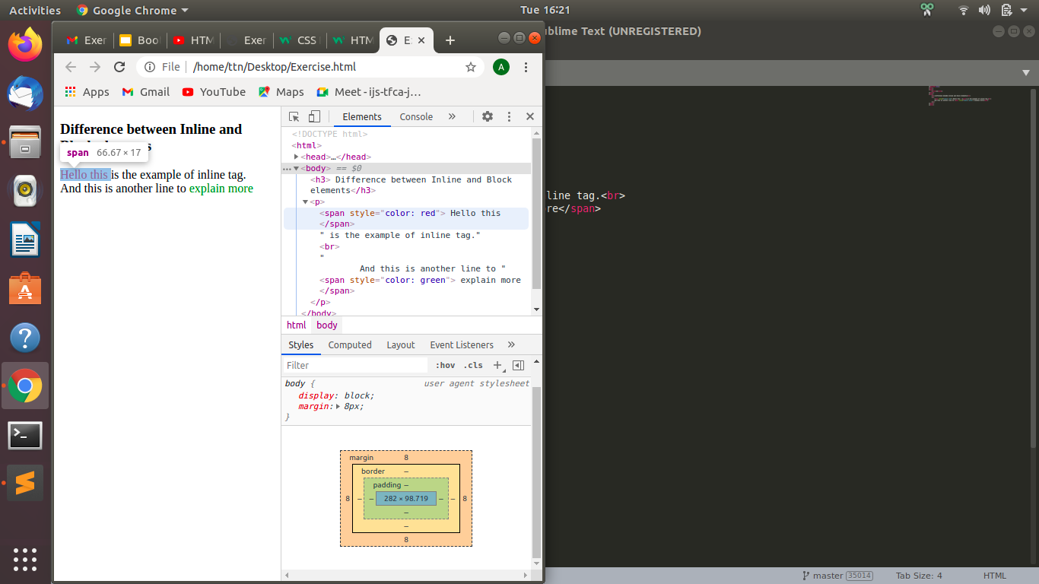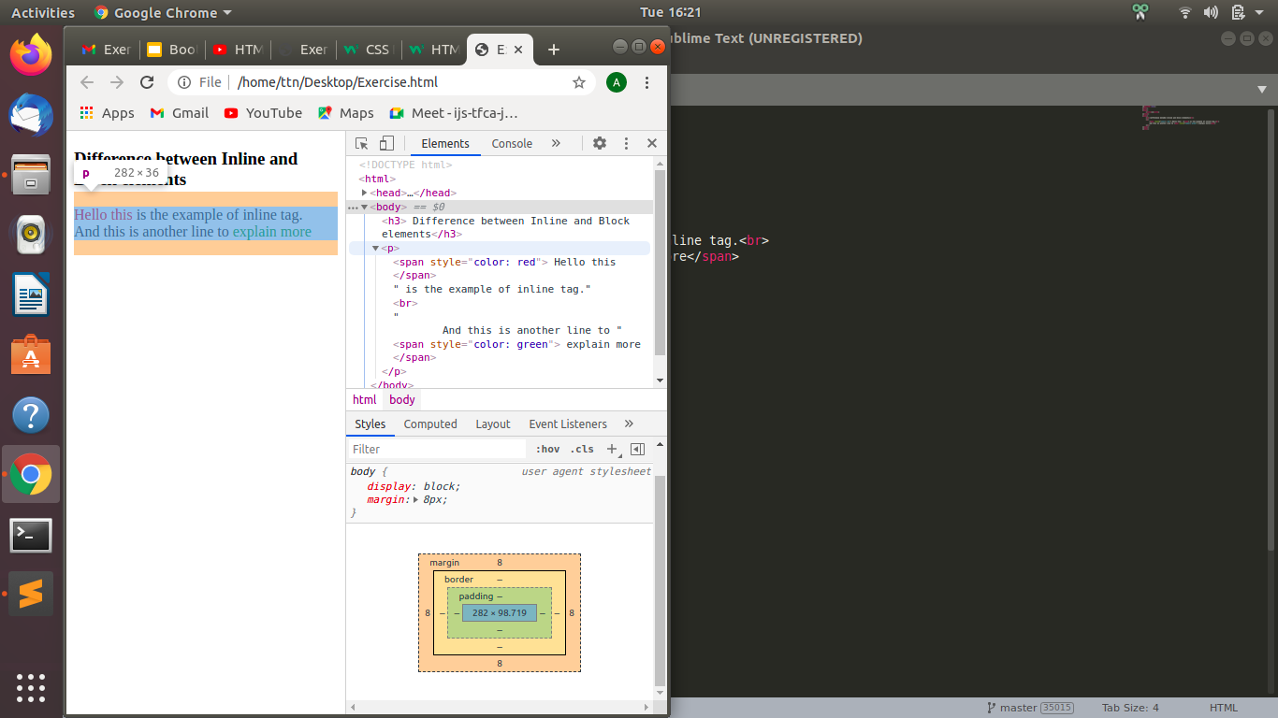

**2.Explain the difference between visibility:hidden and display:none**

The major difference between visibility:hidden and display:none is that in **visibility:hidden** the element won’t be visible but it will take up that space but in **display:none** the page will appear as such that element isn’t there(hidden element won’t occupy any space).

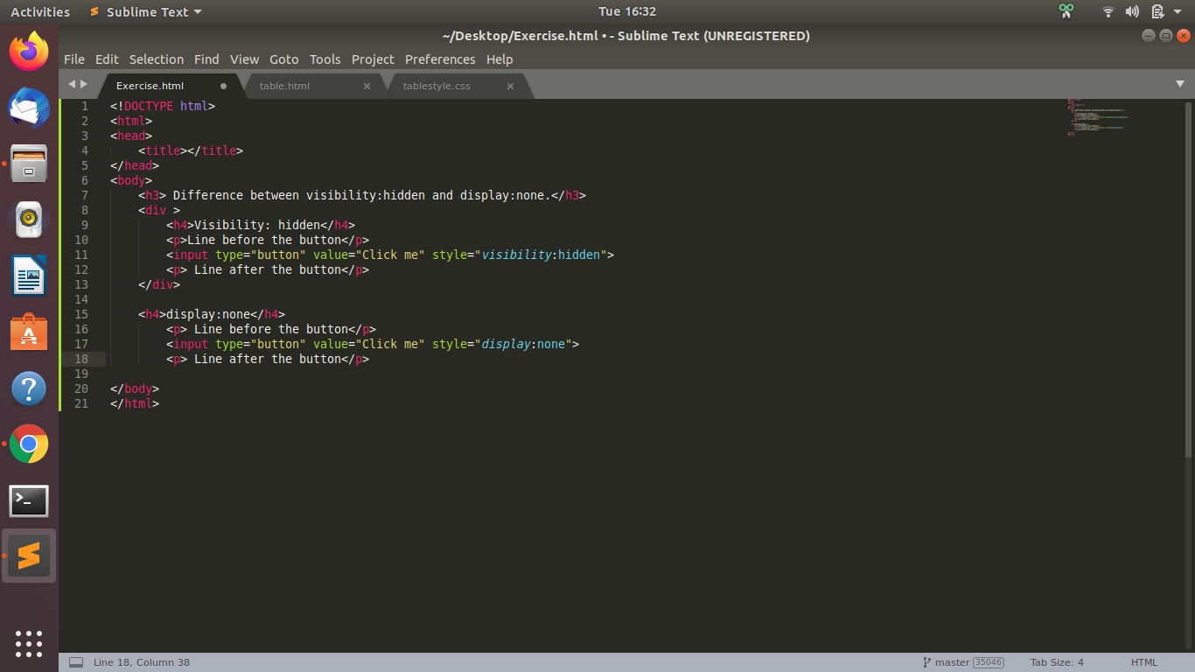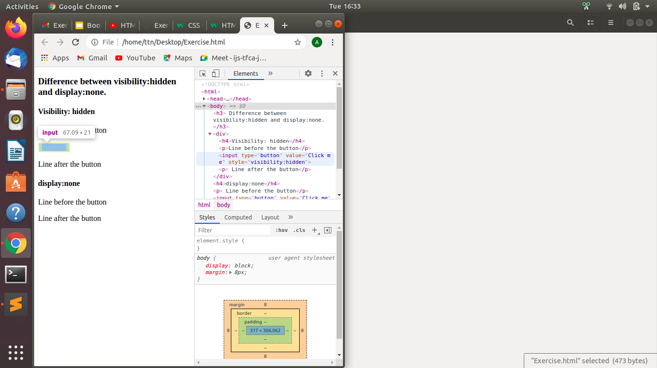

**3. Explain the clear and float properties.**

These are the property of an element in a CSS

* Float

This property is used to decide how an element will float i.e. it is a positioning property and it is used to float an element to the left or right corner of parent element and the next element or text wrapping around the left or right to it.

It has four values, left, right, none, inherit.

**4. explain difference between absolute, relative,fixed and static.**

The position property specifies the type of positioning method used for an element.

1. static - this is default for all the elements, it just means that the element will flow into the page as it normally would.
2. Relative - it means relative to itself, if we don't provide left, right, top or bottom, there will be no effect on the position of the element and we may call it static. Although, if we move it elsewhere, it will appear on top of a statically positioned element.
3. Fixed - it is fixed with respect to the viewport or screen i.e. it won’t up/ down anywhere even if we scroll the screen.
4. Absolute- an element with position absolute is moved relative to it’s nearest parent element.

**5. Write the HTML code to create a table in which there are 4 columns( ID , Employee Name, Designation, Department) and at least 6 rows. Also do some styling to it.**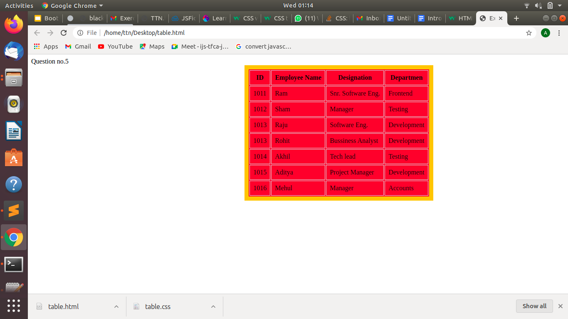

**6. Why do we use meta tags?**

Meta tag<meta> provides information about the HTML page. Meta elements are used to specify page description, keywords, author of the document, last modified, and other metadata. Also, it helps to improve the SEO( Search Engine Optimization) of a web page by using certain keywords related to the web page

Keywords- for search engine optimisation.

Description-description of web page.

Name- author of the web page etc.

**7. Explain box model.**

Every HTML element can be considered as a box as every element consists of margin,padding, border and the element content.

* Content - The content of the box, where text and images appear
* Padding - Clears an area around the content. The padding is transparent
* Border - A border that goes around the padding and content
* Margin - Clears an area outside the border. The margin is transparent

So, basically, a box model refers to the box that wraps around the element.Also, we can change the size and layout of the box(margin, padding, content, border) as well.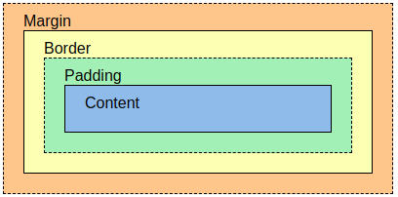

**8. What are the different types of CSS Selectors?**

CSS selector are as follows-

* id selector- The id selector uses the id attribute of an HTML element to select a specific element. We can use single id for an element and same id for multiple elements. Starts with (#) .
* class selector- The class selector selects HTML elements with a specific class attribute. Starts with (.) .
* element selector - The element selector selects HTML elements based on the element name. Eg p
* universal selector - It selects all the element within a page(*)
* grouping selector - an element can use multiple classes.Eg p,h1,h2.

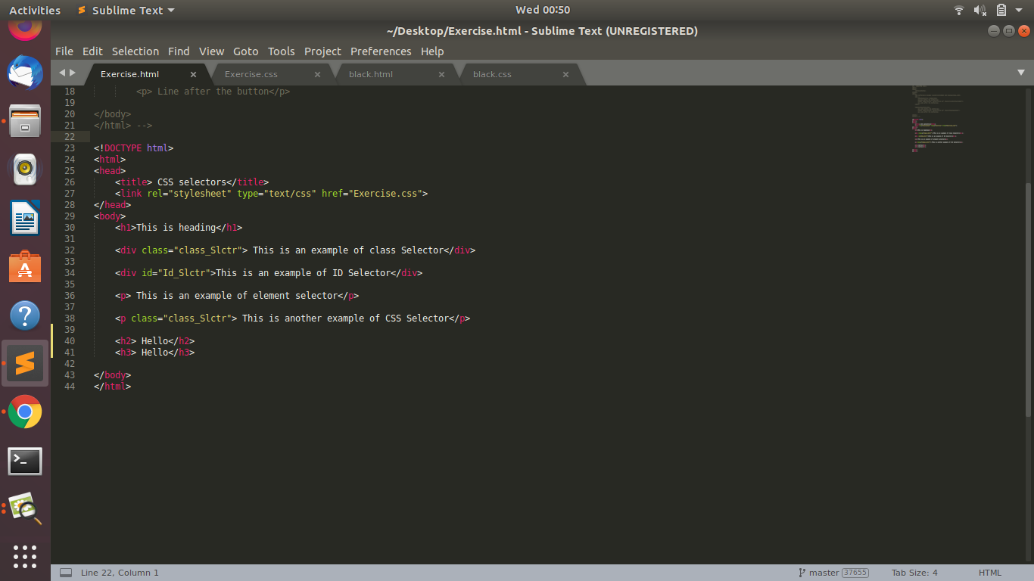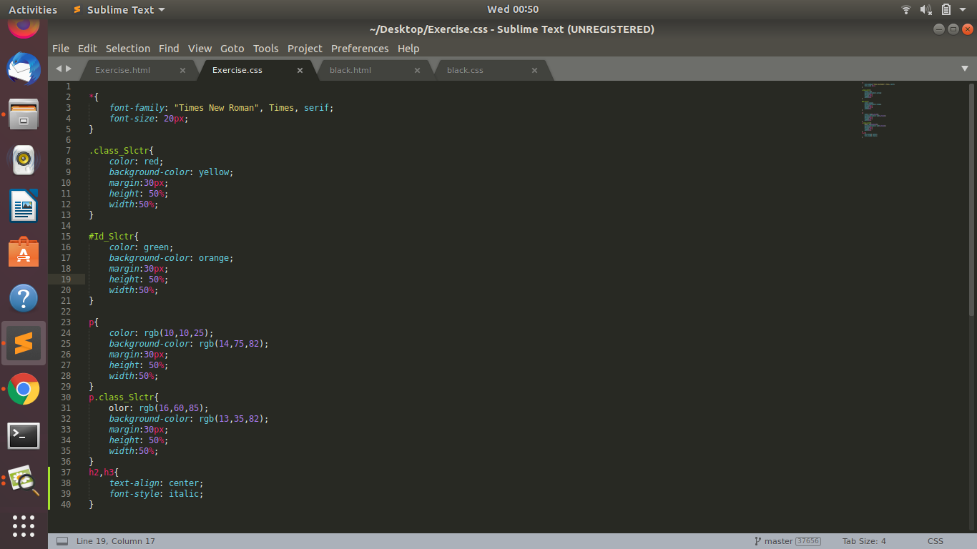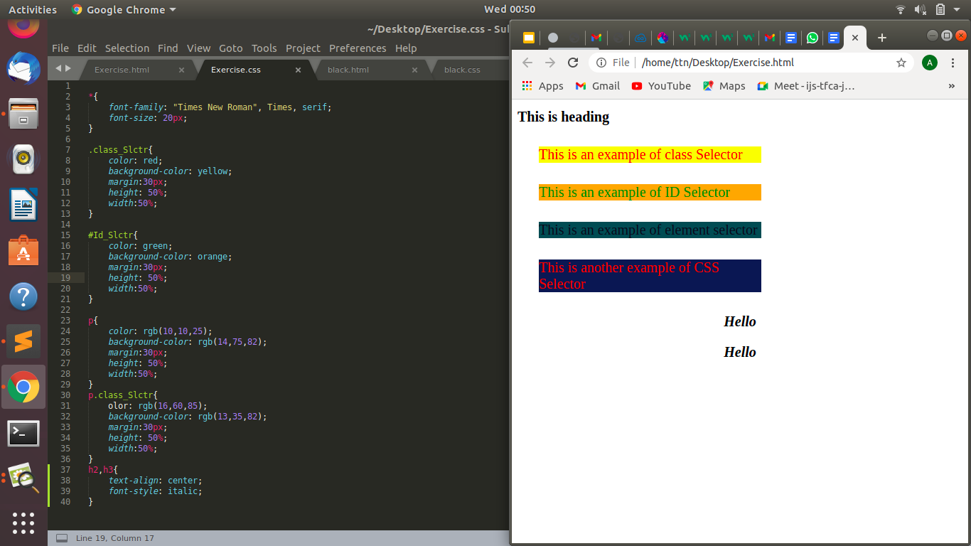

**9. Define Doctype.**

!DOCTYPE> at the beginning of the HTML page gives information about the browser that the given HTML page is is of what document type,

For HTML 5 , it is as such

<!DOCTYPE HTML>

Also, it is not case sensitive.

**10. Explain 5 HTML5 semantic tags.**

1) <sectio> this tag is used to define a section the page.

2) <article> this tag is used to define a independent self contained content.

3) <header> it defines a header for introductory content and set of navigation links. We can have multiple <header>

3)<footer> - defines a footer for a document or a section

4) <nav> - defines navigation link in the document/page etc, is very handy in creating a navigation bar.

5) <main> to specify a main content of the document.

**11. Create HTML for web-page.jpg (check resources, highest weightage for answers).**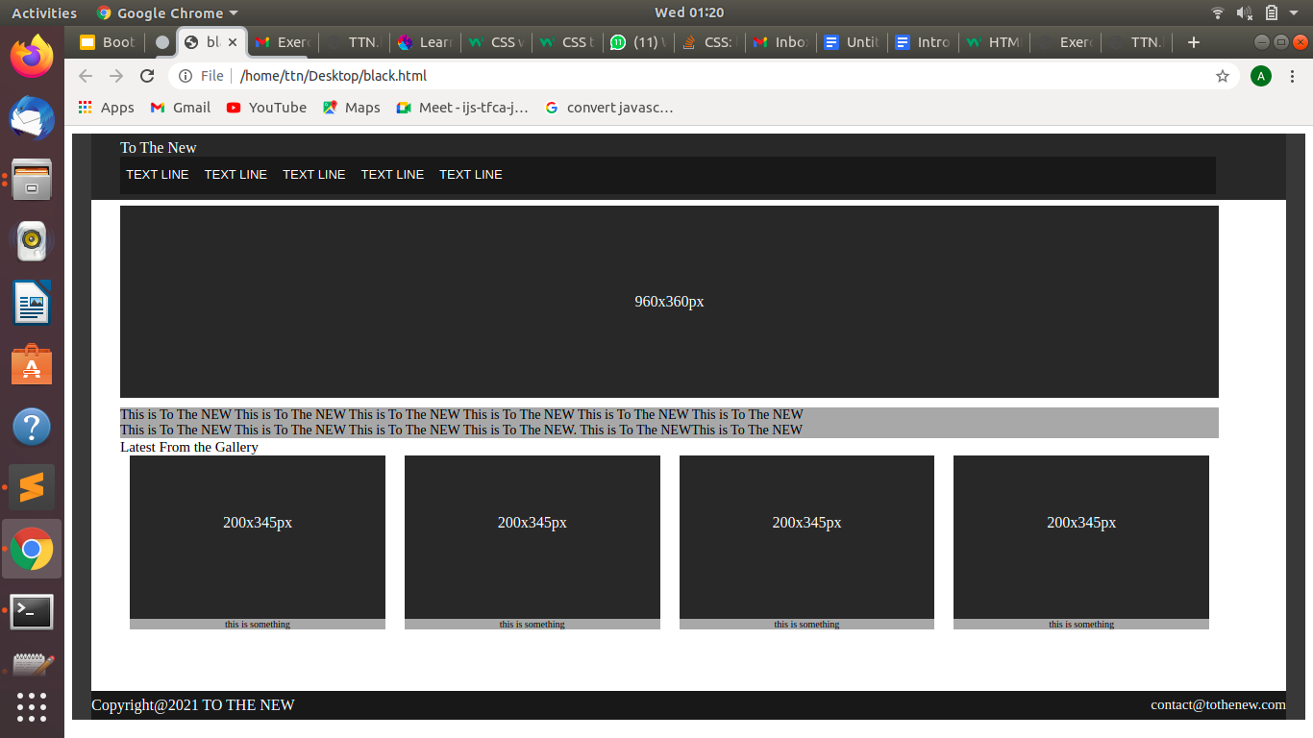

**12. Create HTML for form.png (check resources, highest weightage for answers)**

