PRE-ALGEBRA (7TH) · UNIT 2: SOLVING ONE-STEP EQUATIONS AND INEQUALITIES  Movie Night Fundraiser  Simplify expressions and solve one-step equations and inequalities to run a school movie night. | CP2  2–3 class periods

Name: ________________________________ Date: ______________ Period: ______
The Scenario
The student council is hosting a movie night in the gym to raise money for new sports equipment. You will sell tickets and snacks, rent a projector, and follow the gym rules.
You will use properties, equations, and inequalities to figure out how many tickets and snacks to sell and whether you will reach the goal.

Learning Goals
- I can use properties to simplify expressions.
- I can solve one-step equations.
- I can solve and graph one-step inequalities.
Project Timeline
When | What you will do
Day 1 | Simplify the Costs
Day 2 | Equations
Day 3 | Inequalities
Final | Fundraiser Plan + reflection
Part 1: Simplify the Costs
Day 1 · Use the Price Board.
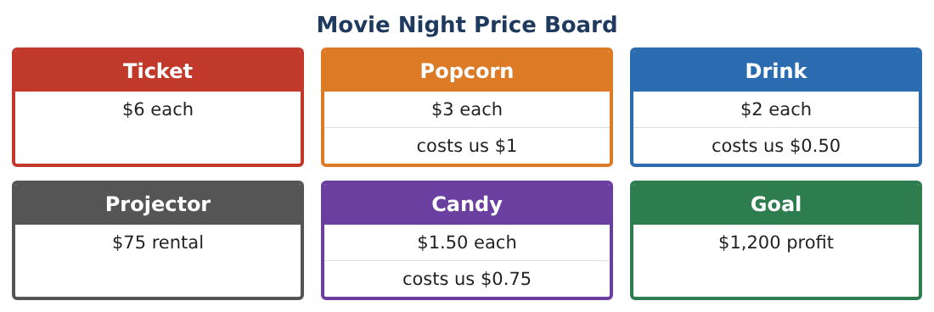
1. Use the distributive property: a family buys 4 tickets and 4 popcorns. Show 4(6 + 3) two ways.
Starter: 4(6 + 3) = 4 × ___ + 4 × ___

2. Simplify 6t + 3p + 2t + p.

3. Which property is shown? 3 + 6 = 6 + 3

4. Simplify 5(2x + 4).

Part 2: Equations
Day 2 · Write and solve an equation for each question.
5. Ticket sales were $540. How many tickets were sold?
Starter: 6t = 540, so t = 540 ÷ ___

6. Popcorn sales were $186. How many bags were sold?

7. After paying for the projector, the council had $415 left. How much did they collect?

8. Check one answer by substituting it back into the equation.

Part 3: Inequalities
Day 3 · Solve and graph each inequality.
9. At most 240 people can be in the gym. 85 people are inside. How many more can come in?
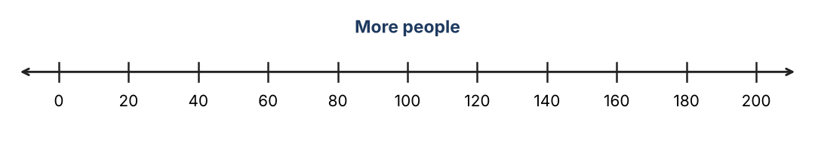

10. The council wants at least $300 from ticket sales. How many tickets t must they sell?

11. Write your own inequality about drinks and solve it.

Final Product: Fundraiser Plan
Your final product must include:
- Two simplified expressions
- Three solved equations with checks
- Two inequalities with graphs
- Your ticket and snack sales plan
- A flyer for movie night
Reflection
R1. How do inverse operations help you solve an equation?

R2. How is the answer to an inequality different from an equation?

Scoring Rubric
Criteria | 4 – Exceeds | 3 – Meets | 2 – Approaching | 1 – Beginning
Mathematical Accuracy | All calculations and solutions are correct; answers include units and are checked. | Nearly all work is correct; minor errors do not change conclusions. | Several errors; some conclusions are affected. | Many errors or missing work.
Reasoning & Justification | Clear, complete explanations connect every answer to the situation; uses precise vocabulary. | Explanations are mostly clear and connected to the situation. | Explanations are brief or partly unclear. | Little or no explanation.
Application & Design | Expressions, equations, and inequalities model sales and limits correctly and are used to reach the goal. Goes beyond the minimum with a creative, realistic choice. | Expressions, equations, and inequalities model sales and limits correctly and are used to reach the goal. | Design is incomplete or only partly uses the math from the unit. | Design is missing or unrelated to the unit math.
Communication & Presentation | Fundraiser plan includes expressions, solved equations, graphed inequalities, and a recommendation. Polished, organized, and visually engaging. | Fundraiser plan includes expressions, solved equations, graphed inequalities, and a recommendation. Organized and easy to follow. | Product is missing required parts or is hard to follow. | Product is mostly missing.

