PRE-ALGEBRA (7TH) · UNIT 13: NONLINEAR FUNCTIONS AND POLYNOMIALS  Rabbit Island Population  Model a growing rabbit population with sequences, exponential functions, and polynomials. | CP1  2–3 class periods

Name: ________________________________ Date: ______________ Period: ______
The Scenario
Ten rabbits were released on a small island with no predators. The population is growing fast, the grass is disappearing, and the wildlife office needs a plan.
You will use sequences, exponential models, and polynomials to predict the population and design habitats.
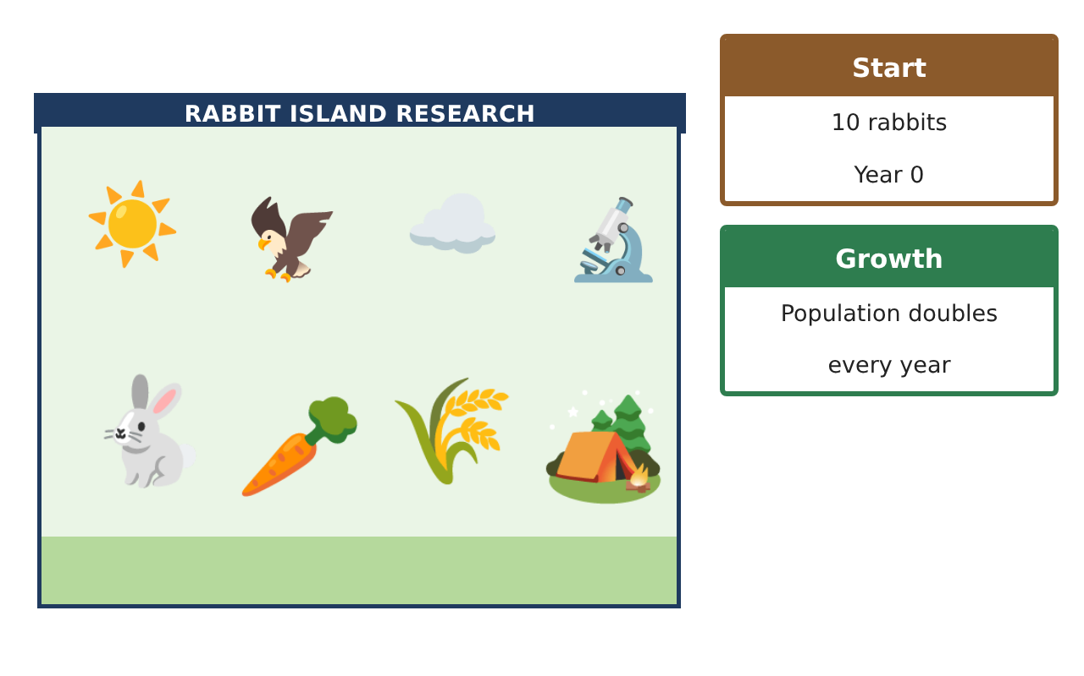
Learning Goals
- I can model growth and decay with exponential functions.
- I can graph and compare linear and nonlinear functions.
- I can add, subtract, and multiply polynomials.
Project Timeline
When | What you will do
Day 1 | Growth Models
Day 2 | Compare Functions
Day 3 | Habitat Design
Final | Wildlife Management Report + reflection
Part 1: Growth Models
Day 1 · Use the Population Survey.
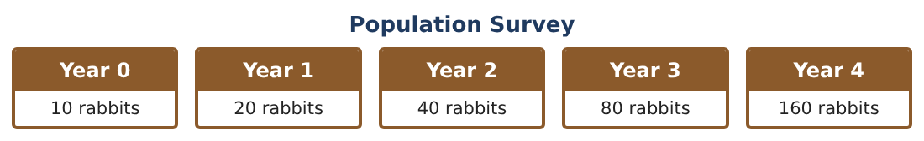
1. Write the population as a function P(n) and find P(7).

2. Each rabbit eats 0.1 grass patch per year. Make a table for years 4–8 comparing the grass patches (200 − 15n) with the grass the rabbits need (0.1 × P(n)). In which year do the rabbits first need more grass than the island has?

3. Biologists bring foxes, and the rabbits now decrease by 30% per year from 640. Write a decay model and find the population after 3 years.

4. Is the decay model linear? Explain using the differences in your table.

Part 2: Compare Functions
Day 2 · Graph on the same axes.
5. Graph y = 10 · 2ˣ and y = 50x + 10 for x = 0 to 5. Where does the exponential pass the linear?

6. Graph y = x² for the area (sq m) of a square pen with side x. What shape is the graph?

7. Which grows fastest eventually: 50x + 10, x², or 10 · 2ˣ?

8. Write the type of each sequence: 3, 9, 27, …; 5, 12, 19, …; 1, 4, 9, 16, …

Part 3: Habitat Design
Day 3 · Pens are rectangles with length 2x + 3 and width x + 1 meters.
9. Write and simplify the area as a polynomial.

10. A larger pen is (3x + 2)(x + 4). Find the difference in area between the larger pen and the first pen.

11. If x = 6, find both areas and the total fence for both pens.

Final Product: Wildlife Management Report
Your final product must include:
- Growth and decay models with predictions
- Graph comparing linear, quadratic, and exponential
- Sequence classification
- Polynomial habitat designs
- Management report with a recommendation
Reflection
R1. How can you tell from a table whether a function is exponential?

R2. How is multiplying binomials like finding the area of a rectangle?

Scoring Rubric
Criteria | 4 – Exceeds | 3 – Meets | 2 – Approaching | 1 – Beginning
Mathematical Accuracy | All calculations and solutions are correct; answers include units and are checked. | Nearly all work is correct; minor errors do not change conclusions. | Several errors; some conclusions are affected. | Many errors or missing work.
Reasoning & Justification | Clear, complete explanations connect every answer to the situation; uses precise vocabulary. | Explanations are mostly clear and connected to the situation. | Explanations are brief or partly unclear. | Little or no explanation.
Application & Design | Sequences, exponential models, graphs, and polynomials are correct and used to make a management plan. Goes beyond the minimum with a creative, realistic choice. | Sequences, exponential models, graphs, and polynomials are correct and used to make a management plan. | Design is incomplete or only partly uses the math from the unit. | Design is missing or unrelated to the unit math.
Communication & Presentation | Report includes tables, graphs, models, habitat designs, and a recommendation. Polished, organized, and visually engaging. | Report includes tables, graphs, models, habitat designs, and a recommendation. Organized and easy to follow. | Product is missing required parts or is hard to follow. | Product is mostly missing.

