PRE-ALGEBRA (7TH) · UNIT 13: NONLINEAR FUNCTIONS AND POLYNOMIALS  Rabbit Island Population  Model a growing rabbit population with sequences, exponential functions, and polynomials. | CP2  2–3 class periods

Name: ________________________________ Date: ______________ Period: ______
The Scenario
Ten rabbits were released on a small island with no predators. The population is growing fast, the grass is disappearing, and the wildlife office needs a plan.
You will use sequences, exponential models, and polynomials to predict the population and design habitats.
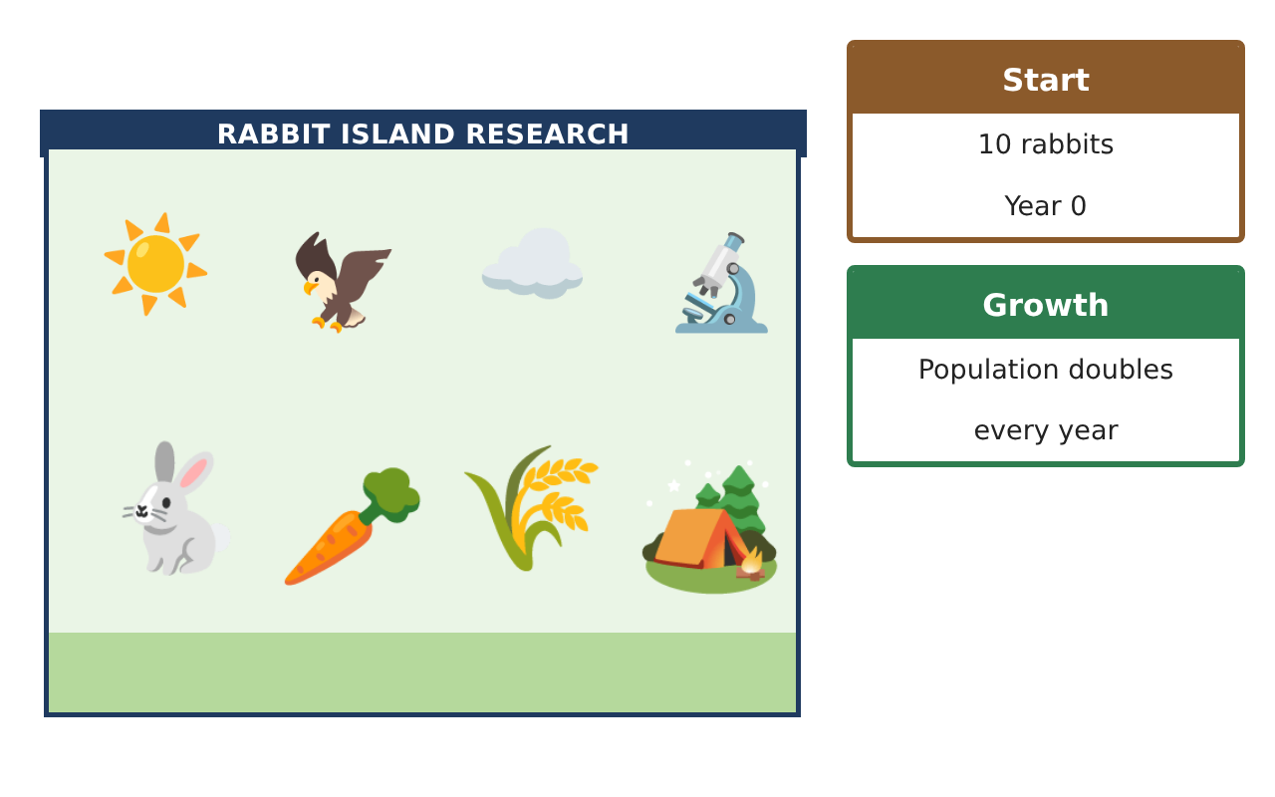
Learning Goals
- I can tell arithmetic and geometric sequences apart.
- I can extend a pattern and graph it.
- I can add and subtract polynomials.
Project Timeline
When | What you will do
Day 1 | Patterns
Day 2 | Graph It
Day 3 | Habitat Fences
Final | Wildlife Management Report + reflection
Part 1: Patterns
Day 1 · Use the Population Survey.
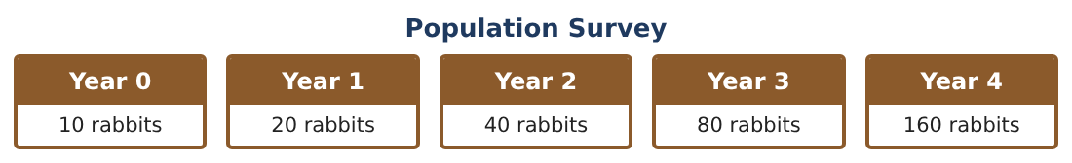
1. What do you multiply by each year?

2. Predict the population in years 5 and 6.

3. Grass patches drop by 15 each year: 200, 185, 170, … Is this arithmetic or geometric? What comes next?

4. In which year will the grass patches reach 50?

Part 2: Graph It
Day 2 · Make a table and a graph.
5. Graph the population for years 0–4. Is the graph a line or a curve?

6. Graph the grass patches for years 0–4. Is it a line or a curve?

7. Write a rule for the population after n years.
Starter: P = 10 × 2^___

8. Use your rule to find the population in year 8.

Part 3: Habitat Fences
Day 3 · A rectangular pen is x + 4 meters long and x meters wide.
9. Write and simplify the perimeter of the pen.

10. Add the perimeters of two pens: (4x + 8) + (2x + 6).

11. If x = 5, how much fence is needed for both pens?

Final Product: Wildlife Management Report
Your final product must include:
- Population table and graph
- Grass pattern and when it runs low
- Your population rule
- Pen fence expressions
- Report to the wildlife office
Reflection
R1. How is doubling different from adding the same number each year?

R2. Why can the rabbit population not keep doubling forever?

Scoring Rubric
Criteria | 4 – Exceeds | 3 – Meets | 2 – Approaching | 1 – Beginning
Mathematical Accuracy | All calculations and solutions are correct; answers include units and are checked. | Nearly all work is correct; minor errors do not change conclusions. | Several errors; some conclusions are affected. | Many errors or missing work.
Reasoning & Justification | Clear, complete explanations connect every answer to the situation; uses precise vocabulary. | Explanations are mostly clear and connected to the situation. | Explanations are brief or partly unclear. | Little or no explanation.
Application & Design | Sequences, exponential models, graphs, and polynomials are correct and used to make a management plan. Goes beyond the minimum with a creative, realistic choice. | Sequences, exponential models, graphs, and polynomials are correct and used to make a management plan. | Design is incomplete or only partly uses the math from the unit. | Design is missing or unrelated to the unit math.
Communication & Presentation | Report includes tables, graphs, models, habitat designs, and a recommendation. Polished, organized, and visually engaging. | Report includes tables, graphs, models, habitat designs, and a recommendation. Organized and easy to follow. | Product is missing required parts or is hard to follow. | Product is mostly missing.

