PRE-ALGEBRA (7TH) · UNIT 13: NONLINEAR FUNCTIONS AND POLYNOMIALS  Rabbit Island Population  Model a growing rabbit population with sequences, exponential functions, and polynomials. | Honors  2–3 class periods

Name: ________________________________ Date: ______________ Period: ______
The Scenario
Ten rabbits were released on a small island with no predators. The population is growing fast, the grass is disappearing, and the wildlife office needs a plan.
You will use sequences, exponential models, and polynomials to predict the population and design habitats.
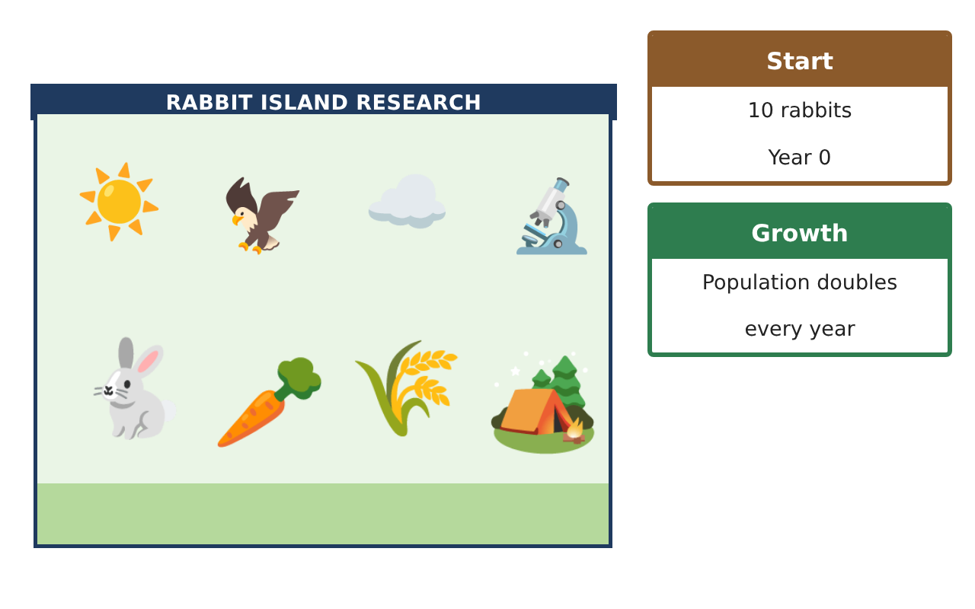
Learning Goals
- I can build exponential models from data and compare them with linear models.
- I can analyze nonlinear graphs and sequences.
- I can use polynomial operations to optimize habitat designs.
Project Timeline
When | What you will do
Day 1 | Model the Data
Day 2 | Sequences & Graphs
Day 3 | Habitat Optimization
Final | Wildlife Management Report + reflection
Part 1: Model the Data
Day 1 · Use the Population Survey.
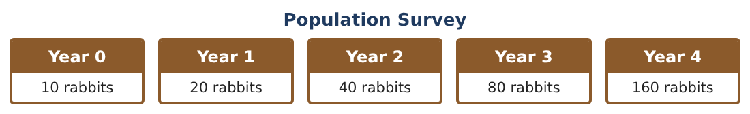
1. Show that the survey data is exponential by finding ratios. Write P(n).

2. In what year does the population first exceed 10,000?

3. The island can support at most 3,000 rabbits. Explain why the model must change before year 9. What might the real graph look like?

4. After foxes arrive, the population falls 30% per year from 2,500. After how many whole years is it below 500?

Part 2: Sequences & Graphs
Day 2 · Compare models.
5. Write the nth term of the grass sequence 200, 185, 170, … and of the rabbit sequence 10, 20, 40, …

6. Each rabbit eats 0.1 grass patch per year. In what year does the rabbits’ need exceed the grass patches?

7. Sketch y = x², y = x³, and y = 2ˣ for 0 ≤ x ≤ 4 on one graph. Where does 2ˣ pass x²?

8. Explain why an exponential function eventually outgrows any polynomial.

Part 3: Habitat Optimization
Day 3 · Fence pens with polynomial dimensions.
9. A pen has length 3x + 2 and width 2x − 1. Write its area and perimeter as polynomials.

10. Square the binomial: a square pen has side x + 5. Find its area and explain why it is not x² + 25.

11. You have 104 m of fence for one rectangular pen. Write the area of a pen with width w as a polynomial and find the width that gives the most area (test values).

Final Product: Wildlife Management Report
Your final product must include:
- Exponential model with justification and limits
- Decay prediction
- Sequence and graph comparisons
- Polynomial pens with optimization
- Management report
Reflection
R1. Why are real populations not exponential forever?

R2. What pattern did you notice when maximizing the pen area?

Scoring Rubric
Criteria | 4 – Exceeds | 3 – Meets | 2 – Approaching | 1 – Beginning
Mathematical Accuracy | All calculations and solutions are correct; answers include units and are checked. | Nearly all work is correct; minor errors do not change conclusions. | Several errors; some conclusions are affected. | Many errors or missing work.
Reasoning & Justification | Clear, complete explanations connect every answer to the situation; uses precise vocabulary. | Explanations are mostly clear and connected to the situation. | Explanations are brief or partly unclear. | Little or no explanation.
Application & Design | Sequences, exponential models, graphs, and polynomials are correct and used to make a management plan. Goes beyond the minimum with a creative, realistic choice. | Sequences, exponential models, graphs, and polynomials are correct and used to make a management plan. | Design is incomplete or only partly uses the math from the unit. | Design is missing or unrelated to the unit math.
Communication & Presentation | Report includes tables, graphs, models, habitat designs, and a recommendation. Polished, organized, and visually engaging. | Report includes tables, graphs, models, habitat designs, and a recommendation. Organized and easy to follow. | Product is missing required parts or is hard to follow. | Product is mostly missing.

