PRE-ALGEBRA (7TH) · UNIT 6: RATIOS, PROPORTIONS, AND PERCENTAGES  Sneaker Store Manager  Use rates, proportions, and percents to run a sneaker store for a week. | CP1  2–3 class periods

Name: ________________________________ Date: ______________ Period: ______
The Scenario
You just became the manager of Fresh Kicks Sneaker Store. You have to order shoes from suppliers, lay out the new store, run a grand-opening raffle, and set prices that bring customers in and still make a profit.
You will use ratios, proportions, and percents to make every decision.
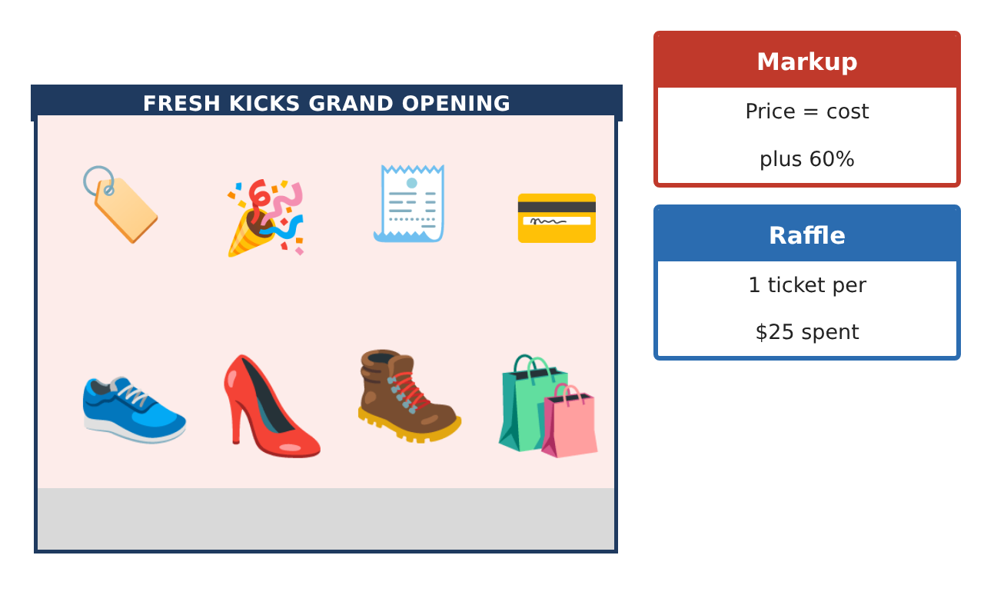
Learning Goals
- I can compare unit rates and solve proportions in context.
- I can use scale drawings and similar figures.
- I can find percent of change, markup, discount, and probability.
Project Timeline
When | What you will do
Day 1 | Ordering
Day 2 | Store Layout
Day 3 | Pricing & Raffle
Final | Store Manager Report + reflection
Part 1: Ordering
Day 1 · Use the Supplier Cards. You need 180 pairs.
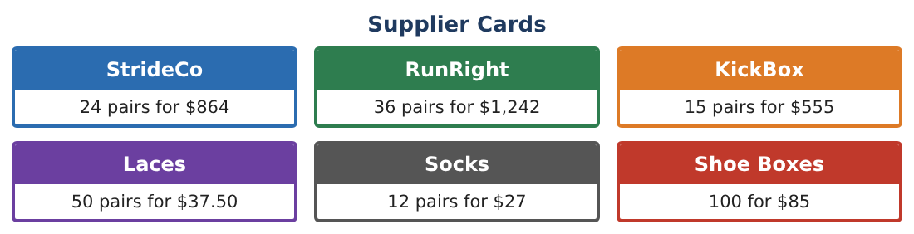
1. Find the unit price of each shoe supplier and rank them.

2. Find the cost of 180 pairs from RunRight. What percent is saved compared to StrideCo?

3. Socks: 12 pairs for $27. Use a proportion to find the cost of 180 pairs.

4. RunRight only sells in packs of 36. How many packs do you need, and how many extra pairs do you get?

Part 2: Store Layout
Day 2 · On the plan, 1 in = 4 ft. The store is 12 in by 7$\frac{1}{2}$ in.
5. Find the real length, width, and floor area of the store.

6. A display table is similar to a 2 ft by 5 ft table and its long side is 7.5 ft. Find its short side and the scale factor.

7. What percent of the floor does a 6 ft by 30 ft wall of shelves cover?

8. If the plan scale changed to 1 in = 3 ft, how long would the store be on the plan?

Part 3: Pricing & Raffle
Day 3 · Prices are cost plus a 60% markup.
9. A RunRight pair costs $34.50. Find the price, then the price after a 30% grand-opening discount. Is the store still making money?

10. Sales were 140 pairs last week and 182 pairs this week. Find the percent change.

11. The raffle has 300 tickets and 5 prizes. You hold 12 tickets. What is the probability that a given drawing picks one of your tickets? What is the theoretical number of times you win if the drawing were repeated 50 times?

Final Product: Store Manager Report
Your final product must include:
- Supplier comparison and order cost
- Scale drawing with real dimensions
- Pricing table with markup and discounts
- Percent change in sales
- Raffle probabilities and manager report
Reflection
R1. Explain how a markup and a discount of the same percent can still leave a profit.

R2. How do scale factors connect similar figures and scale drawings?

Scoring Rubric
Criteria | 4 – Exceeds | 3 – Meets | 2 – Approaching | 1 – Beginning
Mathematical Accuracy | All calculations and solutions are correct; answers include units and are checked. | Nearly all work is correct; minor errors do not change conclusions. | Several errors; some conclusions are affected. | Many errors or missing work.
Reasoning & Justification | Clear, complete explanations connect every answer to the situation; uses precise vocabulary. | Explanations are mostly clear and connected to the situation. | Explanations are brief or partly unclear. | Little or no explanation.
Application & Design | Unit rates, proportions, scale, percents, and probability are used correctly to make store decisions. Goes beyond the minimum with a creative, realistic choice. | Unit rates, proportions, scale, percents, and probability are used correctly to make store decisions. | Design is incomplete or only partly uses the math from the unit. | Design is missing or unrelated to the unit math.
Communication & Presentation | Manager report includes the supplier choice, layout, pricing table, raffle analysis, and recommendations. Polished, organized, and visually engaging. | Manager report includes the supplier choice, layout, pricing table, raffle analysis, and recommendations. Organized and easy to follow. | Product is missing required parts or is hard to follow. | Product is mostly missing.

