PRE-ALGEBRA (7TH) · UNIT 6: RATIOS, PROPORTIONS, AND PERCENTAGES  Sneaker Store Manager  Use rates, proportions, and percents to run a sneaker store for a week. | Honors  2–3 class periods

Name: ________________________________ Date: ______________ Period: ______
The Scenario
You just became the manager of Fresh Kicks Sneaker Store. You have to order shoes from suppliers, lay out the new store, run a grand-opening raffle, and set prices that bring customers in and still make a profit.
You will use ratios, proportions, and percents to make every decision.
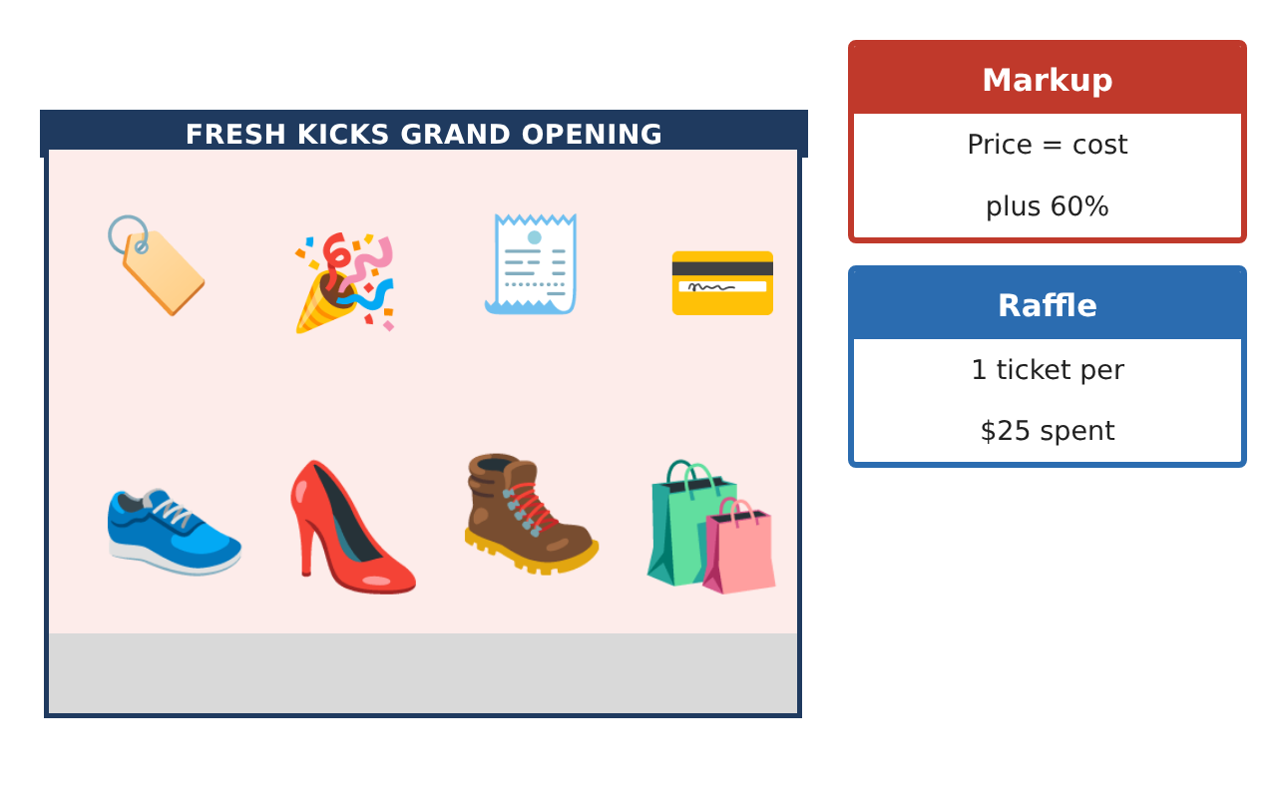
Learning Goals
- I can use unit rates and proportions to make purchasing decisions.
- I can use scale factors for length and area.
- I can analyze percent change, compound discounts, and probability.
Project Timeline
When | What you will do
Day 1 | Purchasing Strategy
Day 2 | Layout & Area
Day 3 | Pricing Analysis
Final | Store Manager Report + reflection
Part 1: Purchasing Strategy
Day 1 · Use the Supplier Cards. Budget $7,000 for exactly 200 pairs.
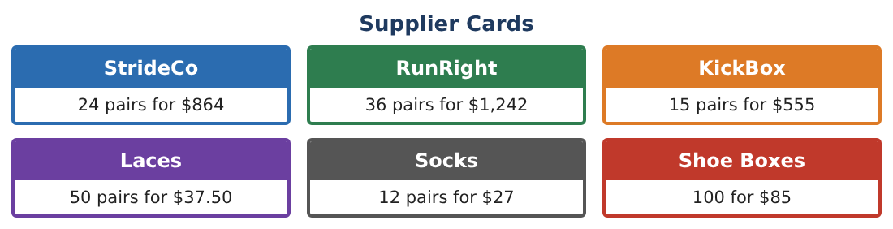
1. Find the cheapest way to buy at least 200 pairs if each supplier only sells full packs. Show the cost.

2. Using a 4% bulk discount on orders over $7,000, does the cheapest option fit the budget?

3. Find the cost per pair for that order after the discount.

4. Shoe boxes come in packs of 100 for $85. How many packs are needed for 204 pairs, and what do they cost? What would 204 boxes cost at the same unit rate?

Part 2: Layout & Area
Day 2 · Plan scale 1 in = 4 ft. Store plan is 12 in by 7$\frac{1}{2}$ in.
5. Find the real area and the area on the plan. What is the ratio of real area to plan area (in sq ft per sq in)?

6. The owner wants a second store with every length 1.25 times as long. Find its area and the percent increase in area.

7. A circular display has a 3 ft radius in store 1. In the larger store it is scaled by 1.25. What is the percent increase in its area?

8. Explain why area increases by more than 25% when lengths increase by 25%.

Part 3: Pricing Analysis
Day 3 · Markup 60% over cost.
9. A $35 pair is marked up 60%, discounted 30%, then given an extra 10% off at checkout. Find the final price and the single equivalent discount from $56.

10. The raffle: 300 tickets, 5 prizes drawn without replacement. You hold 12 tickets. Find the probability that the first two drawings are both yours.

11. Recommend a grand-opening price for the $34.50 pair so that the store earns at least a 20% profit on cost after a 30% discount. Show your inequality.

Final Product: Store Manager Report
Your final product must include:
- Purchasing plan with packs, budget, and discount
- Layout with length and area scale factors
- Compound discount analysis
- Raffle probability without replacement
- Pricing recommendation with justification
Reflection
R1. Why are two successive discounts not the same as adding the percents?

R2. How does probability change when tickets are not replaced?

Scoring Rubric
Criteria | 4 – Exceeds | 3 – Meets | 2 – Approaching | 1 – Beginning
Mathematical Accuracy | All calculations and solutions are correct; answers include units and are checked. | Nearly all work is correct; minor errors do not change conclusions. | Several errors; some conclusions are affected. | Many errors or missing work.
Reasoning & Justification | Clear, complete explanations connect every answer to the situation; uses precise vocabulary. | Explanations are mostly clear and connected to the situation. | Explanations are brief or partly unclear. | Little or no explanation.
Application & Design | Unit rates, proportions, scale, percents, and probability are used correctly to make store decisions. Goes beyond the minimum with a creative, realistic choice. | Unit rates, proportions, scale, percents, and probability are used correctly to make store decisions. | Design is incomplete or only partly uses the math from the unit. | Design is missing or unrelated to the unit math.
Communication & Presentation | Manager report includes the supplier choice, layout, pricing table, raffle analysis, and recommendations. Polished, organized, and visually engaging. | Manager report includes the supplier choice, layout, pricing table, raffle analysis, and recommendations. Organized and easy to follow. | Product is missing required parts or is hard to follow. | Product is mostly missing.

