STATISTICS · UNIT 4: STATISTICAL INFERENCE  The Later Start Investigation  Use confidence intervals and significance tests to advise the school board on a later start time. | CP1  2–3 class periods

Name: ________________________________ Date: ______________ Period: ______
The Scenario
The school board is considering starting school 45 minutes later. Board members want to know whether most students support it and whether students are really short on sleep.
Your team will collect evidence with confidence intervals and significance tests and present a recommendation with the right amount of certainty.
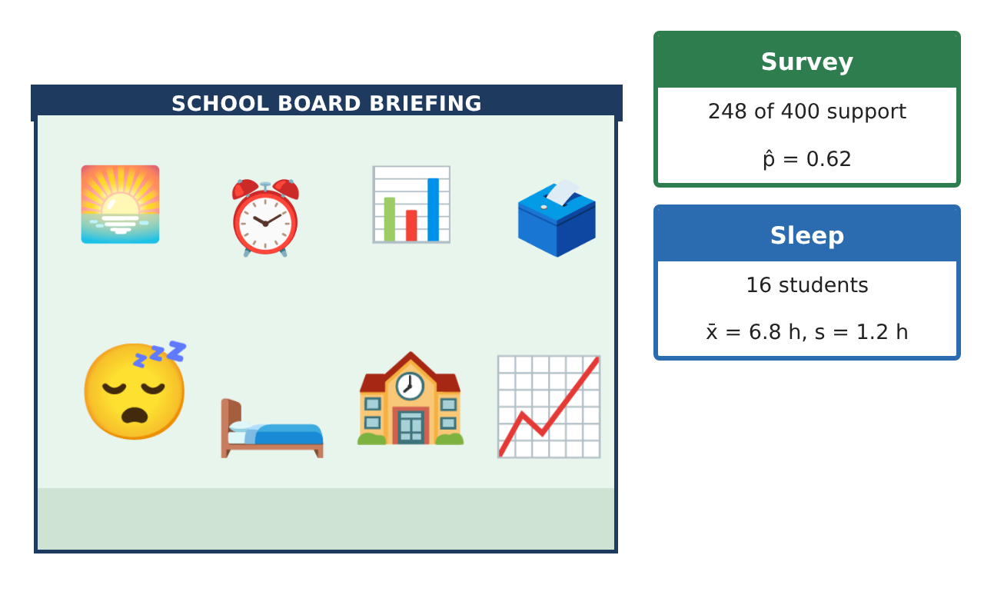
Learning Goals
- I can construct and interpret z-intervals for a proportion and t-intervals for a mean.
- I can carry out one-sample z- and t-tests with conditions.
- I can explain Type I and Type II errors and choose a sample size.
Project Timeline
When | What you will do
Day 1 | Estimate Support
Day 2 | Are Students Short on Sleep?
Day 3 | Errors and Grades
Final | Report to the School Board + reflection
Part 1: Estimate Support
Day 1 · Use the Support survey card (SRS of 400, 248 support).
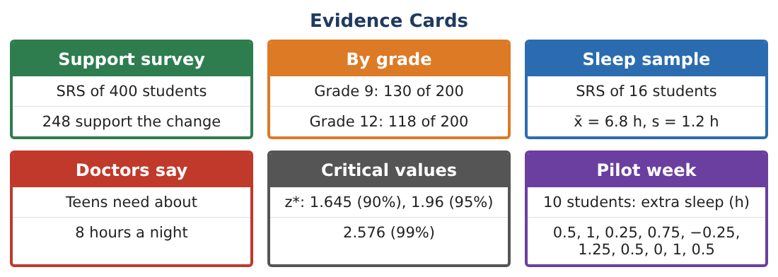
1. Check the conditions (Random, 10%, Large Counts) for a one-proportion z-interval.

2. Construct and interpret a 95% confidence interval.

3. How large a sample is needed for a margin of error of at most 3% at 95% confidence (use p̂ = 0.5)?

4. Test H₀: p = 0.5 vs Hₐ: p > 0.5 at α = 0.05. Give z, the p-value, and a conclusion.

Part 2: Are Students Short on Sleep?
Day 2 · Use the Sleep sample card (n = 16, x̄ = 6.8 h, s = 1.2 h).
5. Construct a 95% t-interval for the mean sleep of all students (df = 15, t* ≈ 2.131).

6. Test H₀: μ = 8 vs Hₐ: μ < 8. Find t and the p-value.

7. Write a conclusion in context. What condition about the data must you check?

Part 3: Errors and Grades
Day 3 · Use the By grade card.
8. Describe a Type I and a Type II error for the sleep test.

9. Find p̂ for each grade and the difference p̂₉ − p̂₁₂.

10. Construct a 95% confidence interval for p₉ − p₁₂ and interpret it.

11. How would increasing α from 0.05 to 0.10 affect the chances of each error?

Final Product: Report to the School Board
Your final product must include:
- One-proportion interval, sample size, and test
- Mean sleep interval and t-test
- Errors in context
- Comparison of grades
- Report to the school board
Reflection
R1. Why do we use t instead of z for the sleep data?

R2. Why does the grade comparison not prove the grades feel the same?

Scoring Rubric
Criteria | 4 – Exceeds | 3 – Meets | 2 – Approaching | 1 – Beginning
Mathematical Accuracy | All calculations and solutions are correct; answers include units and are checked. | Nearly all work is correct; minor errors do not change conclusions. | Several errors; some conclusions are affected. | Many errors or missing work.
Reasoning & Justification | Clear, complete explanations connect every answer to the situation; uses precise vocabulary. | Explanations are mostly clear and connected to the situation. | Explanations are brief or partly unclear. | Little or no explanation.
Application & Design | Intervals and tests are chosen, carried out, and interpreted correctly and support the recommendation. Goes beyond the minimum with a creative, realistic choice. | Intervals and tests are chosen, carried out, and interpreted correctly and support the recommendation. | Design is incomplete or only partly uses the math from the unit. | Design is missing or unrelated to the unit math.
Communication & Presentation | Report states the evidence, uncertainty, and limits of the study clearly for a non-statistician. Polished, organized, and visually engaging. | Report states the evidence, uncertainty, and limits of the study clearly for a non-statistician. Organized and easy to follow. | Product is missing required parts or is hard to follow. | Product is mostly missing.

