STATISTICS · UNIT 4: STATISTICAL INFERENCE  The Later Start Investigation  Use confidence intervals and significance tests to advise the school board on a later start time. | CP2  2–3 class periods

Name: ________________________________ Date: ______________ Period: ______
The Scenario
The school board is considering starting school 45 minutes later. Board members want to know whether most students support it and whether students are really short on sleep.
Your team will collect evidence with confidence intervals and significance tests and present a recommendation with the right amount of certainty.
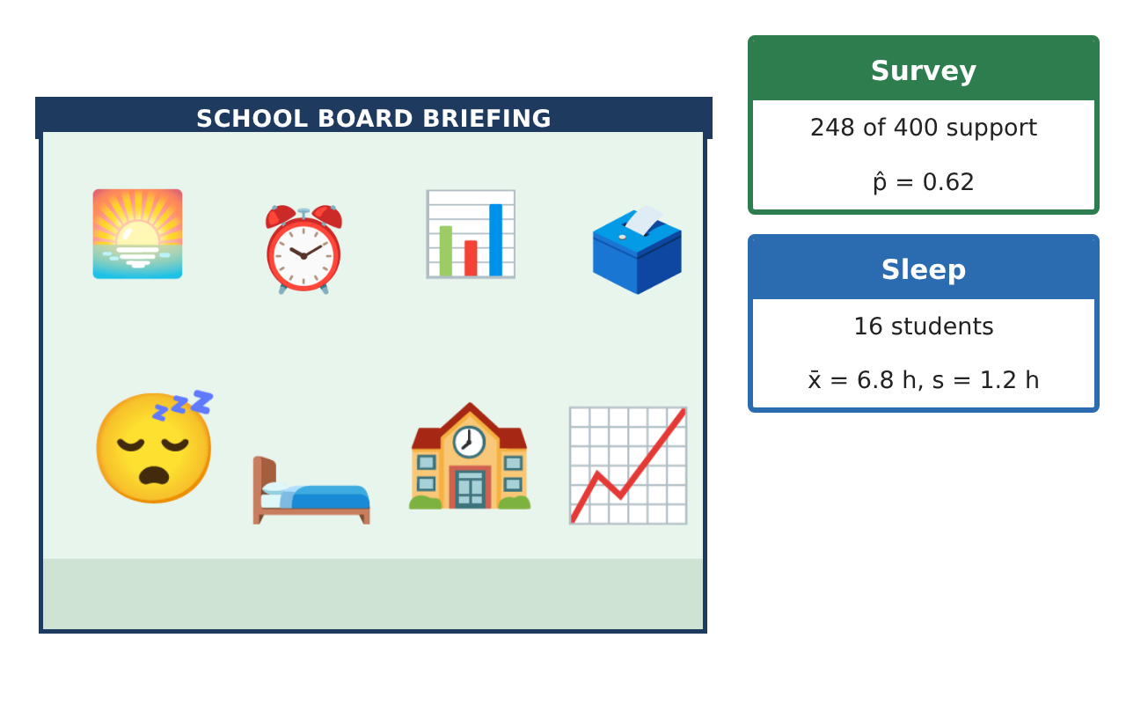
Learning Goals
- I can find and interpret a confidence interval for a proportion.
- I can state hypotheses and interpret a p-value.
- I can describe Type I and Type II errors in context.
Project Timeline
When | What you will do
Day 1 | How Many Support It?
Day 2 | Is It a Majority?
Day 3 | Could We Be Wrong?
Final | Report to the School Board + reflection
Part 1: How Many Support It?
Day 1 · A pilot survey: an SRS of 100 students found 62 support the later start.
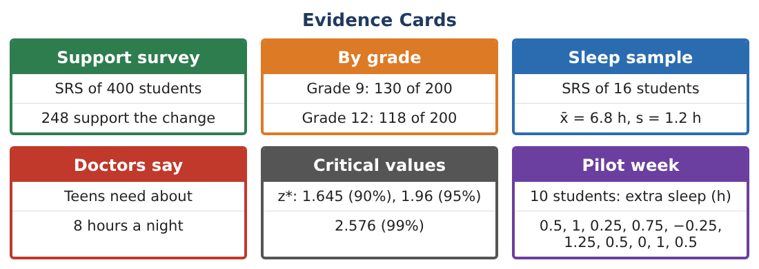
1. Find the sample proportion p̂.

2. Find the standard error √(p̂(1 − p̂) ÷ n).
Starter: SE = √(0.62 × 0.38 ÷ 100)

3. Find the 95% confidence interval p̂ ± 1.96 · SE.

4. Interpret the interval in context.

Part 2: Is It a Majority?
Day 2 · The board asks: is there convincing evidence that more than half of students support the change?
5. Write the null and alternative hypotheses.
Starter: H₀: p = ___ Hₐ: p ___ 0.5

6. The test statistic is z = 2.4 and the p-value is about 0.008. What does the p-value mean?

7. Use α = 0.05 to write a conclusion.

8. Does the confidence interval agree with the test? Explain.

Part 3: Could We Be Wrong?
Day 3 · Any decision based on a sample can be wrong.
9. Describe a Type I error in this context.

10. Describe a Type II error in this context.

11. Which error would be worse for the school board? Explain.

Final Product: Report to the School Board
Your final product must include:
- Confidence interval with interpretation
- Hypotheses, p-value meaning, and conclusion
- Type I and Type II errors in context
- Recommendation
- Report to the school board
Reflection
R1. What does “95% confident” mean?

R2. How would a bigger sample change the interval?

Scoring Rubric
Criteria | 4 – Exceeds | 3 – Meets | 2 – Approaching | 1 – Beginning
Mathematical Accuracy | All calculations and solutions are correct; answers include units and are checked. | Nearly all work is correct; minor errors do not change conclusions. | Several errors; some conclusions are affected. | Many errors or missing work.
Reasoning & Justification | Clear, complete explanations connect every answer to the situation; uses precise vocabulary. | Explanations are mostly clear and connected to the situation. | Explanations are brief or partly unclear. | Little or no explanation.
Application & Design | Intervals and tests are chosen, carried out, and interpreted correctly and support the recommendation. Goes beyond the minimum with a creative, realistic choice. | Intervals and tests are chosen, carried out, and interpreted correctly and support the recommendation. | Design is incomplete or only partly uses the math from the unit. | Design is missing or unrelated to the unit math.
Communication & Presentation | Report states the evidence, uncertainty, and limits of the study clearly for a non-statistician. Polished, organized, and visually engaging. | Report states the evidence, uncertainty, and limits of the study clearly for a non-statistician. Organized and easy to follow. | Product is missing required parts or is hard to follow. | Product is mostly missing.

