STATISTICS · UNIT 4: STATISTICAL INFERENCE  The Later Start Investigation  Use confidence intervals and significance tests to advise the school board on a later start time. | Honors  2–3 class periods

Name: ________________________________ Date: ______________ Period: ______
The Scenario
The school board is considering starting school 45 minutes later. Board members want to know whether most students support it and whether students are really short on sleep.
Your team will collect evidence with confidence intervals and significance tests and present a recommendation with the right amount of certainty.
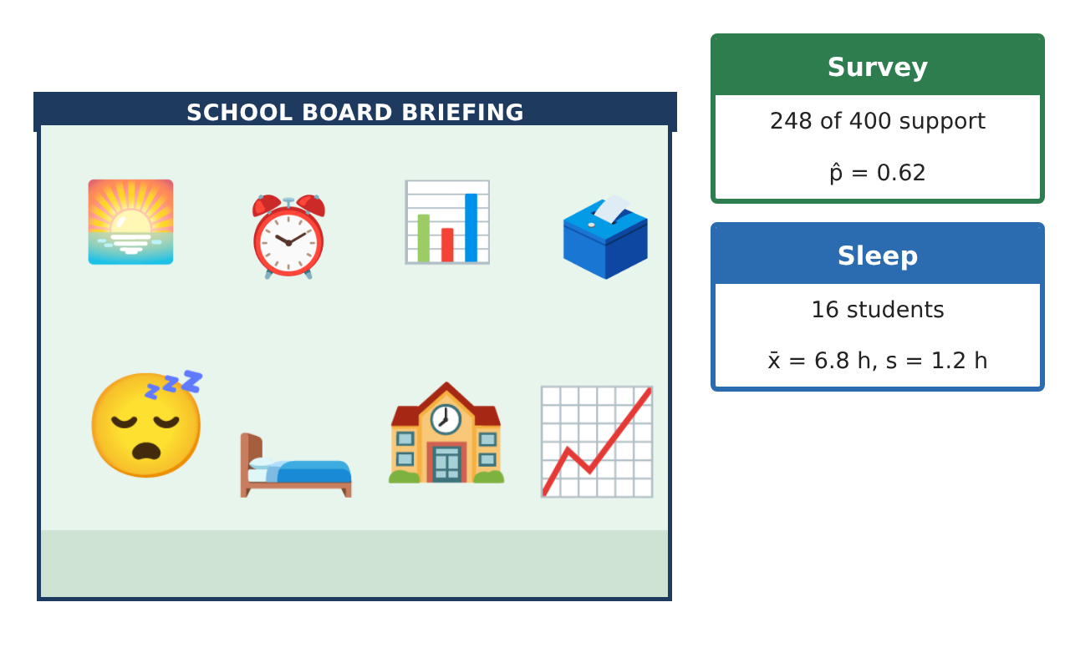
Learning Goals
- I can choose, carry out, and interpret one- and two-sample inference procedures.
- I can analyze matched pairs data and explain the role of conditions.
- I can reason about errors, power, and the strength of a recommendation.
Project Timeline
When | What you will do
Day 1 | Support for the Change
Day 2 | Sleep and the Pilot Week
Day 3 | Errors, Power, and Advice
Final | Report to the School Board + reflection
Part 1: Support for the Change
Day 1 · Use the Support survey and By grade cards.
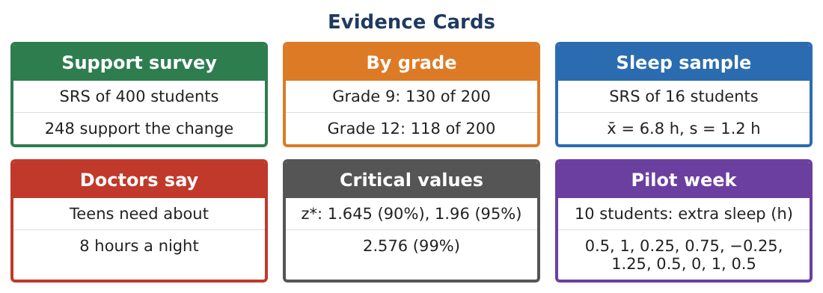
1. Construct and interpret a 99% confidence interval for the proportion who support the later start.

2. Compare the 95% and 99% intervals. Why is one wider?

3. Carry out a two-proportion z-test of H₀: p₉ = p₁₂ vs Hₐ: p₉ ≠ p₁₂ (pooled p̂ = 0.62).

4. Find the sample size per grade needed to estimate p₉ − p₁₂ within ±0.05 at 95% (use 0.5 for each p).

Part 2: Sleep and the Pilot Week
Day 2 · Use the Sleep sample and Pilot week cards.
5. Test H₀: μ = 8 vs Hₐ: μ < 8 for the sleep sample and state the conclusion.

6. Pilot week: find the mean and SD of the 10 differences (later start − normal).

7. Carry out a paired t-test of H₀: μ_d = 0 vs Hₐ: μ_d > 0.

8. Construct a 95% interval for μ_d (t* ≈ 2.262) and interpret it in minutes.

Part 3: Errors, Power, and Advice
Day 3 · Write as a statistician advising the board.
9. For the paired test, describe a Type II error and one consequence.

10. Give two ways to increase the power of the pilot study.

11. Explain why the pilot volunteers limit the conclusion and why the paired design was a good choice.

12. Write a three-sentence recommendation to the board that states your evidence and its uncertainty.

Final Product: Report to the School Board
Your final product must include:
- 99% interval and two-proportion test
- Sample-size plan
- One-sample and paired t procedures with conditions
- Error and power analysis
- Report to the school board with a justified recommendation
Reflection
R1. Why is a paired t-test, not a two-sample t-test, correct for the pilot week?

R2. How do a confidence interval and a significance test give different kinds of information to the board?

Scoring Rubric
Criteria | 4 – Exceeds | 3 – Meets | 2 – Approaching | 1 – Beginning
Mathematical Accuracy | All calculations and solutions are correct; answers include units and are checked. | Nearly all work is correct; minor errors do not change conclusions. | Several errors; some conclusions are affected. | Many errors or missing work.
Reasoning & Justification | Clear, complete explanations connect every answer to the situation; uses precise vocabulary. | Explanations are mostly clear and connected to the situation. | Explanations are brief or partly unclear. | Little or no explanation.
Application & Design | Intervals and tests are chosen, carried out, and interpreted correctly and support the recommendation. Goes beyond the minimum with a creative, realistic choice. | Intervals and tests are chosen, carried out, and interpreted correctly and support the recommendation. | Design is incomplete or only partly uses the math from the unit. | Design is missing or unrelated to the unit math.
Communication & Presentation | Report states the evidence, uncertainty, and limits of the study clearly for a non-statistician. Polished, organized, and visually engaging. | Report states the evidence, uncertainty, and limits of the study clearly for a non-statistician. Organized and easy to follow. | Product is missing required parts or is hard to follow. | Product is mostly missing.

