STATISTICS · UNIT 1: EXPLORING DATA  Lunch Line Data Detectives  Use displays, summary statistics, normal models, and regression to fix the school lunch line. | CP1  2–3 class periods

Name: ________________________________ Date: ______________ Period: ______
The Scenario
Students say the lunch line is too slow, and the principal wants evidence before changing anything. Your team has been given data from the cafeteria: wait times at the Grill line and the Salad Bar, lunch choices by grade, and how wait time depends on the number of people in line.
You will describe, compare, and model the data, then recommend one change backed by statistics.
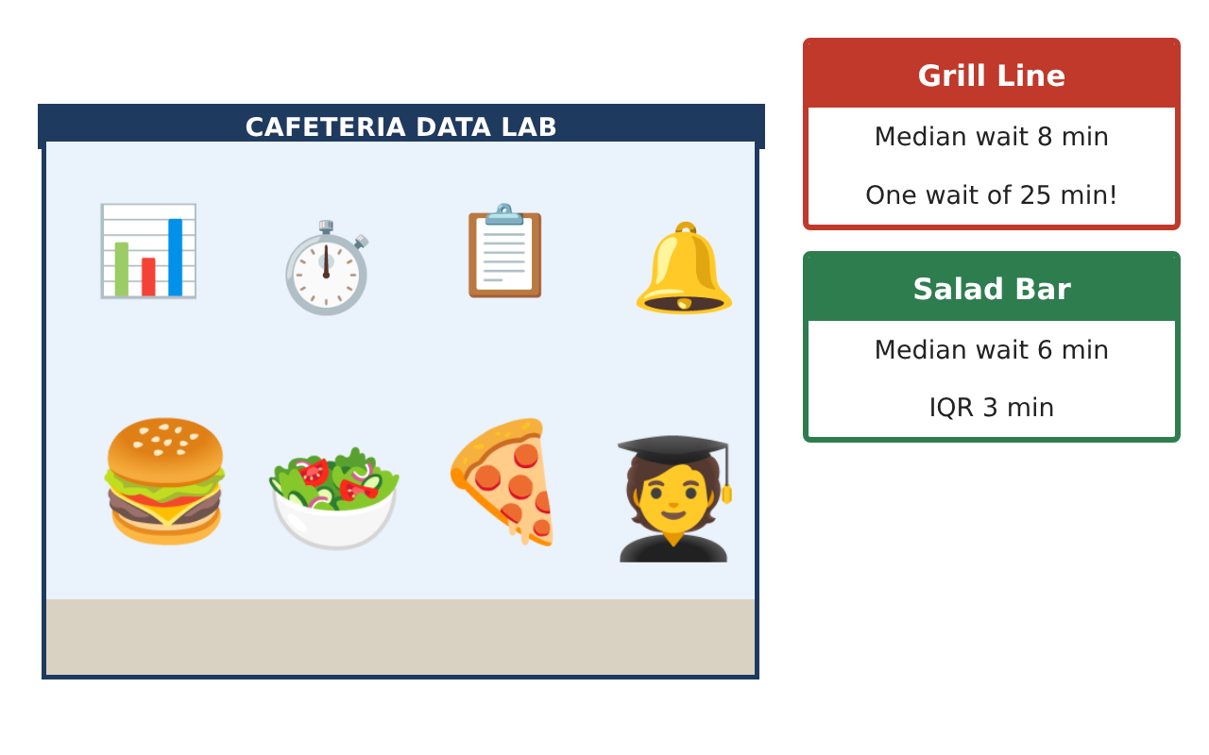
Learning Goals
- I can describe and compare distributions using shape, center, spread, and outliers.
- I can use a normal model and z-scores.
- I can analyze two-way tables and fit a least-squares regression line.
Project Timeline
When | What you will do
Day 1 | Compare the Lines
Day 2 | Normal Model and Choices
Day 3 | Model the Wait
Final | Data Report to the Principal + reflection
Part 1: Compare the Lines
Day 1 · Use the Grill and Salad wait times on the Data Cards.
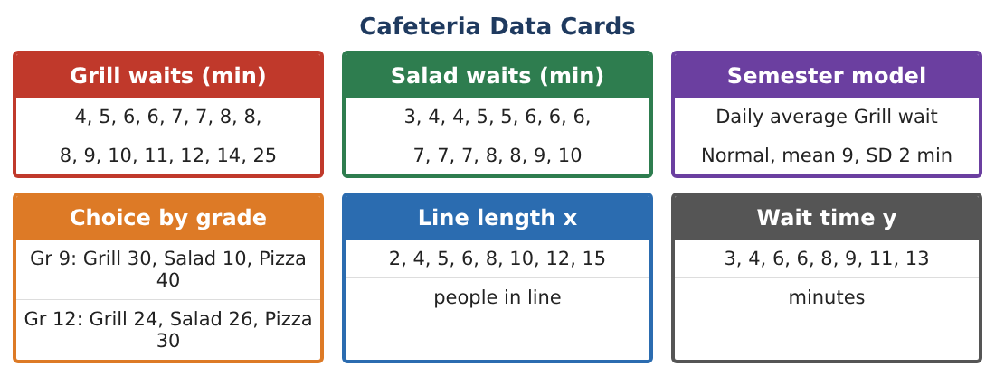
1. Make parallel box plots and give the five-number summary of each line.

2. Compute the mean and standard deviation of each line (use technology).

3. Identify any outliers with the 1.5 × IQR rule, then find the Grill’s mean and SD without it.

4. Write a comparison of the two distributions that addresses shape, center, spread, and outliers in context.

Part 2: Normal Model and Choices
Day 2 · Daily average Grill wait over the semester is approximately Normal with mean 9 min and SD 2 min.
5. Find the z-score of a day with an average wait of 12 minutes and interpret it.

6. About what percent of days have an average wait over 12 minutes?

7. Find the percent of seniors who choose salad and the percent of salad buyers who are seniors.

8. Use conditional relative frequencies to decide whether lunch choice and grade are associated.

Part 3: Model the Wait
Day 3 · Use the line-length (x) and wait-time (y) data.
9. Make a scatterplot and describe the direction, form, and strength.

10. Find the least-squares regression line and the correlation r.

11. Find the residual for the student who waited 9 minutes with 10 people in line. Interpret it.

12. Interpret r² and explain why predicting the wait for 40 people would be risky.

Final Product: Data Report to the Principal
Your final product must include:
- Parallel box plots and a written comparison
- Normal-model calculations
- Two-way table with conditional percents
- Scatterplot, regression line, residual, and r²
- Data report with a recommendation
Reflection
R1. Why does removing the outlier change the standard deviation so much more than the median?

R2. Does the strong correlation prove that more people cause longer waits? Explain.

Scoring Rubric
Criteria | 4 – Exceeds | 3 – Meets | 2 – Approaching | 1 – Beginning
Mathematical Accuracy | All calculations and solutions are correct; answers include units and are checked. | Nearly all work is correct; minor errors do not change conclusions. | Several errors; some conclusions are affected. | Many errors or missing work.
Reasoning & Justification | Clear, complete explanations connect every answer to the situation; uses precise vocabulary. | Explanations are mostly clear and connected to the situation. | Explanations are brief or partly unclear. | Little or no explanation.
Application & Design | Displays, summaries, and models describe the lunch data correctly and support the recommendation. Goes beyond the minimum with a creative, realistic choice. | Displays, summaries, and models describe the lunch data correctly and support the recommendation. | Design is incomplete or only partly uses the math from the unit. | Design is missing or unrelated to the unit math.
Communication & Presentation | Report includes displays, statistics in context, and one clear recommendation for the principal. Polished, organized, and visually engaging. | Report includes displays, statistics in context, and one clear recommendation for the principal. Organized and easy to follow. | Product is missing required parts or is hard to follow. | Product is mostly missing.

