STATISTICS · UNIT 1: EXPLORING DATA  Lunch Line Data Detectives  Use displays, summary statistics, normal models, and regression to fix the school lunch line. | CP2  2–3 class periods

Name: ________________________________ Date: ______________ Period: ______
The Scenario
Students say the lunch line is too slow, and the principal wants evidence before changing anything. Your team has been given data from the cafeteria: wait times at the Grill line and the Salad Bar, lunch choices by grade, and how wait time depends on the number of people in line.
You will describe, compare, and model the data, then recommend one change backed by statistics.
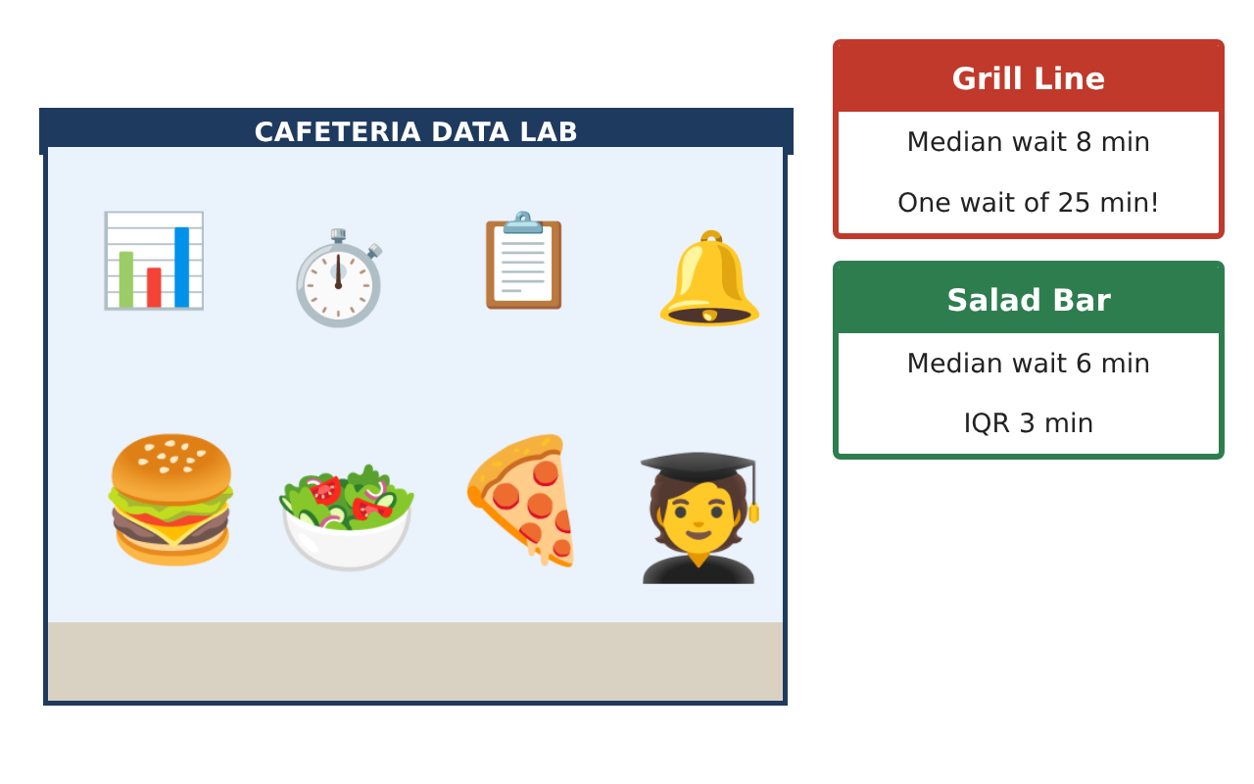
Learning Goals
- I can make and read dot plots and box plots.
- I can find the mean, median, quartiles, and IQR and spot outliers.
- I can use a two-way table and a regression line to answer questions.
Project Timeline
When | What you will do
Day 1 | Two Lines, Two Plots
Day 2 | Box Plots and Outliers
Day 3 | Choices and Predictions
Final | Data Report to the Principal + reflection
Part 1: Two Lines, Two Plots
Day 1 · Use the Grill and Salad wait times (15 students each) on the Data Cards.
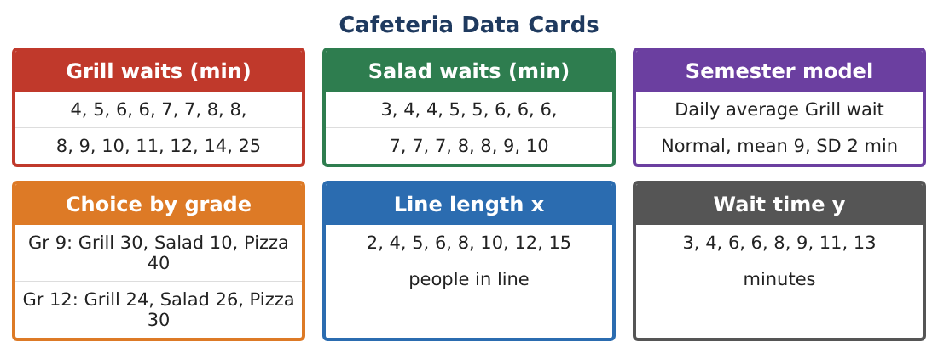
1. Make a dot plot of each line’s wait times on the same scale (0 to 26 minutes).
Starter: Draw a number line from 0 to 26, then one dot per student.

2. Find the median and the mean wait for each line.
Starter: Median = the 8th value in order; mean = sum ÷ 15.

3. Why is the Grill mean larger than its median?

4. Which line usually has the shorter wait? Use a number to support your answer.

Part 2: Box Plots and Outliers
Day 2 · A box plot uses the five-number summary: min, Q1, median, Q3, max.
5. Find the five-number summary for each line.
Starter: Q1 is the median of the 7 values below the median.

6. Find the IQR of each line.

7. Use the 1.5 × IQR rule to check the Grill data for outliers.

8. Draw both box plots on one scale and compare them in one sentence.

Part 3: Choices and Predictions
Day 3 · Use the Choice-by-grade card (80 ninth graders, 80 seniors) and the line-length data.
9. What percent of ninth graders choose salad? What percent of seniors?

10. Is lunch choice associated with grade? Explain.

11. A computer gives the line ŷ = 1.5 + 0.8x for wait time y and line length x. Predict the wait when 9 people are in line.

12. What does the slope 0.8 mean here?

Final Product: Data Report to the Principal
Your final product must include:
- Dot plots and box plots of both lines
- Summary statistics table (mean, median, IQR)
- Outlier check
- Two-way table percents
- Prediction from the regression line and a one-page recommendation
Reflection
R1. Should the principal use the mean or the median to describe the Grill wait? Why?

R2. What change would you recommend for the cafeteria, and which number best supports it?

Scoring Rubric
Criteria | 4 – Exceeds | 3 – Meets | 2 – Approaching | 1 – Beginning
Mathematical Accuracy | All calculations and solutions are correct; answers include units and are checked. | Nearly all work is correct; minor errors do not change conclusions. | Several errors; some conclusions are affected. | Many errors or missing work.
Reasoning & Justification | Clear, complete explanations connect every answer to the situation; uses precise vocabulary. | Explanations are mostly clear and connected to the situation. | Explanations are brief or partly unclear. | Little or no explanation.
Application & Design | Displays, summaries, and models describe the lunch data correctly and support the recommendation. Goes beyond the minimum with a creative, realistic choice. | Displays, summaries, and models describe the lunch data correctly and support the recommendation. | Design is incomplete or only partly uses the math from the unit. | Design is missing or unrelated to the unit math.
Communication & Presentation | Report includes displays, statistics in context, and one clear recommendation for the principal. Polished, organized, and visually engaging. | Report includes displays, statistics in context, and one clear recommendation for the principal. Organized and easy to follow. | Product is missing required parts or is hard to follow. | Product is mostly missing.

