STATISTICS · UNIT 1: EXPLORING DATA  Lunch Line Data Detectives  Use displays, summary statistics, normal models, and regression to fix the school lunch line. | Honors  2–3 class periods

Name: ________________________________ Date: ______________ Period: ______
The Scenario
Students say the lunch line is too slow, and the principal wants evidence before changing anything. Your team has been given data from the cafeteria: wait times at the Grill line and the Salad Bar, lunch choices by grade, and how wait time depends on the number of people in line.
You will describe, compare, and model the data, then recommend one change backed by statistics.
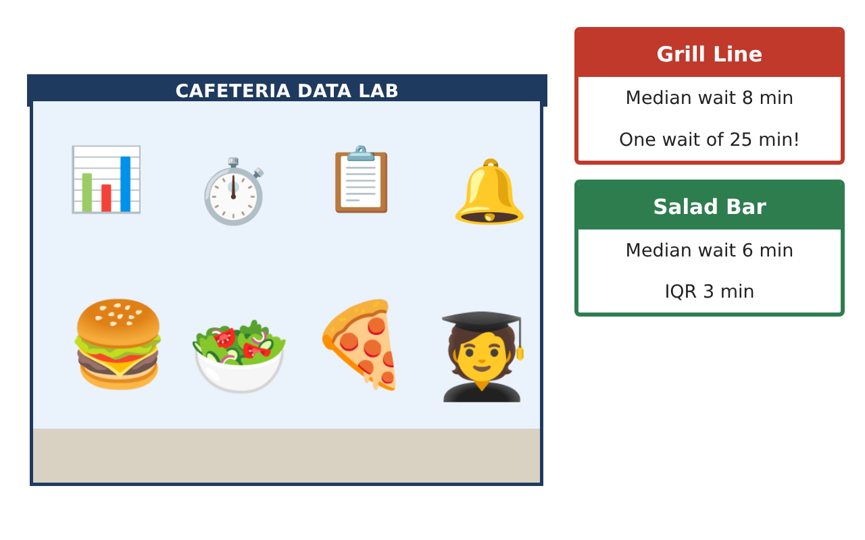
Learning Goals
- I can choose and justify summary statistics for skewed and symmetric data.
- I can use normal calculations, percentiles, and conditional distributions.
- I can build, assess, and critique a least-squares model using residuals and influence.
Project Timeline
When | What you will do
Day 1 | Distributions
Day 2 | Normal Model and Tables
Day 3 | Regression and Influence
Final | Data Report to the Principal + reflection
Part 1: Distributions
Day 1 · Use the Grill and Salad wait times on the Data Cards.
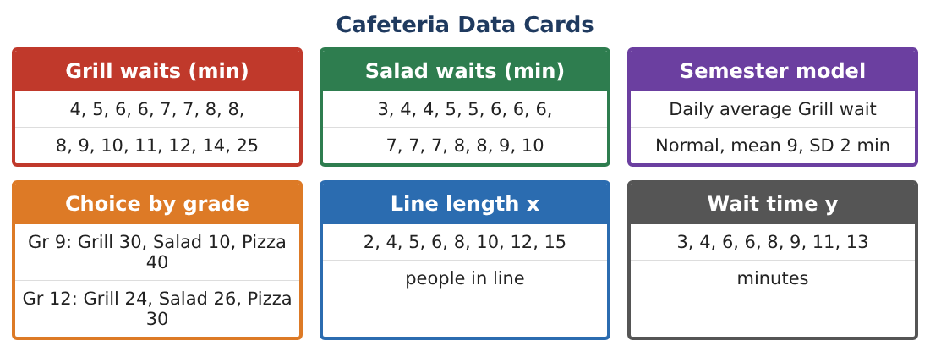
1. Give the five-number summaries, means, and SDs of both lines, and identify outliers.

2. The cafeteria adds 2 minutes to every Grill wait to account for paying. What happens to the median, IQR, mean, and SD?

3. The times are converted to seconds. Find the new median and SD of the Salad Bar.

4. Write a full comparison and argue which measure of center and spread the principal should use for each line.

Part 2: Normal Model and Tables
Day 2 · Daily average Grill wait is approximately N(9, 2) minutes.
5. Find the proportion of days with averages between 8 and 11 minutes.

6. The principal wants to flag the slowest 10% of days. Find the cutoff.

7. Make segmented bar graphs of lunch choice by grade and find P(senior | salad).

8. If grade and choice were not associated, how many seniors would be expected to choose salad? Compare with the data.

Part 3: Regression and Influence
Day 3 · Use the line-length (x) and wait-time (y) data.
9. Use x̄ = 7.75, ȳ = 7.5, sx ≈ 4.367, sy ≈ 3.423, and r ≈ 0.994 to find the LSRL by formula.

10. Interpret the slope, the y-intercept, r², and the residual at x = 10 (y = 9).

11. A new point (30 people, 8 min) is added. Is it an outlier, a high-leverage point, or influential? Predict how it changes the slope and r.

12. Describe what a residual plot would need to look like for the linear model to be appropriate.

Final Product: Data Report to the Principal
Your final product must include:
- Full distribution comparison with justified statistics
- Effects of shifting and rescaling
- Normal calculations and the slow-day cutoff
- Conditional distributions and expected counts
- Regression by formula with an influence analysis and a recommendation
Reflection
R1. Why does adding a constant change the center but not the spread?

R2. How could one unusual point mislead the principal about the line-length model?

Scoring Rubric
Criteria | 4 – Exceeds | 3 – Meets | 2 – Approaching | 1 – Beginning
Mathematical Accuracy | All calculations and solutions are correct; answers include units and are checked. | Nearly all work is correct; minor errors do not change conclusions. | Several errors; some conclusions are affected. | Many errors or missing work.
Reasoning & Justification | Clear, complete explanations connect every answer to the situation; uses precise vocabulary. | Explanations are mostly clear and connected to the situation. | Explanations are brief or partly unclear. | Little or no explanation.
Application & Design | Displays, summaries, and models describe the lunch data correctly and support the recommendation. Goes beyond the minimum with a creative, realistic choice. | Displays, summaries, and models describe the lunch data correctly and support the recommendation. | Design is incomplete or only partly uses the math from the unit. | Design is missing or unrelated to the unit math.
Communication & Presentation | Report includes displays, statistics in context, and one clear recommendation for the principal. Polished, organized, and visually engaging. | Report includes displays, statistics in context, and one clear recommendation for the principal. Organized and easy to follow. | Product is missing required parts or is hard to follow. | Product is mostly missing.

