STATISTICS · UNIT 3: ANTICIPATING PATTERNS  Mystery Box Pop-Up  Use probability, random variables, and sampling distributions to run a profitable mystery box shop. | CP1  2–3 class periods

Name: ________________________________ Date: ______________ Period: ______
The Scenario
The student council will sell $5 mystery boxes at the spring fair to raise money. Each box holds one prize, and the council decides how often each prize appears.
Your team must show that the boxes are fun for buyers but still make money, and predict what could happen on the day of the fair.

Learning Goals
- I can use the addition, multiplication, and conditional probability rules.
- I can find the mean and standard deviation of a random variable and transform it.
- I can use binomial and geometric models.
Project Timeline
When | What you will do
Day 1 | Probability Rules
Day 2 | Random Variables
Day 3 | Rare Prizes
Final | Business Pitch + reflection
Part 1: Probability Rules
Day 1 · Use the Prize Cards. Boxes are independent.
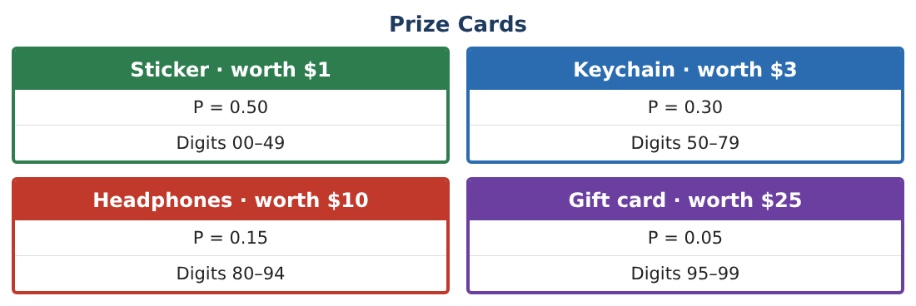
1. Find P(headphones or gift card) and P(at least one gift card in 2 boxes).

2. A buyer shakes the box and can tell the prize is worth more than $2. Find P(gift card | worth more than $2).

3. Are “worth more than $2” and “gift card” independent? Explain.

4. Describe how to use random digits to simulate how many boxes a buyer opens until getting headphones or a gift card.

Part 2: Random Variables
Day 2 · X = prize value for one box.
5. Find E(X) and SD(X).

6. Profit per box is Y = 5 − X. Find the mean and SD of Y.

7. The council raises the price to $6. Find the new mean and SD of profit.

8. Find the mean and SD of the total prize value T of two boxes.

Part 3: Rare Prizes
Day 3 · G = number of gift cards in 20 boxes.
9. Explain why G is binomial and find its mean.

10. Find P(G = 0) and P(G ≥ 1).

11. A buyer keeps buying until getting a gift card. Find the probability the first gift card is in box 3, and the expected number of boxes.

Final Product: Business Pitch
Your final product must include:
- Probability rules and a conditional probability
- Mean and SD of prize and profit
- Effect of a price change
- Binomial and geometric calculations
- Business pitch
Reflection
R1. Why does changing the price change the mean profit but not the SD?

R2. Why do the variances (not SDs) add when combining two independent boxes?

Scoring Rubric
Criteria | 4 – Exceeds | 3 – Meets | 2 – Approaching | 1 – Beginning
Mathematical Accuracy | All calculations and solutions are correct; answers include units and are checked. | Nearly all work is correct; minor errors do not change conclusions. | Several errors; some conclusions are affected. | Many errors or missing work.
Reasoning & Justification | Clear, complete explanations connect every answer to the situation; uses precise vocabulary. | Explanations are mostly clear and connected to the situation. | Explanations are brief or partly unclear. | Little or no explanation.
Application & Design | Probability models and calculations correctly predict prize costs and profit and support the pitch. Goes beyond the minimum with a creative, realistic choice. | Probability models and calculations correctly predict prize costs and profit and support the pitch. | Design is incomplete or only partly uses the math from the unit. | Design is missing or unrelated to the unit math.
Communication & Presentation | Pitch includes the model, expected profit, risk, and a clear recommendation. Polished, organized, and visually engaging. | Pitch includes the model, expected profit, risk, and a clear recommendation. Organized and easy to follow. | Product is missing required parts or is hard to follow. | Product is mostly missing.

