STATISTICS · UNIT 3: ANTICIPATING PATTERNS  Mystery Box Pop-Up  Use probability, random variables, and sampling distributions to run a profitable mystery box shop. | CP2  2–3 class periods

Name: ________________________________ Date: ______________ Period: ______
The Scenario
The student council will sell $5 mystery boxes at the spring fair to raise money. Each box holds one prize, and the council decides how often each prize appears.
Your team must show that the boxes are fun for buyers but still make money, and predict what could happen on the day of the fair.
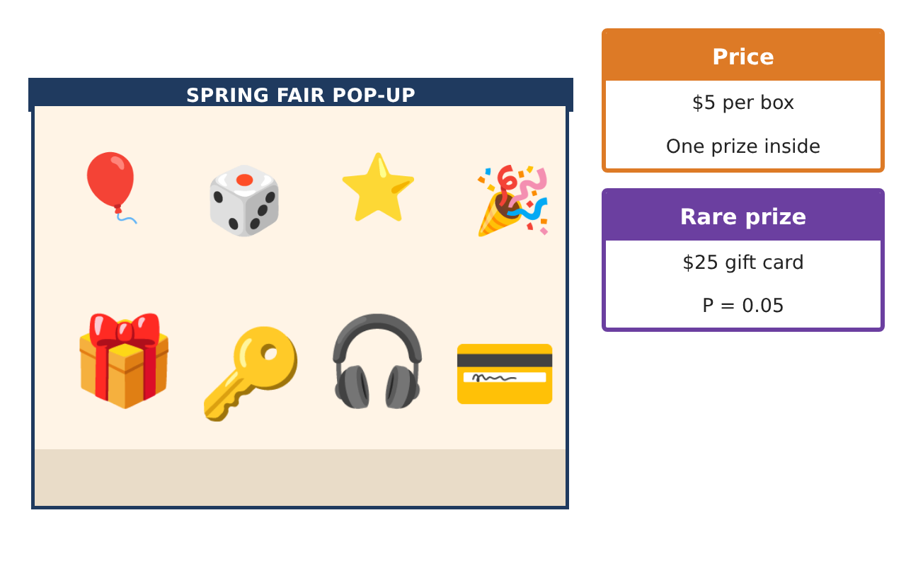
Learning Goals
- I can use a probability model and the addition rule.
- I can simulate a chance process with random digits.
- I can find and interpret an expected value.
Project Timeline
When | What you will do
Day 1 | The Prize Model
Day 2 | Simulate a Line of Buyers
Day 3 | Will We Make Money?
Final | Business Pitch + reflection
Part 1: The Prize Model
Day 1 · Use the Prize Cards. X = the value of the prize in one box.
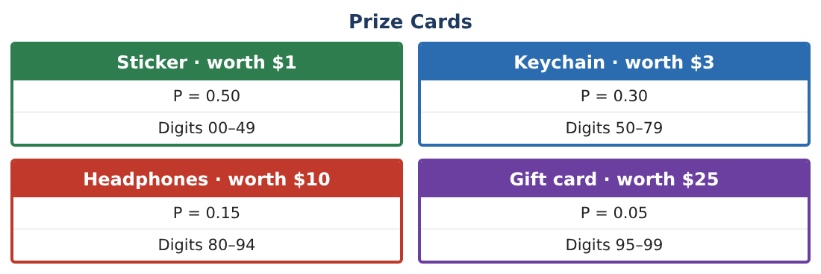
1. Show that the probabilities form a valid model.

2. Find P(headphones or gift card).

3. Find P(the prize is not a sticker).

4. Two boxes are bought. Find P(both are stickers).

Part 2: Simulate a Line of Buyers
Day 2 · Random digits in pairs: 19 22 39 50 34 05 75 62 87 13.
5. Use the digit ranges on the Prize Cards to find the prize for each of the 10 buyers.
Starter: 19 is in 00–49, so buyer 1 gets a …

6. Find the total and the average prize value in your simulation.

7. Did anyone win a gift card? Is that surprising for 10 buyers?

Part 3: Will We Make Money?
Day 3 · The expected value E(X) = Σ x · P(x).
8. Find E(X), the expected prize value per box.
Starter: Multiply each value by its probability and add.

9. What is the expected profit per $5 box?

10. How much profit should the council expect from 200 boxes?

11. Explain why the council could still lose money on a day it sells only a few boxes.

Final Product: Business Pitch
Your final product must include:
- Valid probability model
- Simulation of 10 buyers
- Expected value and expected profit
- Profit prediction for 200 boxes
- Business pitch poster
Reflection
R1. Why did your simulated average differ from $4.15?

R2. Would you change the prizes? How would it change the expected profit?

Scoring Rubric
Criteria | 4 – Exceeds | 3 – Meets | 2 – Approaching | 1 – Beginning
Mathematical Accuracy | All calculations and solutions are correct; answers include units and are checked. | Nearly all work is correct; minor errors do not change conclusions. | Several errors; some conclusions are affected. | Many errors or missing work.
Reasoning & Justification | Clear, complete explanations connect every answer to the situation; uses precise vocabulary. | Explanations are mostly clear and connected to the situation. | Explanations are brief or partly unclear. | Little or no explanation.
Application & Design | Probability models and calculations correctly predict prize costs and profit and support the pitch. Goes beyond the minimum with a creative, realistic choice. | Probability models and calculations correctly predict prize costs and profit and support the pitch. | Design is incomplete or only partly uses the math from the unit. | Design is missing or unrelated to the unit math.
Communication & Presentation | Pitch includes the model, expected profit, risk, and a clear recommendation. Polished, organized, and visually engaging. | Pitch includes the model, expected profit, risk, and a clear recommendation. Organized and easy to follow. | Product is missing required parts or is hard to follow. | Product is mostly missing.

