STATISTICS · UNIT 3: ANTICIPATING PATTERNS  Mystery Box Pop-Up  Use probability, random variables, and sampling distributions to run a profitable mystery box shop. | Honors  2–3 class periods

Name: ________________________________ Date: ______________ Period: ______
The Scenario
The student council will sell $5 mystery boxes at the spring fair to raise money. Each box holds one prize, and the council decides how often each prize appears.
Your team must show that the boxes are fun for buyers but still make money, and predict what could happen on the day of the fair.
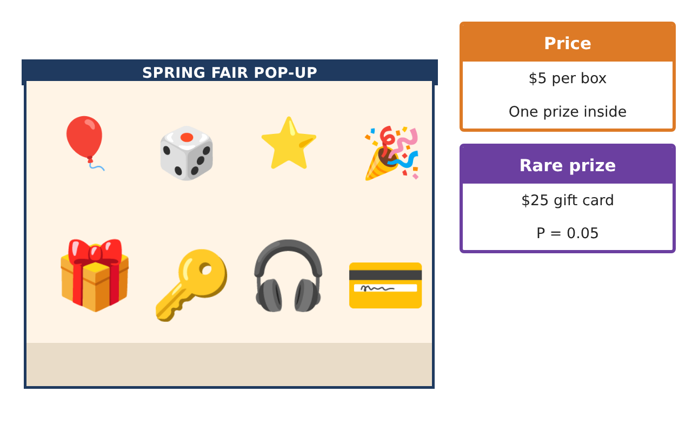
Learning Goals
- I can model a business with random variables and combine them.
- I can use binomial, geometric, and sampling distributions.
- I can use the Central Limit Theorem to predict a full day of sales.
Project Timeline
When | What you will do
Day 1 | Model the Box
Day 2 | Binomial and Geometric
Day 3 | A Day at the Fair
Final | Business Pitch + reflection
Part 1: Model the Box
Day 1 · X = prize value; Y = 5 − X is profit for one box.
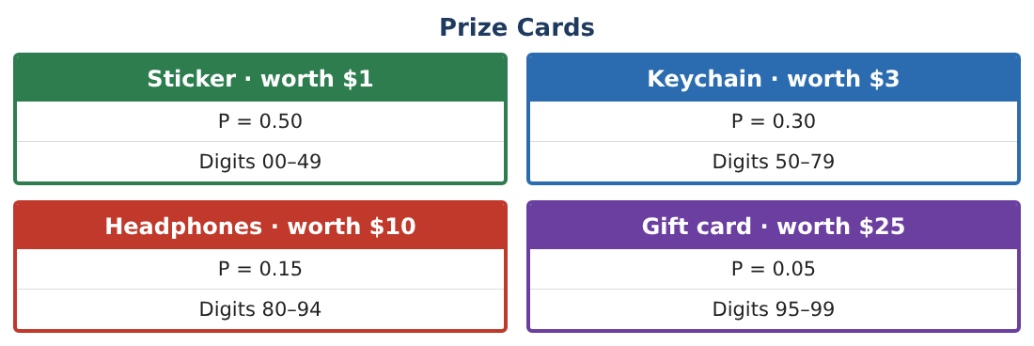
1. Find E(X), SD(X), and the mean and SD of Y.

2. Find P(gift card | worth more than $2) and explain whether the events are independent.

3. Two buyers each buy one box. Find the mean and SD of the difference of their prize values, X₁ − X₂.

4. Design a new prize table with E(X) = $4.00 that still has a $25 prize. Show it is valid.

Part 2: Binomial and Geometric
Day 2 · Use the original prize table.
5. In 10 boxes, let H = number of headphones-or-gift-card prizes. Find P(H = 2) and P(H ≥ 3).

6. Find the mean and SD of H.

7. Find the probability a buyer gets a gift card within the first 10 boxes.

Part 3: A Day at the Fair
Day 3 · The council expects to sell 100 boxes. Total profit is the sum of 100 independent profits Y.
8. Find the mean and SD of total profit for 100 boxes.

9. Use the CLT to find P(total profit < $0).

10. In 200 boxes, let p̂ be the proportion with gift cards. Find its mean and SD and check the Large Counts condition.

11. Find P(p̂ ≥ 0.08). Would 16 gift cards in 200 boxes make you suspect the box packer?

Final Product: Business Pitch
Your final product must include:
- Prize and profit random variables
- Combined and redesigned distributions
- Binomial and geometric probabilities
- CLT prediction of a day’s profit and risk of loss
- Business pitch with a recommended prize table
Reflection
R1. Why can we use a Normal model for total profit even though one box’s profit is very skewed?

R2. What is the trade-off between a bigger top prize and the risk of a losing day?

Scoring Rubric
Criteria | 4 – Exceeds | 3 – Meets | 2 – Approaching | 1 – Beginning
Mathematical Accuracy | All calculations and solutions are correct; answers include units and are checked. | Nearly all work is correct; minor errors do not change conclusions. | Several errors; some conclusions are affected. | Many errors or missing work.
Reasoning & Justification | Clear, complete explanations connect every answer to the situation; uses precise vocabulary. | Explanations are mostly clear and connected to the situation. | Explanations are brief or partly unclear. | Little or no explanation.
Application & Design | Probability models and calculations correctly predict prize costs and profit and support the pitch. Goes beyond the minimum with a creative, realistic choice. | Probability models and calculations correctly predict prize costs and profit and support the pitch. | Design is incomplete or only partly uses the math from the unit. | Design is missing or unrelated to the unit math.
Communication & Presentation | Pitch includes the model, expected profit, risk, and a clear recommendation. Polished, organized, and visually engaging. | Pitch includes the model, expected profit, risk, and a clear recommendation. Organized and easy to follow. | Product is missing required parts or is hard to follow. | Product is mostly missing.

