STATISTICS · UNIT 2: SAMPLING AND EXPERIMENTATION  The Study Music Experiment  Design a survey and a randomized experiment to find out whether music helps students study. | CP1  2–3 class periods

Name: ________________________________ Date: ______________ Period: ______
The Scenario
Many students study with music on. Some teachers think it hurts focus; students say it helps. The school’s research club wants a real answer, not opinions.
Your team will first survey the school about study habits, then design an experiment that tests whether music actually changes how many vocabulary words students remember.
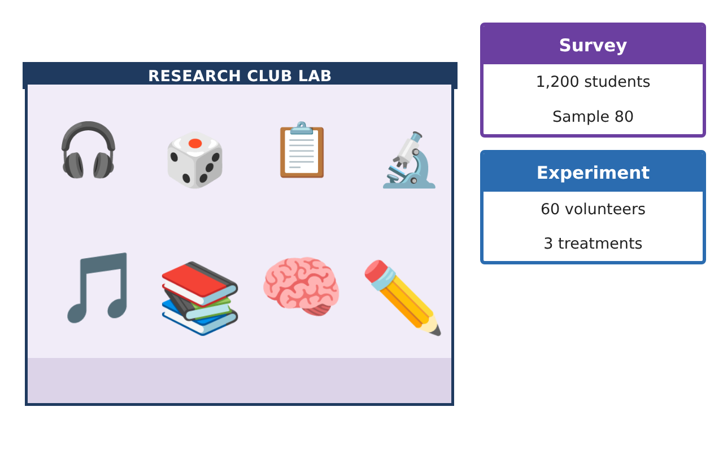
Learning Goals
- I can choose and compare SRS, stratified, and cluster samples and identify bias.
- I can design a completely randomized experiment with a control and blinding.
- I can explain confounding and decide when a cause-and-effect conclusion is justified.
Project Timeline
When | What you will do
Day 1 | Sampling Plans
Day 2 | Design the Experiment
Day 3 | Results and Conclusions
Final | Study Design Proposal + reflection
Part 1: Sampling Plans
Day 1 · Use the Enrollment, Homerooms, and Random digits cards.
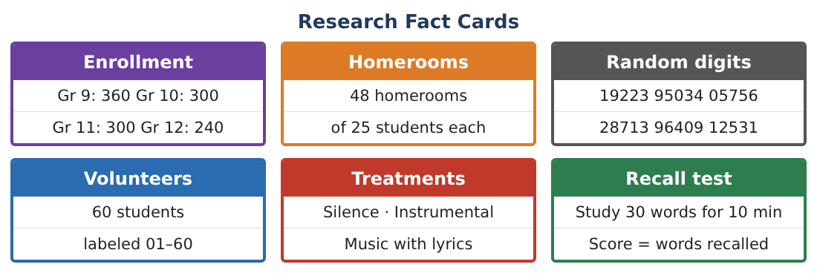
1. Use the digits 19223 95034 05756 28713 to choose 6 volunteers labeled 01–60.

2. Describe a proportional stratified random sample of 80 students by grade. Why might grade be a good stratum?

3. Describe a cluster sample using homerooms. How many homerooms give about 100 students? What is one advantage and one risk?

4. Name the bias in each: (a) leading question “Don’t you agree music helps?”; (b) 30 of 80 reply; (c) only students with school email are reached.

Part 2: Design the Experiment
Day 2 · Treatments: silence, instrumental music, music with lyrics. 60 volunteers.
5. Outline a completely randomized design (a diagram is fine).

6. Explain how the experiment uses the four principles: comparison, random assignment, control, replication.

7. Can the experiment be double-blind? Who could be blinded and how?

8. A student says, “Just let students choose music or silence.” Explain how this creates confounding.

Part 3: Results and Conclusions
Day 3 · Mean words recalled: silence 18.2, instrumental 19.0, lyrics 15.6.
9. Find the difference in means between silence and lyrics.

10. The club reshuffled the 40 scores into two random groups 200 times. Only 3 reshuffles gave a difference of 2.6 or more. What does this suggest?

11. Can the club conclude that lyrics cause lower recall? To whom can they generalize?

Final Product: Study Design Proposal
Your final product must include:
- SRS, stratified, and cluster plans
- Bias analysis
- Experiment diagram with the four principles
- Simulation-based conclusion
- Study design proposal with limits of the conclusion
Reflection
R1. What is the difference between random sampling and random assignment?

R2. Why is the silence group important even if we mainly care about lyrics?

Scoring Rubric
Criteria | 4 – Exceeds | 3 – Meets | 2 – Approaching | 1 – Beginning
Mathematical Accuracy | All calculations and solutions are correct; answers include units and are checked. | Nearly all work is correct; minor errors do not change conclusions. | Several errors; some conclusions are affected. | Many errors or missing work.
Reasoning & Justification | Clear, complete explanations connect every answer to the situation; uses precise vocabulary. | Explanations are mostly clear and connected to the situation. | Explanations are brief or partly unclear. | Little or no explanation.
Application & Design | Sampling and experiment designs use randomization correctly and address bias and confounding. Goes beyond the minimum with a creative, realistic choice. | Sampling and experiment designs use randomization correctly and address bias and confounding. | Design is incomplete or only partly uses the math from the unit. | Design is missing or unrelated to the unit math.
Communication & Presentation | Proposal includes a clear diagram, a bias plan, and a correct scope of inference. Polished, organized, and visually engaging. | Proposal includes a clear diagram, a bias plan, and a correct scope of inference. Organized and easy to follow. | Product is missing required parts or is hard to follow. | Product is mostly missing.

