STATISTICS · UNIT 2: SAMPLING AND EXPERIMENTATION  The Study Music Experiment  Design a survey and a randomized experiment to find out whether music helps students study. | CP2  2–3 class periods

Name: ________________________________ Date: ______________ Period: ______
The Scenario
Many students study with music on. Some teachers think it hurts focus; students say it helps. The school’s research club wants a real answer, not opinions.
Your team will first survey the school about study habits, then design an experiment that tests whether music actually changes how many vocabulary words students remember.
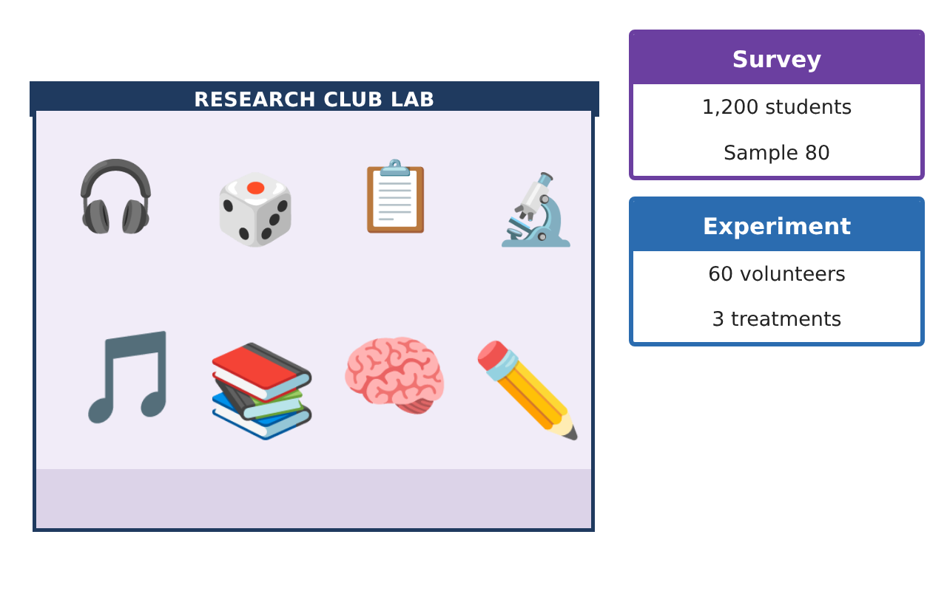
Learning Goals
- I can tell a population from a sample and choose a random sample.
- I can spot bias in how data are collected.
- I can tell an experiment from an observational study and name its parts.
Project Timeline
When | What you will do
Day 1 | Who Do We Ask?
Day 2 | Watch for Bias
Day 3 | Plan the Experiment
Final | Study Design Proposal + reflection
Part 1: Who Do We Ask?
Day 1 · The research club wants to know what percent of the school’s 1,200 students study with music.
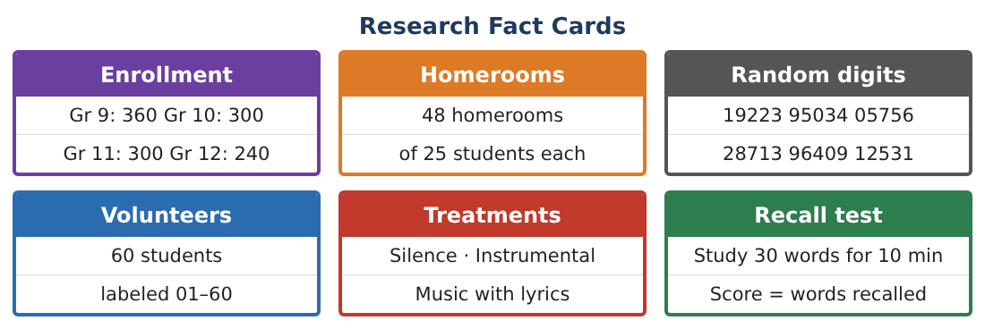
1. What is the population? Why not just take a census?
Starter: The population is …

2. Ana suggests asking her 25 friends in the band. Why is this a bad sample?

3. Label the volunteers 01–60. Use the random digits 19223 95034 05756 to choose 5 students. Skip numbers over 60 and repeats.
Starter: Read the digits in pairs: 19, 22, …

4. Explain how to take a stratified sample of 80 students by grade with the same fraction from each grade.

Part 2: Watch for Bias
Day 2 · A survey question and its results can be misleading.
5. “Don’t you agree that music helps you focus?” What kind of bias does this question create? Rewrite it.

6. Surveys are emailed; only 30 of 80 reply. What kind of bias could this cause?

7. Students without school email are left out. Name this bias.

Part 3: Plan the Experiment
Day 3 · The club will test whether music changes how many of 30 words students recall.
8. Why is this an experiment and not an observational study?

9. Name the explanatory variable, the response variable, and the treatments.

10. Explain how to randomly assign the 60 volunteers to 3 groups of 20.

11. Why should the silence group be part of the experiment?

Final Product: Study Design Proposal
Your final product must include:
- Population and a random sample
- Stratified sample counts
- Bias checklist for the survey
- Experiment plan with treatments and random assignment
- Study design proposal poster
Reflection
R1. Why does choosing the sample at random help?

R2. If students who study with music get lower grades, does that prove music hurts? Explain.

Scoring Rubric
Criteria | 4 – Exceeds | 3 – Meets | 2 – Approaching | 1 – Beginning
Mathematical Accuracy | All calculations and solutions are correct; answers include units and are checked. | Nearly all work is correct; minor errors do not change conclusions. | Several errors; some conclusions are affected. | Many errors or missing work.
Reasoning & Justification | Clear, complete explanations connect every answer to the situation; uses precise vocabulary. | Explanations are mostly clear and connected to the situation. | Explanations are brief or partly unclear. | Little or no explanation.
Application & Design | Sampling and experiment designs use randomization correctly and address bias and confounding. Goes beyond the minimum with a creative, realistic choice. | Sampling and experiment designs use randomization correctly and address bias and confounding. | Design is incomplete or only partly uses the math from the unit. | Design is missing or unrelated to the unit math.
Communication & Presentation | Proposal includes a clear diagram, a bias plan, and a correct scope of inference. Polished, organized, and visually engaging. | Proposal includes a clear diagram, a bias plan, and a correct scope of inference. Organized and easy to follow. | Product is missing required parts or is hard to follow. | Product is mostly missing.

