STATISTICS · UNIT 2: SAMPLING AND EXPERIMENTATION  The Study Music Experiment  Design a survey and a randomized experiment to find out whether music helps students study. | Honors  2–3 class periods

Name: ________________________________ Date: ______________ Period: ______
The Scenario
Many students study with music on. Some teachers think it hurts focus; students say it helps. The school’s research club wants a real answer, not opinions.
Your team will first survey the school about study habits, then design an experiment that tests whether music actually changes how many vocabulary words students remember.
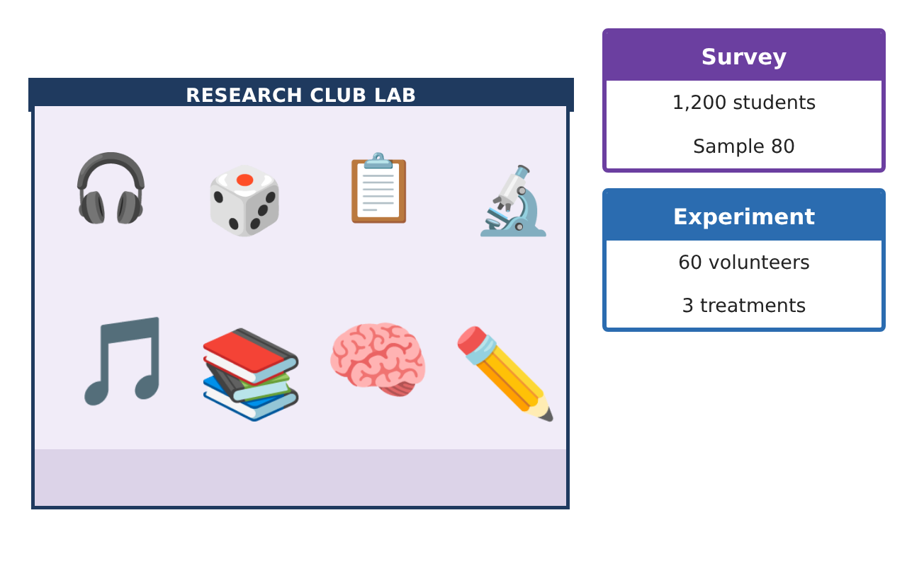
Learning Goals
- I can choose and justify a sampling design and anticipate bias.
- I can design completely randomized, randomized block, and matched pairs experiments.
- I can use a randomization simulation and state the scope of inference.
Project Timeline
When | What you will do
Day 1 | Survey Design
Day 2 | Better Experiments
Day 3 | Is the Difference Real?
Final | Study Design Proposal + reflection
Part 1: Survey Design
Day 1 · Use the Enrollment, Homerooms, and Random digits cards.
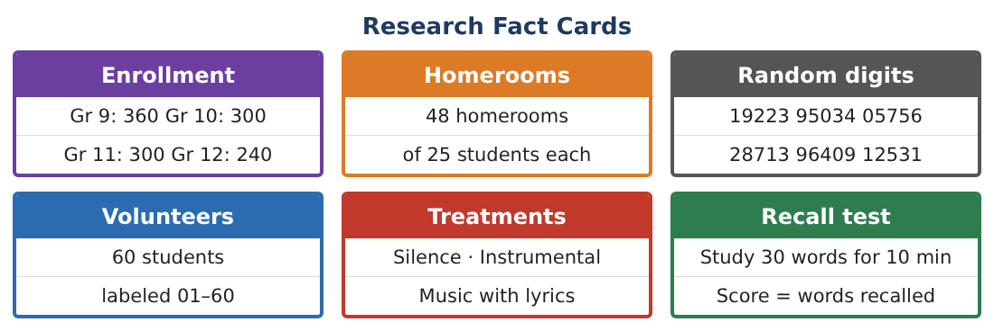
1. Compare an SRS of 80, a stratified sample by grade, and a cluster sample of homerooms. Which would you choose and why?

2. Use the random digits (all of 19223 95034 05756 28713 96409 12531) to choose 10 volunteers from 01–60. List them.

3. Write a neutral survey question and describe two ways nonresponse or response bias could still affect results and how to reduce them.

Part 2: Better Experiments
Day 2 · Recall ability varies a lot from student to student.
4. Design a randomized block experiment that blocks by grade level. Why block?

5. Design a matched pairs experiment comparing silence and lyrics using each student as their own pair.

6. Why must the order be randomized and the two word lists be equally hard?

7. Is a placebo possible here? Describe what could serve as one.

Part 3: Is the Difference Real?
Day 3 · Completely randomized results: silence mean 18.2 (20 students), lyrics mean 15.6 (20 students).
8. State the question the simulation answers, in terms of chance.

9. In 200 re-randomizations, 3 differences were 2.6 or more. Estimate the p-value and draw a conclusion.

10. Write the scope of inference: cause and effect? Generalize to whom?

11. Suggest one change that would let the club generalize to the whole school.

Final Product: Study Design Proposal
Your final product must include:
- Justified sampling plan with random selection
- Bias-reduction plan
- Block and matched pairs designs
- Simulation p-value and conclusion
- Proposal with scope of inference
Reflection
R1. When is a matched pairs design better than a completely randomized design?

R2. Why can a significant result still be limited in who it applies to?

Scoring Rubric
Criteria | 4 – Exceeds | 3 – Meets | 2 – Approaching | 1 – Beginning
Mathematical Accuracy | All calculations and solutions are correct; answers include units and are checked. | Nearly all work is correct; minor errors do not change conclusions. | Several errors; some conclusions are affected. | Many errors or missing work.
Reasoning & Justification | Clear, complete explanations connect every answer to the situation; uses precise vocabulary. | Explanations are mostly clear and connected to the situation. | Explanations are brief or partly unclear. | Little or no explanation.
Application & Design | Sampling and experiment designs use randomization correctly and address bias and confounding. Goes beyond the minimum with a creative, realistic choice. | Sampling and experiment designs use randomization correctly and address bias and confounding. | Design is incomplete or only partly uses the math from the unit. | Design is missing or unrelated to the unit math.
Communication & Presentation | Proposal includes a clear diagram, a bias plan, and a correct scope of inference. Polished, organized, and visually engaging. | Proposal includes a clear diagram, a bias plan, and a correct scope of inference. Organized and easy to follow. | Product is missing required parts or is hard to follow. | Product is mostly missing.

