ALGEBRA 1 · UNIT 3: LINEAR INEQUALITIES  Aquarium Keeper  Keep a classroom aquarium safe using compound inequalities. | CP1  2–3 class periods

Name: ________________________________ Date: ______________ Period: ______
The Scenario
The science department is setting up a 75-gallon tropical fish tank, and your group is in charge of keeping the fish alive. Every species has a safe temperature range, the water needs the right pH, and too many fish in one tank makes the water dirty.
You will turn every rule into an inequality, find the conditions where all of your fish can live together, and write a care plan that the next class can follow.
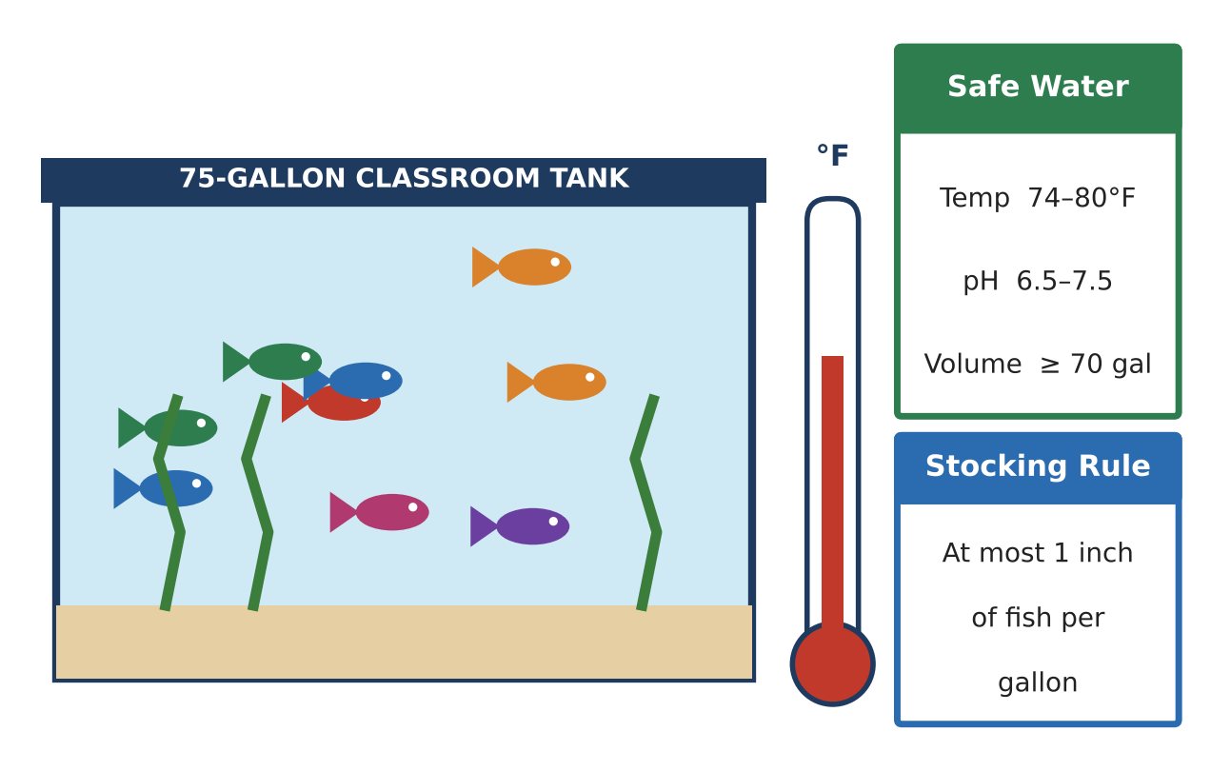
Learning Goals
- I can find and graph the overlap of two ranges as a compound inequality.
- I can solve multi-step and compound inequalities, including unit conversions.
- I can compare constraints to decide which one limits a plan.
Project Timeline
When | What you will do
Day 1 | Safe Ranges & Overlaps
Day 2 | Stocking, Heaters & Budget
Day 3 | Design a Community Tank
Final | Aquarium Care Plan + reflection

Part 1: Safe Ranges & Overlaps
Day 1 · Use the Safe Water card and the fish cards.
1. Write compound inequalities for the safe ranges of neon tetras and angelfish.
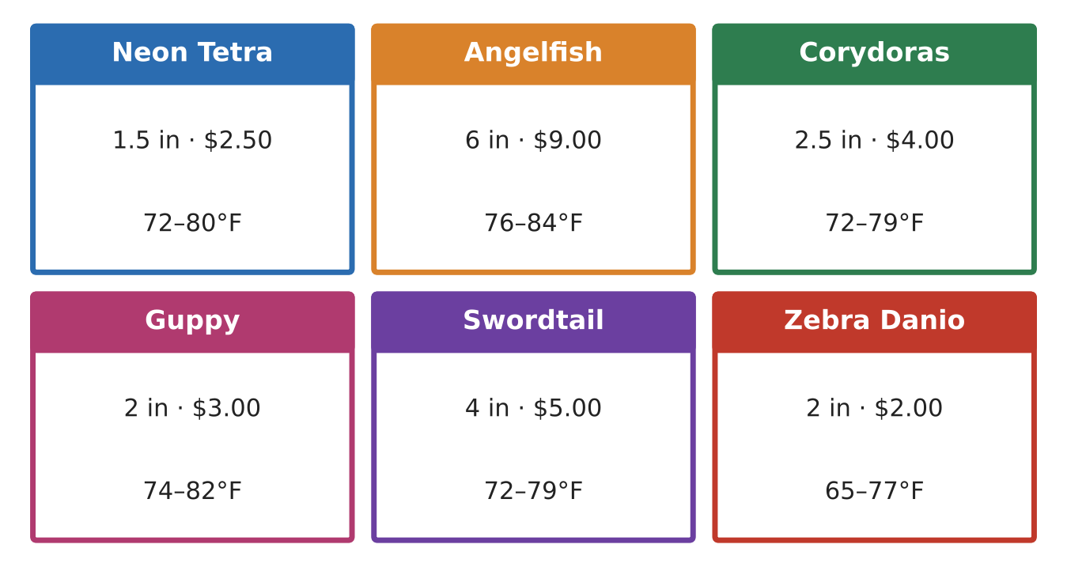

2. Write one compound inequality for temperatures that are safe for both species. Graph it.
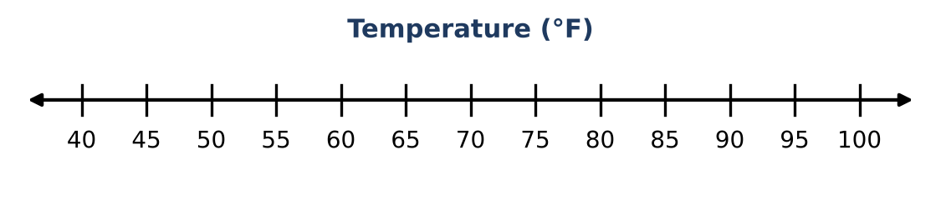

3. The tank's digital thermometer reads Celsius, and F = 1.8C + 32. Write and solve a compound inequality for the safe Celsius range for both species. Round to the nearest tenth.

4. Write an inequality for the temperatures that would be unsafe for at least one of the two species.

Part 2: Stocking, Heaters & Budget
Day 2 · The tank will have 2 angelfish and 6 corydoras. You want to add neon tetras.
5. Write and solve a stocking inequality for the number of neon tetras n.

6. The water starts at 68°F and the heater adds 1.5°F per hour. When is the water safe for both species? Give your answer in hours and minutes.

7. The tank loses 0.5 gallon per day to evaporation and must stay at or above 70 gallons. Within how many days must it be refilled?

8. Your budget for fish is $120. Corydoras cost $4 each and tetras cost $2.50 each (the angelfish are already paid for). How many tetras can you afford? Which constraint limits you more, stocking or budget?

Part 3: Design a Community Tank
Day 3 · Build a tank with at least three species from the fish cards. Budget: $150.
9. List your species and find the overlap of all their temperature ranges as one compound inequality. If there is no overlap, change a species.

10. Write and solve stocking and budget inequalities for your tank. Show that your final numbers satisfy both.

11. Write a maintenance schedule using at least two inequality results (heater time, refill days, safe readings).

Final Product: Aquarium Care Plan
Your final product must include:
- Species list and the overlap compound inequality with graph
- Celsius conversion for your overlap range
- Stocking and budget inequalities with final fish counts
- The more limiting constraint, explained
- Maintenance schedule
Reflection
R1. Explain why the overlap of two 'and' ranges always gives a smaller (or equal) range.

R2. Describe a situation where the budget would be the limiting constraint instead of stocking.

Scoring Rubric
Criteria | 4 – Exceeds | 3 – Meets | 2 – Approaching | 1 – Beginning
Mathematical Accuracy | All calculations and solutions are correct; answers include units and are checked. | Nearly all work is correct; minor errors do not change conclusions. | Several errors; some conclusions are affected. | Many errors or missing work.
Reasoning & Justification | Clear, complete explanations connect every answer to the situation; uses precise vocabulary. | Explanations are mostly clear and connected to the situation. | Explanations are brief or partly unclear. | Little or no explanation.
Application & Design | Chosen fish share a common temperature range and the stocking and budget inequalities are satisfied. Goes beyond the minimum with a creative, realistic choice. | Chosen fish share a common temperature range and the stocking and budget inequalities are satisfied. | Design is incomplete or only partly uses the math from the unit. | Design is missing or unrelated to the unit math.
Communication & Presentation | Care plan includes the fish list, every safe range as an inequality, graphs of the overlap, and a maintenance schedule. Polished, organized, and visually engaging. | Care plan includes the fish list, every safe range as an inequality, graphs of the overlap, and a maintenance schedule. Organized and easy to follow. | Product is missing required parts or is hard to follow. | Product is mostly missing.

