ALGEBRA 1 · UNIT 3: LINEAR INEQUALITIES  Aquarium Keeper  Keep a classroom aquarium safe using compound inequalities. | CP2  2–3 class periods

Name: ________________________________ Date: ______________ Period: ______
The Scenario
The science department is setting up a 75-gallon tropical fish tank, and your group is in charge of keeping the fish alive. Every species has a safe temperature range, the water needs the right pH, and too many fish in one tank makes the water dirty.
You will turn every rule into an inequality, find the conditions where all of your fish can live together, and write a care plan that the next class can follow.
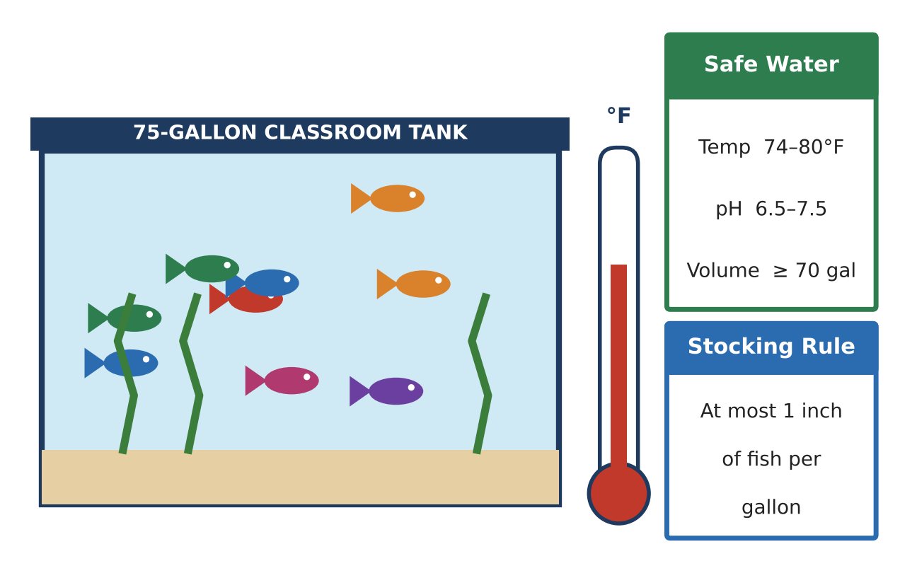
Learning Goals
- I can write and graph compound inequalities for safe ranges.
- I can solve two-step inequalities about fish, heaters, and water.
- I can use inequalities to make a care plan.
Project Timeline
When | What you will do
Day 1 | Safe Ranges
Day 2 | Fish, Heaters & Water
Day 3 | Design Your Tank
Final | Aquarium Care Plan + reflection

Part 1: Safe Ranges
Day 1 · Use the Safe Water card.
1. Write a compound inequality for the safe temperature T. Then graph it.
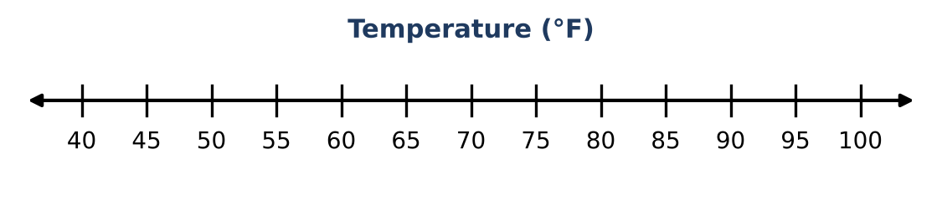
Starter: ___ ≤ T ≤ ___

2. Which of these thermometer readings are safe: 73°F, 76.5°F, 80°F, 81°F? Explain.

3. Write a compound inequality for the safe pH level p.

4. Write an inequality for the temperatures that are NOT safe.
Starter: T < ___ or T > ___

Part 2: Fish, Heaters & Water
Day 2 · Write and solve an inequality for each question.
5. The tank already has 6 angelfish that are 6 inches long (36 inches of fish). How many 1.5-inch neon tetras can you add without breaking the stocking rule?
Starter: 36 + 1.5n ≤ ___

6. The water starts at 68°F. The heater warms it 1.5°F every hour. After how many hours h is the water at least 74°F?

7. Write and solve a compound inequality to find the hours when the water is in the safe range: 74 ≤ 68 + 1.5h ≤ 80.

8. When should the class turn the heater down? Explain using your answer.

Part 3: Design Your Tank
Day 3 · Use the fish cards to build your own tank.
9. Choose two kinds of fish. Write each one's temperature range as a compound inequality.
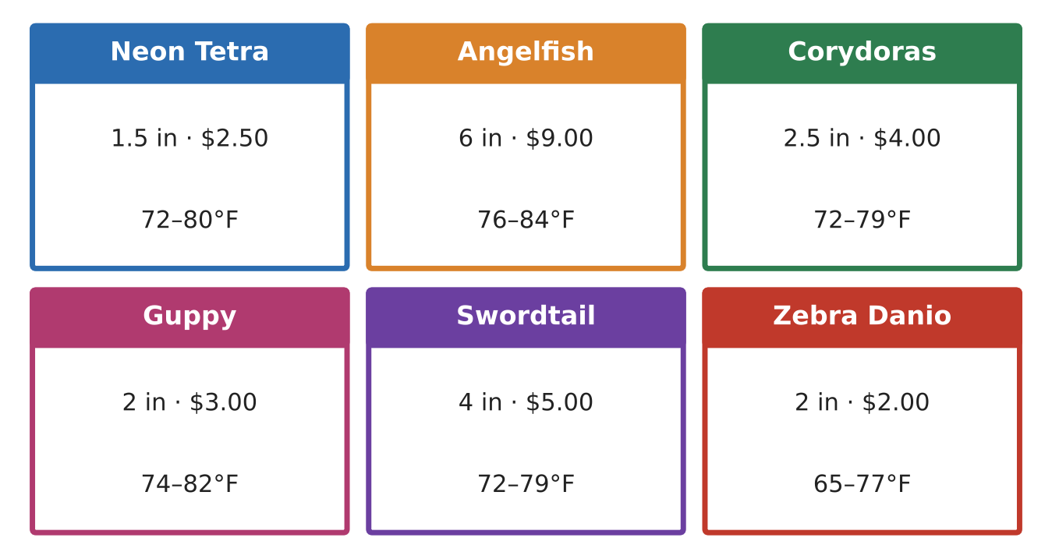

10. Find the temperatures that are safe for BOTH fish. Write one compound inequality.

11. Choose how many of each fish to buy. Show that the total length is at most 75 inches.

Final Product: Aquarium Care Plan
Your final product must include:
- Your fish choices with pictures
- Each safe range as a compound inequality and graph
- The overlap range for your tank
- The stocking check (total inches ≤ 75)
- A care schedule: when to check temperature and add water
Reflection
R1. Why does a safe range need a compound inequality instead of just one inequality?

R2. What would happen to the fish if you used "or" instead of "and" for the safe range?

Scoring Rubric
Criteria | 4 – Exceeds | 3 – Meets | 2 – Approaching | 1 – Beginning
Mathematical Accuracy | All calculations and solutions are correct; answers include units and are checked. | Nearly all work is correct; minor errors do not change conclusions. | Several errors; some conclusions are affected. | Many errors or missing work.
Reasoning & Justification | Clear, complete explanations connect every answer to the situation; uses precise vocabulary. | Explanations are mostly clear and connected to the situation. | Explanations are brief or partly unclear. | Little or no explanation.
Application & Design | Chosen fish share a common temperature range and the stocking and budget inequalities are satisfied. Goes beyond the minimum with a creative, realistic choice. | Chosen fish share a common temperature range and the stocking and budget inequalities are satisfied. | Design is incomplete or only partly uses the math from the unit. | Design is missing or unrelated to the unit math.
Communication & Presentation | Care plan includes the fish list, every safe range as an inequality, graphs of the overlap, and a maintenance schedule. Polished, organized, and visually engaging. | Care plan includes the fish list, every safe range as an inequality, graphs of the overlap, and a maintenance schedule. Organized and easy to follow. | Product is missing required parts or is hard to follow. | Product is mostly missing.

