ALGEBRA 1 · UNIT 3: LINEAR INEQUALITIES  Aquarium Keeper  Keep a classroom aquarium safe using compound inequalities. | Honors  2–3 class periods

Name: ________________________________ Date: ______________ Period: ______
The Scenario
The science department is setting up a 75-gallon tropical fish tank, and your group is in charge of keeping the fish alive. Every species has a safe temperature range, the water needs the right pH, and too many fish in one tank makes the water dirty.
You will turn every rule into an inequality, find the conditions where all of your fish can live together, and write a care plan that the next class can follow.
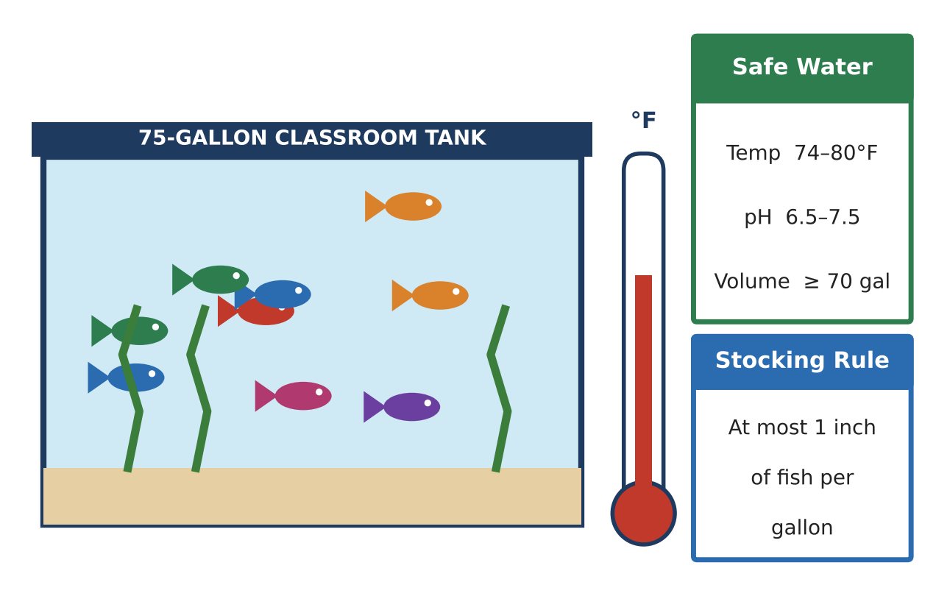
Learning Goals
- I can describe ranges with compound and absolute value inequalities.
- I can choose parameters (like a thermostat setting) so that a tolerance stays inside a safe range.
- I can combine several constraints to justify a design.
Project Timeline
When | What you will do
Day 1 | Ranges as Distances
Day 2 | Thermostats, Cooling & Stocking
Day 3 | Engineer a Community Tank
Final | Aquarium Care Plan + reflection

Part 1: Ranges as Distances
Day 1 · Use the Safe Water card and the fish cards.
1. Write the safe ranges for neon tetras (72–80°F) and angelfish (76–84°F) as absolute value inequalities.
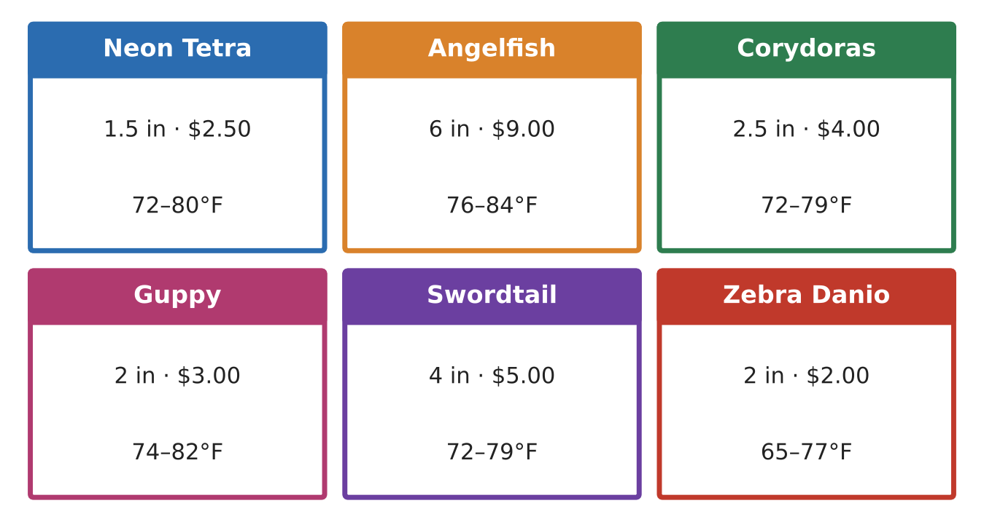

2. Find the overlap of the two ranges. Write it as a compound inequality and as an absolute value inequality.

3. Convert the overlap to Celsius using F = 1.8C + 32 (round to the nearest hundredth). Then write it as an absolute value inequality in C.

4. The safe pH range is 6.5 to 7.5. Write it as an absolute value inequality. A test reads 7.6. By how much is it outside the range?

Part 2: Thermostats, Cooling & Stocking
Day 2 · Use the overlap range 76 ≤ T ≤ 80 for all questions.
5. The thermostat keeps the water within 0.8°F of its setting s, so |T − s| ≤ 0.8. Find every setting s that keeps the water safe. Explain your reasoning.

6. If the power goes out at night, the water cools 0.4°F per hour starting from 79°F. After how many hours is the water unsafe?

7. The tank loses 0.6 gallon per day and must stay at least 70 gallons. Find the longest whole number of days between refills.

8. The tank has 2 angelfish (6 in each) and 6 corydoras (2.5 in each). Tetras must be added in a school of at least 6. The fish budget is $120 (only corydoras and tetras are bought now). Write one compound inequality for the number of tetras that meets all three rules.

Part 3: Engineer a Community Tank
Day 3 · Use at least four species. Budget: $180.
9. Write each species' range as an absolute value inequality. Find the overlap of all of them and the thermostat settings that keep a 0.8°F tolerance safe.

10. Write and solve stocking and budget inequalities. Choose final counts and prove they satisfy every constraint.

11. Write a care plan that explains what to do if the power goes out, using an inequality to give a time limit.

Final Product: Aquarium Care Plan
Your final product must include:
- Species list with absolute value ranges
- Overlap and thermostat settings with justification
- Stocking, budget, and schooling constraints with final counts
- Power-outage time limit
- Complete care plan
Reflection
R1. Explain how the center and radius of an absolute value inequality relate to the endpoints of a range.

R2. Why does a thermostat tolerance shrink the set of safe settings?

Scoring Rubric
Criteria | 4 – Exceeds | 3 – Meets | 2 – Approaching | 1 – Beginning
Mathematical Accuracy | All calculations and solutions are correct; answers include units and are checked. | Nearly all work is correct; minor errors do not change conclusions. | Several errors; some conclusions are affected. | Many errors or missing work.
Reasoning & Justification | Clear, complete explanations connect every answer to the situation; uses precise vocabulary. | Explanations are mostly clear and connected to the situation. | Explanations are brief or partly unclear. | Little or no explanation.
Application & Design | Chosen fish share a common temperature range and the stocking and budget inequalities are satisfied. Goes beyond the minimum with a creative, realistic choice. | Chosen fish share a common temperature range and the stocking and budget inequalities are satisfied. | Design is incomplete or only partly uses the math from the unit. | Design is missing or unrelated to the unit math.
Communication & Presentation | Care plan includes the fish list, every safe range as an inequality, graphs of the overlap, and a maintenance schedule. Polished, organized, and visually engaging. | Care plan includes the fish list, every safe range as an inequality, graphs of the overlap, and a maintenance schedule. Organized and easy to follow. | Product is missing required parts or is hard to follow. | Product is mostly missing.

