ALGEBRA 1 · UNIT 5: LINEAR FUNCTIONS AND GRAPHING  Balloon Festival  Compare four hot air balloons shown in four different ways. | CP1  2–3 class periods

Name: ________________________________ Date: ______________ Period: ______
The Scenario
Welcome to the Sky Valley Balloon Festival! Four balloons are in the air, and the judges have data on each one, but every judge recorded it in a different way: a table, an equation, a graph, and a description.
Your team is the festival's data crew. You will turn all four into equations, compare the balloons, predict what happens next, and then enter a balloon of your own.
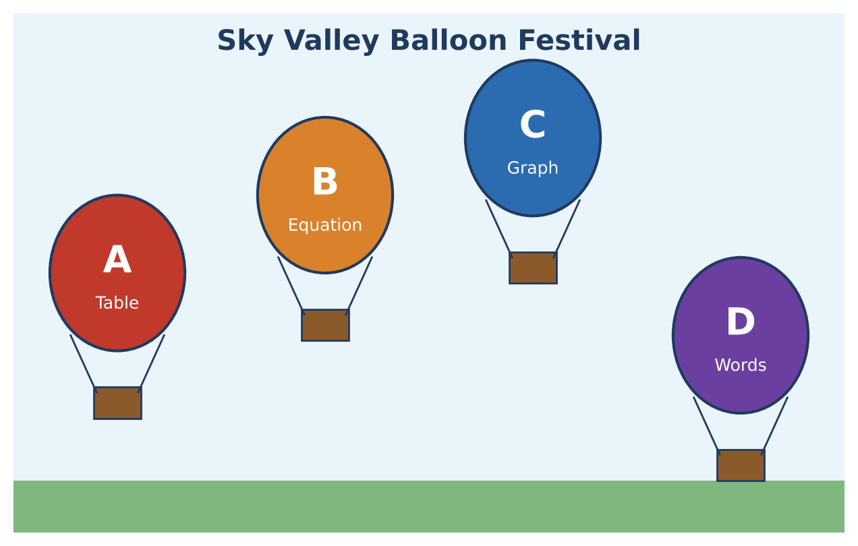
Learning Goals
- I can write linear equations from tables, graphs, words, and two points.
- I can solve linear equations to find when two situations are equal.
- I can design a linear model that meets given conditions.
Project Timeline
When | What you will do
Day 1 | Read the Judges' Data
Day 2 | When Do They Meet?
Day 3 | Enter Your Own Balloon
Final | Festival Flight Report + reflection

Part 1: Read the Judges' Data
Day 1 · Write an equation y = mt + b for each balloon (t in minutes, y in feet).
1. Balloon A is given in the table.
Time t (min) | 0 | 2 | 4 | 6
Altitude (ft) | 150 | 270 | 390 | 510

2. Balloon C is given in the graph.
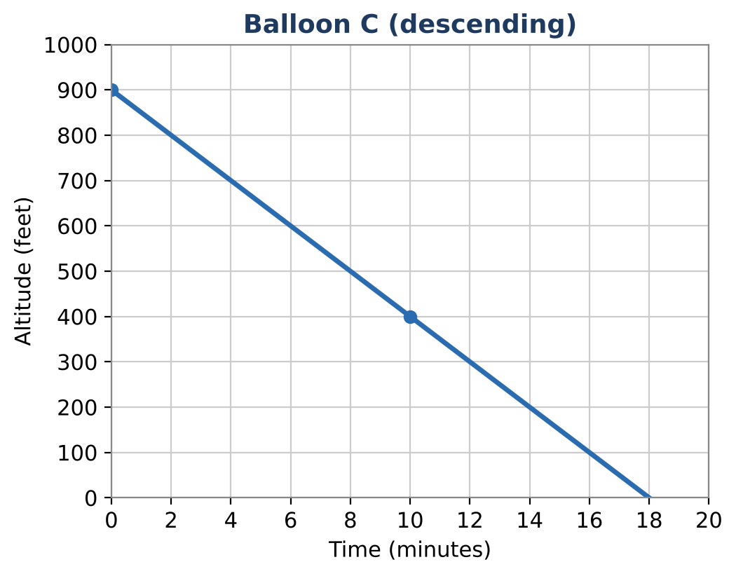

3. Balloon D: "Launched from a hill 75 feet above the field and rises 80 feet per minute."

4. A fifth balloon, E, was spotted at 420 feet at 3 minutes and at 700 feet at 7 minutes. Write its equation and interpret its y-intercept.

5. Balloon B is y = 45t + 300. Compare B and E: which started higher, and which is rising faster?

Part 2: When Do They Meet?
Day 2 · Write and solve an equation for each question. Round to the nearest hundredth if needed.
6. When are Balloons A and B at the same altitude? What is that altitude?

7. When does Balloon D pass Balloon B? Give the time in minutes and seconds.

8. Balloon A is going up and Balloon C is coming down. When are they at the same altitude?

9. The festival ceiling is 1,500 feet. Which rising balloon reaches the ceiling first? Show your work.

Part 3: Enter Your Own Balloon
Day 3 · Festival rule: your balloon must start between 100 and 300 feet and reach 1,000 feet before Balloon B does.
10. Find when Balloon B reaches 1,000 feet.

11. Design your balloon. Write its equation and show it meets both rules.

12. Graph Balloons A, B, and yours on one grid and mark every meeting point.
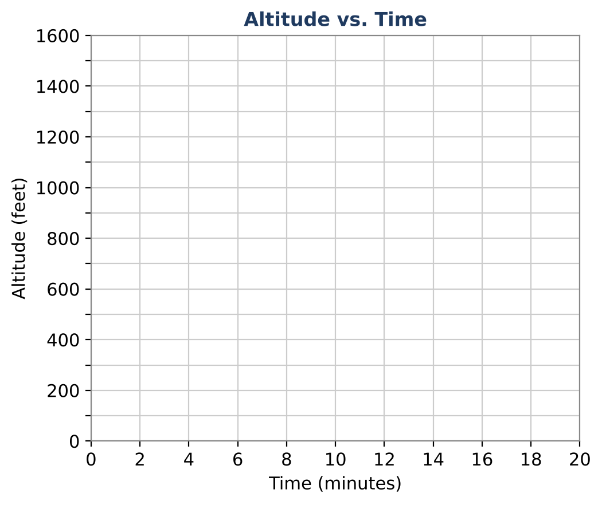

Final Product: Festival Flight Report
Your final product must include:
- Equations for Balloons A–E
- One graph with all balloons and labeled meeting points
- Solutions to all meeting and ceiling questions
- Your balloon's design with proof that it meets the rules
- A one-paragraph flight report
Reflection
R1. How does the graph show when two balloons have the same altitude?

R2. If two balloons rise at the same rate but start at different heights, will they ever meet? Explain.

Scoring Rubric
Criteria | 4 – Exceeds | 3 – Meets | 2 – Approaching | 1 – Beginning
Mathematical Accuracy | All calculations and solutions are correct; answers include units and are checked. | Nearly all work is correct; minor errors do not change conclusions. | Several errors; some conclusions are affected. | Many errors or missing work.
Reasoning & Justification | Clear, complete explanations connect every answer to the situation; uses precise vocabulary. | Explanations are mostly clear and connected to the situation. | Explanations are brief or partly unclear. | Little or no explanation.
Application & Design | Your balloon meets the festival rules, with an equation, table, and graph that match. Goes beyond the minimum with a creative, realistic choice. | Your balloon meets the festival rules, with an equation, table, and graph that match. | Design is incomplete or only partly uses the math from the unit. | Design is missing or unrelated to the unit math.
Communication & Presentation | Flight report shows all balloons as equations and graphs, answers the judges' questions, and presents your balloon. Polished, organized, and visually engaging. | Flight report shows all balloons as equations and graphs, answers the judges' questions, and presents your balloon. Organized and easy to follow. | Product is missing required parts or is hard to follow. | Product is mostly missing.

