ALGEBRA 1 · UNIT 5: LINEAR FUNCTIONS AND GRAPHING  Balloon Festival  Compare four hot air balloons shown in four different ways. | CP2  2–3 class periods

Name: ________________________________ Date: ______________ Period: ______
The Scenario
Welcome to the Sky Valley Balloon Festival! Four balloons are in the air, and the judges have data on each one, but every judge recorded it in a different way: a table, an equation, a graph, and a description.
Your team is the festival's data crew. You will turn all four into equations, compare the balloons, predict what happens next, and then enter a balloon of your own.
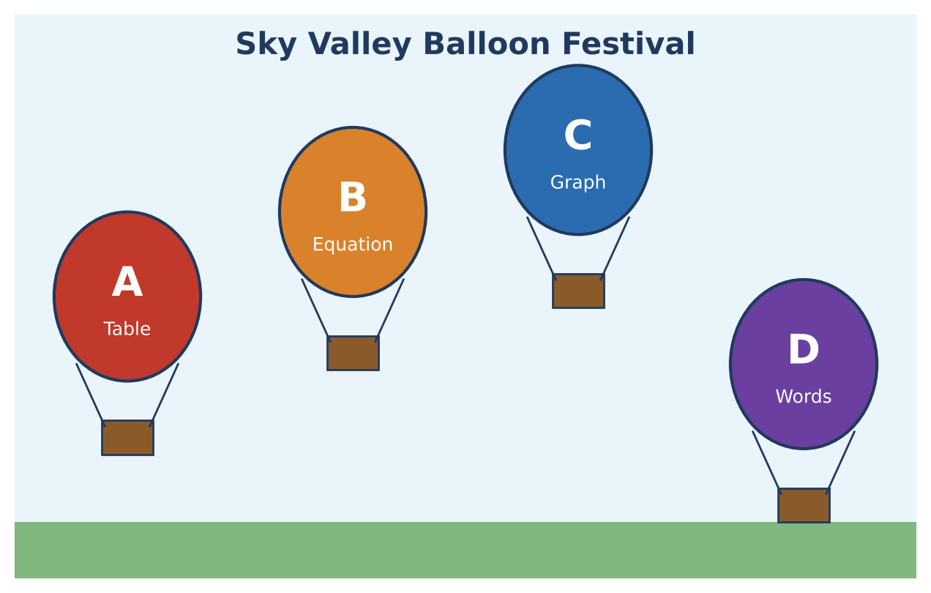
Learning Goals
- I can find the rate of change and starting value from a table, an equation, a graph, and words.
- I can write and use linear equations.
- I can compare linear situations.
Project Timeline
When | What you will do
Day 1 | Read the Judges' Data
Day 2 | Equations & Predictions
Day 3 | Enter Your Own Balloon
Final | Festival Flight Report + reflection

Part 1: Read the Judges' Data
Day 1 · Find each balloon's starting altitude and rate of change (feet per minute).
1. Balloon A (table): Find the rate of change and the starting altitude.
Time t (min) | 0 | 2 | 4 | 6
Altitude (ft) | 150 | 270 | 390 | 510

Starter: Rate = change in altitude ÷ change in time

2. Balloon B (equation): y = 45t + 300. What is the rate of change? What is the starting altitude?

3. Balloon C (graph): Find the starting altitude and the rate of change. Is the balloon going up or down?
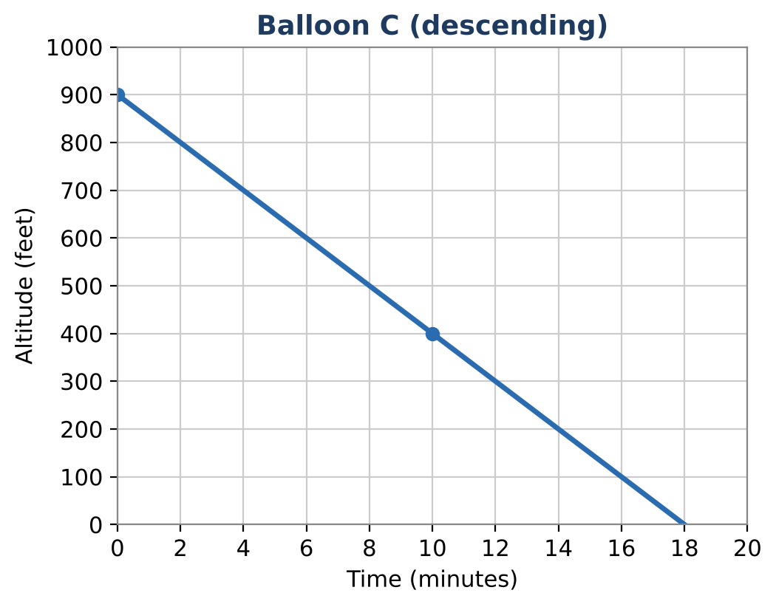

4. Balloon D (words): "Balloon D launched from a hill 75 feet above the field and rises 80 feet every minute." Find its rate and starting altitude.

5. List the balloons from fastest rising to slowest. Which balloon is coming down?

Part 2: Equations & Predictions
Day 2 · Write equations in the form y = mt + b.
6. Write equations for Balloons A, C, and D.

7. Find the altitude of each balloon after 5 minutes. Which is highest?
Balloon | A | B | C | D
Altitude at t = 5

8. When will Balloon A reach 1,050 feet? Write and solve an equation.

9. When will Balloon C land (altitude 0)?

Part 3: Enter Your Own Balloon
Day 3 · Design a balloon for the festival.
10. Choose a starting altitude and a rate of change for your balloon. Write its equation.

11. Make a table for t = 0, 2, 4, 6, 8, and 10 minutes and graph your balloon with Balloons A and B.
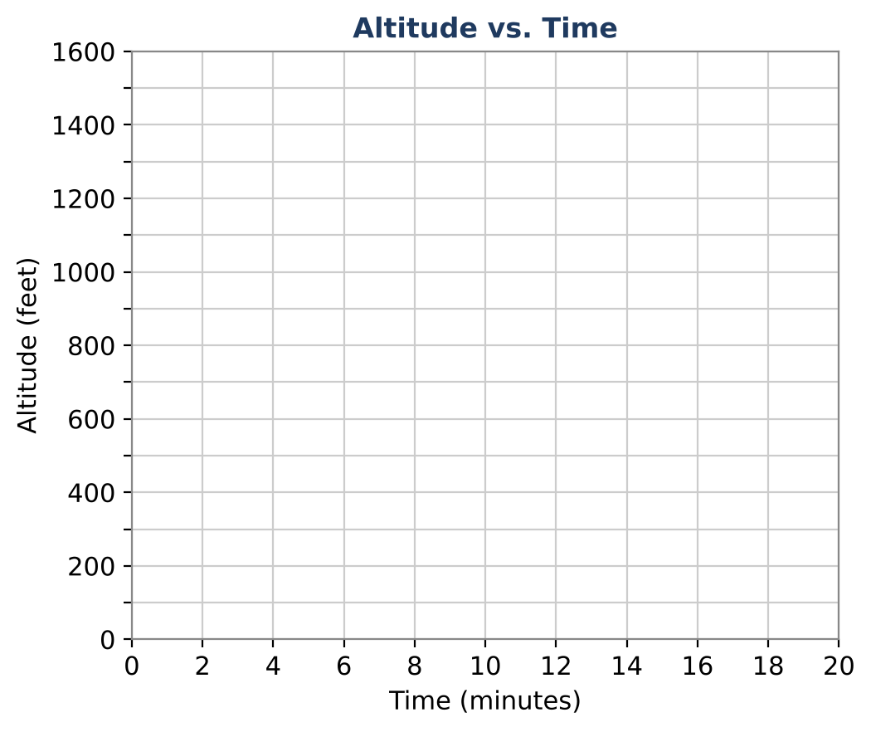

12. Is your balloon higher or lower than Balloon A at 10 minutes? How do you know?

Final Product: Festival Flight Report
Your final product must include:
- All four balloons as equations
- A graph of the balloons on one grid (one color each)
- Answers to the judges' questions
- Your balloon's equation, table, and graph
- A short announcement about your balloon
Reflection
R1. Which representation (table, equation, graph, words) made the rate easiest to find? Why?

R2. What does a negative rate of change mean for a balloon?

Scoring Rubric
Criteria | 4 – Exceeds | 3 – Meets | 2 – Approaching | 1 – Beginning
Mathematical Accuracy | All calculations and solutions are correct; answers include units and are checked. | Nearly all work is correct; minor errors do not change conclusions. | Several errors; some conclusions are affected. | Many errors or missing work.
Reasoning & Justification | Clear, complete explanations connect every answer to the situation; uses precise vocabulary. | Explanations are mostly clear and connected to the situation. | Explanations are brief or partly unclear. | Little or no explanation.
Application & Design | Your balloon meets the festival rules, with an equation, table, and graph that match. Goes beyond the minimum with a creative, realistic choice. | Your balloon meets the festival rules, with an equation, table, and graph that match. | Design is incomplete or only partly uses the math from the unit. | Design is missing or unrelated to the unit math.
Communication & Presentation | Flight report shows all balloons as equations and graphs, answers the judges' questions, and presents your balloon. Polished, organized, and visually engaging. | Flight report shows all balloons as equations and graphs, answers the judges' questions, and presents your balloon. Organized and easy to follow. | Product is missing required parts or is hard to follow. | Product is mostly missing.

