ALGEBRA 1 · UNIT 5: LINEAR FUNCTIONS AND GRAPHING  Balloon Festival  Compare four hot air balloons shown in four different ways. | Honors  2–3 class periods

Name: ________________________________ Date: ______________ Period: ______
The Scenario
Welcome to the Sky Valley Balloon Festival! Four balloons are in the air, and the judges have data on each one, but every judge recorded it in a different way: a table, an equation, a graph, and a description.
Your team is the festival's data crew. You will turn all four into equations, compare the balloons, predict what happens next, and then enter a balloon of your own.
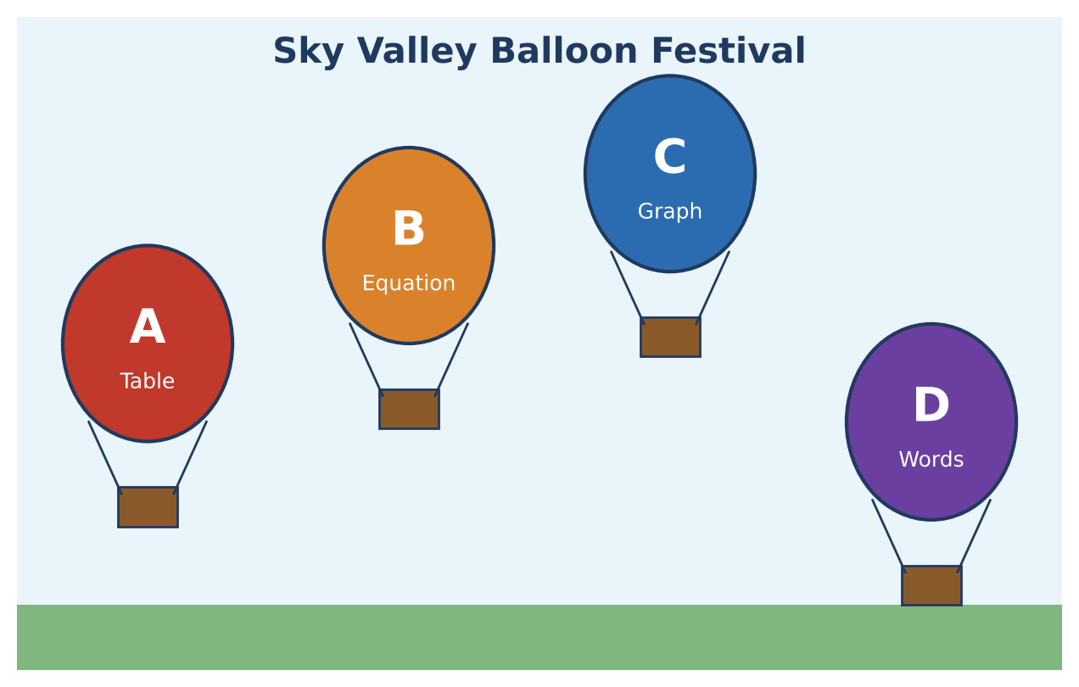
Learning Goals
- I can move fluently among tables, graphs, equations (all forms), and words.
- I can derive and use a general formula for when two linear models are equal.
- I can use inequalities to describe every design that meets the rules.
Project Timeline
When | What you will do
Day 1 | Read the Judges' Data
Day 2 | General Meeting Times
Day 3 | Design Within the Rules
Final | Festival Flight Report + reflection

Part 1: Read the Judges' Data
Day 1 · Write each balloon in slope-intercept form (t in minutes, y in feet).
1. Balloons A (table), C (graph), and D ("launched from a hill 75 feet above the field, rising 80 feet per minute").
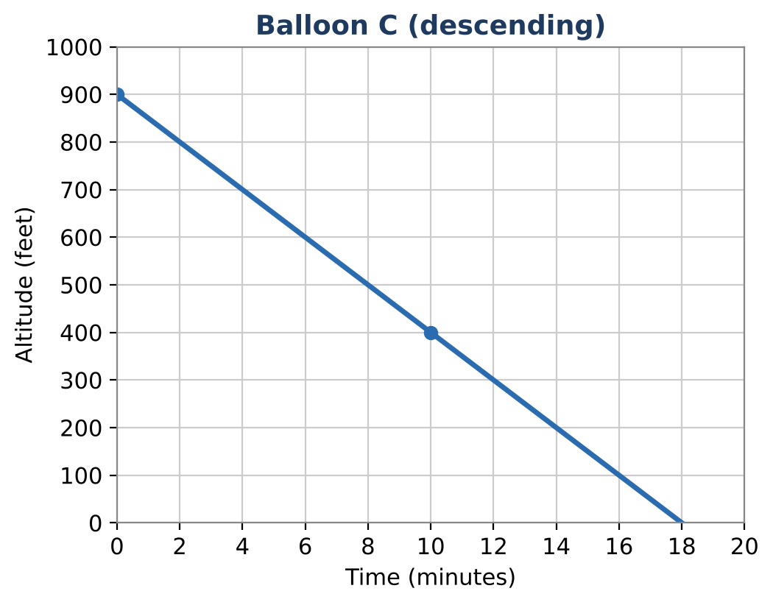
Time t (min) | 0 | 2 | 4 | 6
Altitude (ft) | 150 | 270 | 390 | 510

2. Balloon E was at 420 feet at 3 minutes and at 700 feet at 7 minutes.

3. Balloon F is given in standard form: 150t − 3y = −600. Rewrite it in slope-intercept form and interpret.

4. Convert Balloon A's rate to feet per second. Write A's equation with time s in seconds.

Part 2: General Meeting Times
Day 2 · Two balloons follow y = m₁t + b₁ and y = m₂t + b₂.
5. Derive a formula for the time t when they have the same altitude. When does the formula fail, and what does that mean?

6. Use your formula to find when A meets B, and when D meets B.

7. Do Balloons C and F ever meet? Do Balloons B and a new balloon y = 45t + 200 ever meet? Explain using slopes.

8. Wind pushes Balloon A east 300 feet per minute. Write the horizontal distance x as a function of t, then write A's altitude y as a function of x. Interpret the slope.

Part 3: Design Within the Rules
Day 3 · Rule: your balloon must start between 100 and 200 feet and be at 1,000 feet at some time between 8 and 10 minutes.
9. Write the rate m in terms of the starting altitude b and the time T when the balloon reaches 1,000 feet.

10. Find the smallest and largest possible rates that follow the rule. Write the result as a compound inequality.

11. Choose a design, show it meets every rule, and graph it with A, B, and D. Will your balloon meet each of them? When?
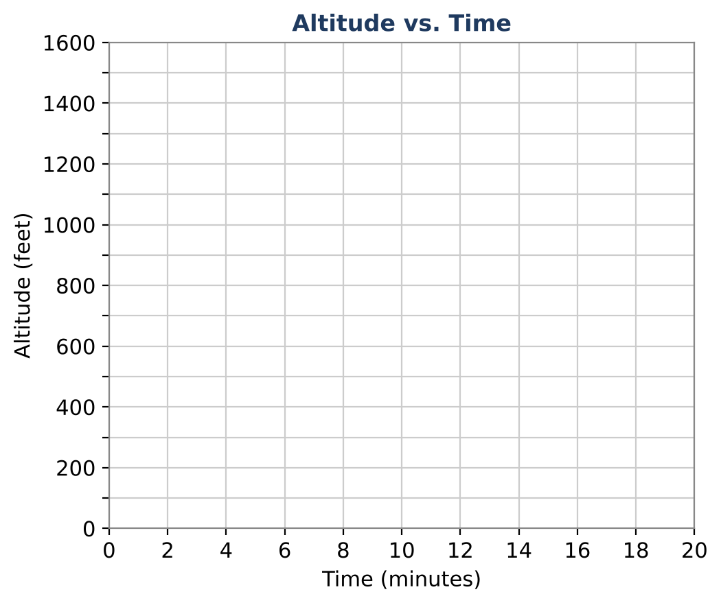

Final Product: Festival Flight Report
Your final product must include:
- Equations for Balloons A–F (including the converted forms)
- The general meeting-time formula with explanation
- The drift model y as a function of x
- The compound inequality for possible rates
- Your design with a complete flight report
Reflection
R1. Why does your meeting-time formula fail when the slopes are equal? Connect to parallel lines.

R2. How did changing variables (t to x) change the slope but not the starting altitude?

Scoring Rubric
Criteria | 4 – Exceeds | 3 – Meets | 2 – Approaching | 1 – Beginning
Mathematical Accuracy | All calculations and solutions are correct; answers include units and are checked. | Nearly all work is correct; minor errors do not change conclusions. | Several errors; some conclusions are affected. | Many errors or missing work.
Reasoning & Justification | Clear, complete explanations connect every answer to the situation; uses precise vocabulary. | Explanations are mostly clear and connected to the situation. | Explanations are brief or partly unclear. | Little or no explanation.
Application & Design | Your balloon meets the festival rules, with an equation, table, and graph that match. Goes beyond the minimum with a creative, realistic choice. | Your balloon meets the festival rules, with an equation, table, and graph that match. | Design is incomplete or only partly uses the math from the unit. | Design is missing or unrelated to the unit math.
Communication & Presentation | Flight report shows all balloons as equations and graphs, answers the judges' questions, and presents your balloon. Polished, organized, and visually engaging. | Flight report shows all balloons as equations and graphs, answers the judges' questions, and presents your balloon. Organized and easy to follow. | Product is missing required parts or is hard to follow. | Product is mostly missing.

