ALGEBRA 1 · UNIT 6: SYSTEMS OF EQUATIONS AND INEQUALITIES  Banquet Planner  Compare venues with systems of equations and plan the spring banquet. | CP1  2–3 class periods

Name: ________________________________ Date: ______________ Period: ______
The Scenario
The student council is planning the spring banquet, and you are on the planning committee. Three venues want your business, and each one charges in a different way.
The best choice depends on how many guests come. Systems of equations show exactly where one option becomes cheaper than another. Your job is to compare the options and present a recommendation to the council.
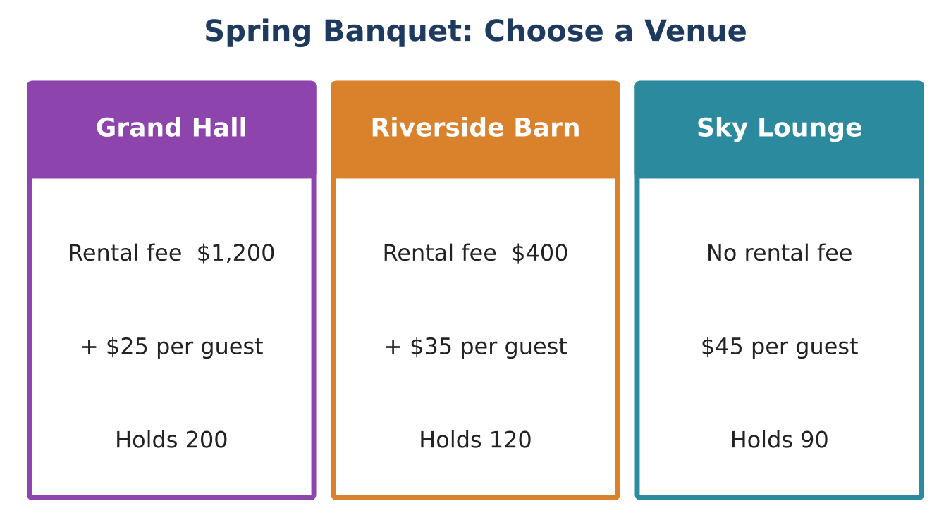
Learning Goals
- I can write and solve systems of linear equations by graphing, substitution, and elimination.
- I can interpret intersections as break-even points.
- I can recognize systems with no solution or infinitely many solutions.
Project Timeline
When | What you will do
Day 1 | Three Venues
Day 2 | Decorations & DJs
Day 3 | Final Plan
Final | Banquet Proposal + reflection

Part 1: Three Venues
Day 1 · Let x = number of guests and y = total cost.
1. Write an equation for each venue.

2. Graph all three on the grid.
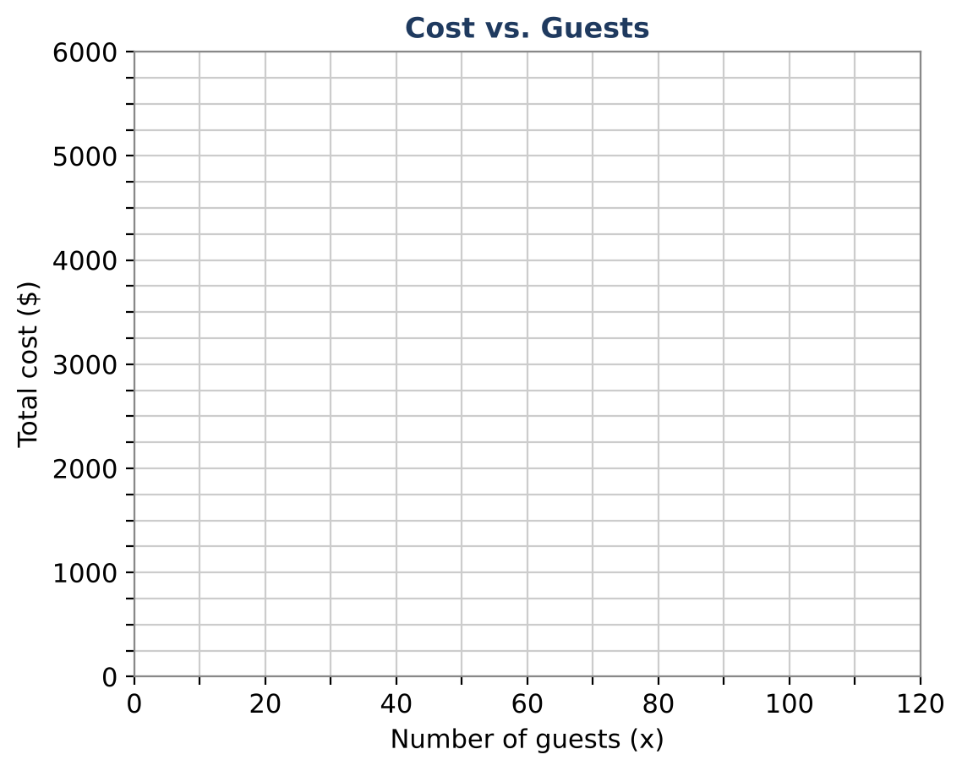

3. Use substitution to find all three break-even points (one for each pair of venues).

4. Use your break-even points to state which venue is cheapest for each range of guests. Remember the capacity of each venue.

Part 2: Decorations & DJs
Day 2 · Solve each system using the method of your choice. Show your work.
5. Order 1: 12 tablecloths and 30 centerpieces cost $420. Order 2: 8 tablecloths and 25 centerpieces cost $320. Use elimination to find the price of each item.

6. A committee member says: "I only remember that 12 tablecloths and 30 centerpieces cost $420, and 8 tablecloths and 20 centerpieces cost $280." Can you find the prices from this? Explain algebraically.

7. DJ Max charges $300 plus $2 per guest. DJ Nova charges $150 plus $4.50 per guest. When do they cost the same?

8. Photo Booth A charges $250 plus $3 per guest. Photo Booth B charges $100 plus $3 per guest. Write the system. What happens when you solve it? What does that mean?

Part 3: Final Plan
Day 3 · The council expects between 70 and 110 guests.
9. For 70 guests and for 110 guests, find the cheapest venue + DJ combination and the total cost.

10. Tickets will be priced so that the banquet at least breaks even for 90 guests with your plan. What ticket price do you recommend?

11. Write a recommendation that uses at least two break-even points.

Final Product: Banquet Proposal
Your final product must include:
- Three venue equations and one graph with all intersections labeled
- The best-venue intervals
- Decoration prices and the special-case explanation
- Final plan for 70 and 110 guests and a ticket price
- Written recommendation
Reflection
R1. How do you know when a system has no solution before you solve it?

R2. Explain why the second decoration conversation does not give enough information.

Scoring Rubric
Criteria | 4 – Exceeds | 3 – Meets | 2 – Approaching | 1 – Beginning
Mathematical Accuracy | All calculations and solutions are correct; answers include units and are checked. | Nearly all work is correct; minor errors do not change conclusions. | Several errors; some conclusions are affected. | Many errors or missing work.
Reasoning & Justification | Clear, complete explanations connect every answer to the situation; uses precise vocabulary. | Explanations are mostly clear and connected to the situation. | Explanations are brief or partly unclear. | Little or no explanation.
Application & Design | Recommendation correctly uses the break-even points for the expected number of guests. Goes beyond the minimum with a creative, realistic choice. | Recommendation correctly uses the break-even points for the expected number of guests. | Design is incomplete or only partly uses the math from the unit. | Design is missing or unrelated to the unit math.
Communication & Presentation | Proposal shows equations, a graph with intersections labeled, the break-even analysis, and a clear recommendation. Polished, organized, and visually engaging. | Proposal shows equations, a graph with intersections labeled, the break-even analysis, and a clear recommendation. Organized and easy to follow. | Product is missing required parts or is hard to follow. | Product is mostly missing.

