ALGEBRA 1 · UNIT 6: SYSTEMS OF EQUATIONS AND INEQUALITIES  Banquet Planner  Compare venues with systems of equations and plan the spring banquet. | CP2  2–3 class periods

Name: ________________________________ Date: ______________ Period: ______
The Scenario
The student council is planning the spring banquet, and you are on the planning committee. Three venues want your business, and each one charges in a different way.
The best choice depends on how many guests come. Systems of equations show exactly where one option becomes cheaper than another. Your job is to compare the options and present a recommendation to the council.
For now, compare only the Grand Hall and the Riverside Barn.
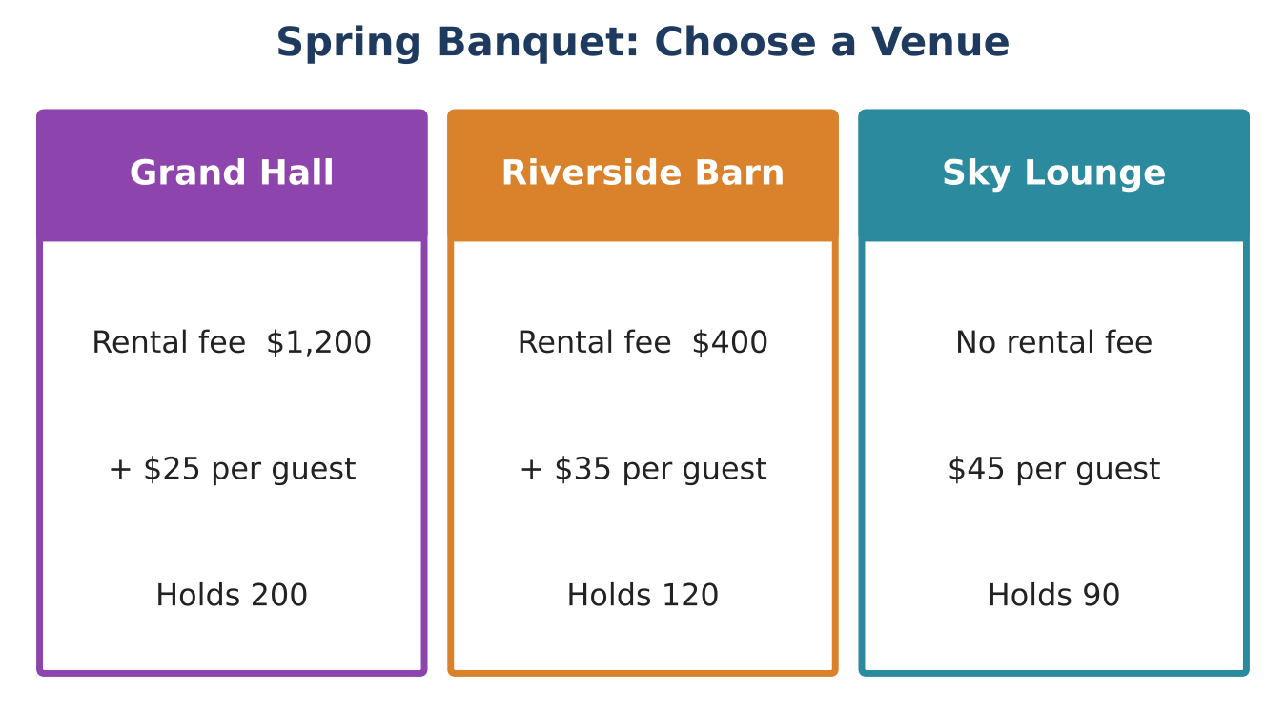
Learning Goals
- I can write equations for costs with a fixed fee and a rate.
- I can solve a system by table, graph, and substitution.
- I can explain what the solution of a system means.
Project Timeline
When | What you will do
Day 1 | Compare Two Venues
Day 2 | Solve It Algebraically
Day 3 | Pick the DJ & Plan
Final | Banquet Proposal + reflection

Part 1: Compare Two Venues
Day 1 · Let x = number of guests and y = total cost.
1. Complete the table.
Guests | 20 | 40 | 60 | 80 | 100
Grand Hall ($) | 1,700
Riverside Barn ($) | 1,100

2. At what number of guests do the two venues cost the same? How does the table show it?

3. Write an equation for each venue.
Starter: y = (cost per guest)x + (rental fee)

4. Graph both equations on the grid. Label the point where the lines cross.
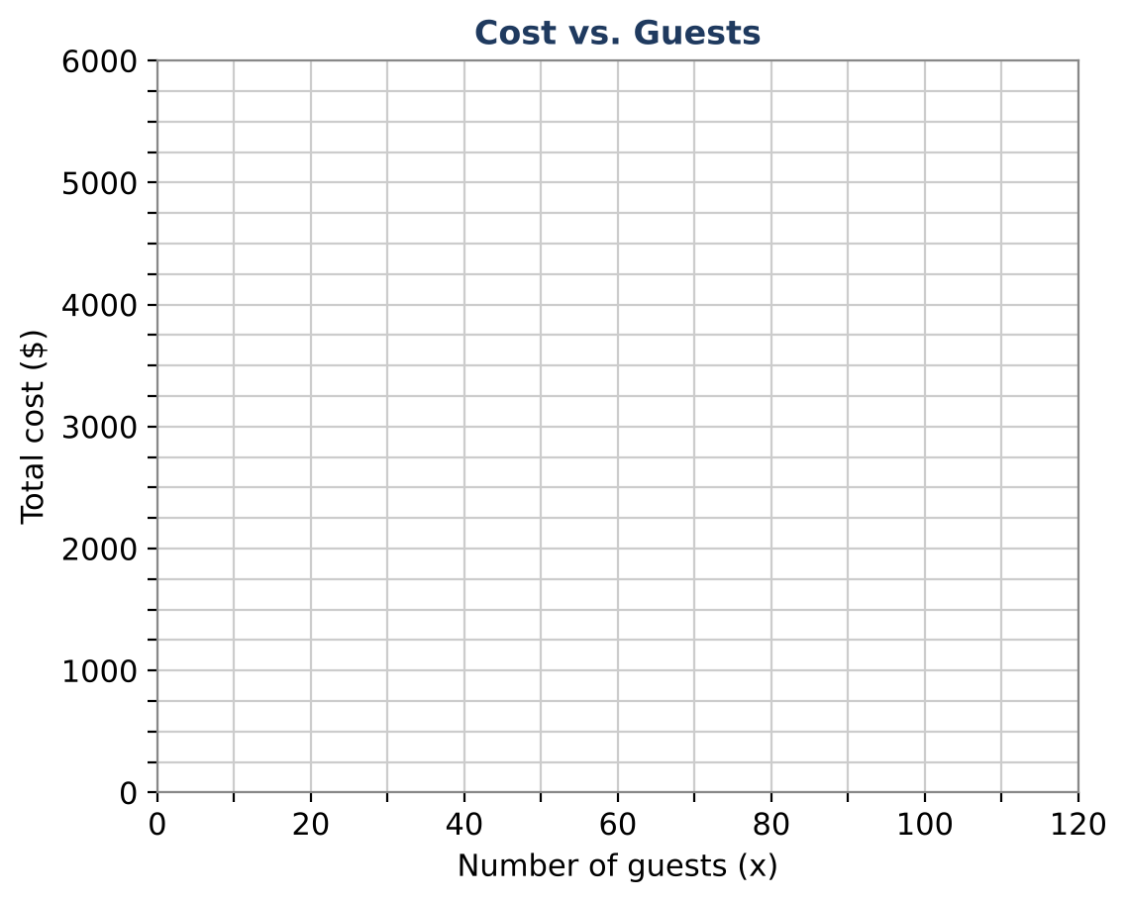

Part 2: Solve It Algebraically
Day 2 · Use substitution to check what the graph shows.
5. Solve the system y = 25x + 1200 and y = 35x + 400 by substitution. Write the solution as an ordered pair.
Starter: Set the two expressions equal: 25x + 1200 = 35x + 400

6. What does the ordered pair mean for the banquet?

7. If 60 guests come, which venue is cheaper and by how much?

8. If 100 guests come, which venue is cheaper and by how much?

Part 3: Pick the DJ & Plan
Day 3 · DJ Max charges $300 plus $2 per guest. DJ Nova charges $150 plus $4.50 per guest.
9. Write an equation for each DJ and solve the system to find when they cost the same.

10. The council expects about 70 guests. Choose a venue and a DJ. Find the total cost.

11. Write a short recommendation to the council using your break-even points.

Final Product: Banquet Proposal
Your final product must include:
- Equations and graph for both venues with the break-even point labeled
- The DJ comparison
- Your choice of venue and DJ for 70 guests with the total cost
- A recommendation to the student council
Reflection
R1. Why is the point where the lines cross called the break-even point?

R2. How would your recommendation change if only 30 guests were coming?

Scoring Rubric
Criteria | 4 – Exceeds | 3 – Meets | 2 – Approaching | 1 – Beginning
Mathematical Accuracy | All calculations and solutions are correct; answers include units and are checked. | Nearly all work is correct; minor errors do not change conclusions. | Several errors; some conclusions are affected. | Many errors or missing work.
Reasoning & Justification | Clear, complete explanations connect every answer to the situation; uses precise vocabulary. | Explanations are mostly clear and connected to the situation. | Explanations are brief or partly unclear. | Little or no explanation.
Application & Design | Recommendation correctly uses the break-even points for the expected number of guests. Goes beyond the minimum with a creative, realistic choice. | Recommendation correctly uses the break-even points for the expected number of guests. | Design is incomplete or only partly uses the math from the unit. | Design is missing or unrelated to the unit math.
Communication & Presentation | Proposal shows equations, a graph with intersections labeled, the break-even analysis, and a clear recommendation. Polished, organized, and visually engaging. | Proposal shows equations, a graph with intersections labeled, the break-even analysis, and a clear recommendation. Organized and easy to follow. | Product is missing required parts or is hard to follow. | Product is mostly missing.

