ALGEBRA 1 · UNIT 6: SYSTEMS OF EQUATIONS AND INEQUALITIES  Banquet Planner  Compare venues with systems of equations and plan the spring banquet. | Honors  2–3 class periods

Name: ________________________________ Date: ______________ Period: ______
The Scenario
The student council is planning the spring banquet, and you are on the planning committee. Three venues want your business, and each one charges in a different way.
The best choice depends on how many guests come. Systems of equations show exactly where one option becomes cheaper than another. Your job is to compare the options and present a recommendation to the council.
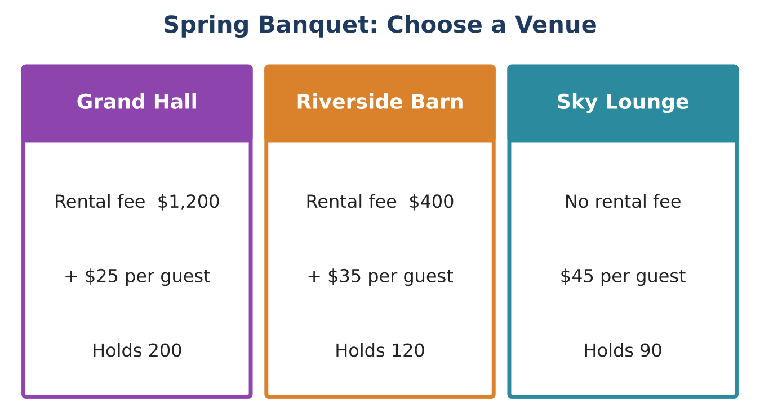
Learning Goals
- I can solve and interpret systems in multiple ways, including systems with parameters.
- I can use systems to set prices and analyze mixed ticket sales.
- I can justify a decision across a range of conditions.
Project Timeline
When | What you will do
Day 1 | Three Venues
Day 2 | Tickets & Revenue
Day 3 | Final Plan
Final | Banquet Proposal + reflection

Part 1: Three Venues
Day 1 · Let x = number of guests and y = total cost.
1. Write all three cost equations and find every break-even point.
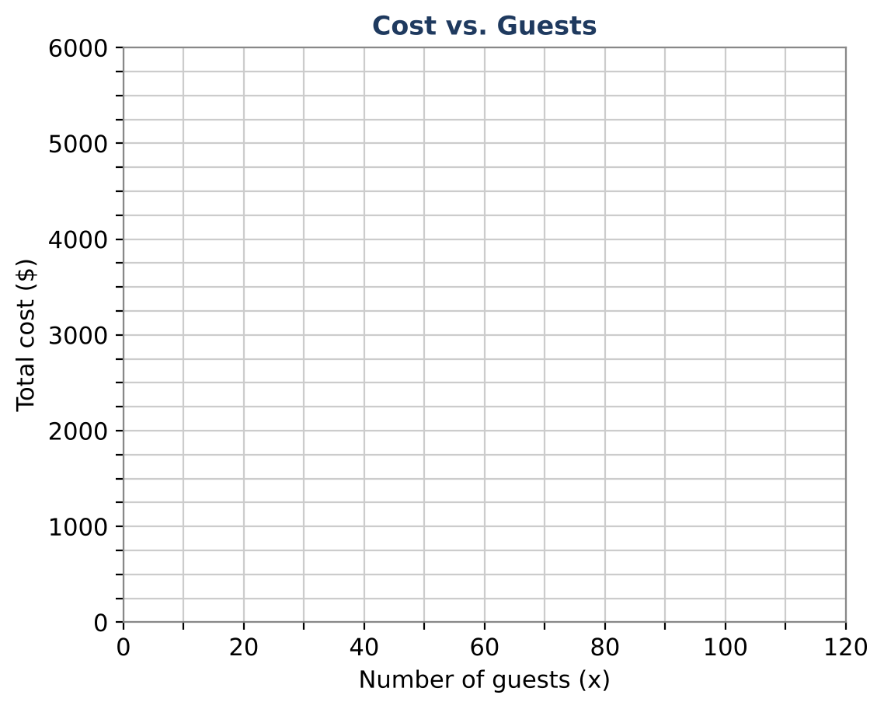

2. Write the cheapest-venue rule as a piecewise description using inequalities on x (include capacity).

3. The Barn offers to lower its rental fee to R dollars. For what value of R would the Barn and the Grand Hall tie at exactly 100 guests?

4. For what per-guest price would the Sky Lounge tie the Grand Hall at 75 guests?

Part 2: Tickets & Revenue
Day 2 · Couple tickets admit 2 people. Single tickets admit 1 person.
5. Couple tickets cost $60 and single tickets cost $35. A total of 150 people attended and ticket sales were $4,750. How many of each ticket were sold?

6. Show that the price per person is lower with a couple ticket. Explain how that affects revenue when more couples buy tickets.

7. Using the Grand Hall and DJ Max ($300 + $2 per guest), write the total cost for x guests. If every guest pays $p, write the revenue. Find the break-even number of guests if p = $40.

8. For a single ticket price p, write the break-even attendance as a function of p. What happens as p gets close to $27?

Part 3: Final Plan
Day 3 · Expected attendance: between 80 and 150 guests.
9. Choose the venue and DJ that minimize cost for this whole range. Justify with your break-even points.

10. Choose couple and single ticket prices so the banquet breaks even if 80 guests come as 25 couples and 30 singles. Show your system or equation.

11. Write a recommendation explaining what happens to profit if 150 guests come instead.

Final Product: Banquet Proposal
Your final product must include:
- All break-even points and the piecewise cheapest-venue rule
- Parameter solutions (rental fee and per-guest price)
- Mixed-ticket system and analysis
- Break-even attendance function
- Final plan with ticket prices and profit analysis
Reflection
R1. How did changing a parameter (like R) move the intersection point on the graph?

R2. Why does the break-even attendance blow up as the ticket price approaches the cost per guest?

Scoring Rubric
Criteria | 4 – Exceeds | 3 – Meets | 2 – Approaching | 1 – Beginning
Mathematical Accuracy | All calculations and solutions are correct; answers include units and are checked. | Nearly all work is correct; minor errors do not change conclusions. | Several errors; some conclusions are affected. | Many errors or missing work.
Reasoning & Justification | Clear, complete explanations connect every answer to the situation; uses precise vocabulary. | Explanations are mostly clear and connected to the situation. | Explanations are brief or partly unclear. | Little or no explanation.
Application & Design | Recommendation correctly uses the break-even points for the expected number of guests. Goes beyond the minimum with a creative, realistic choice. | Recommendation correctly uses the break-even points for the expected number of guests. | Design is incomplete or only partly uses the math from the unit. | Design is missing or unrelated to the unit math.
Communication & Presentation | Proposal shows equations, a graph with intersections labeled, the break-even analysis, and a clear recommendation. Polished, organized, and visually engaging. | Proposal shows equations, a graph with intersections labeled, the break-even analysis, and a clear recommendation. Organized and easy to follow. | Product is missing required parts or is hard to follow. | Product is mostly missing.

