ALGEBRA 1 · UNIT 3: LINEAR INEQUALITIES  Class Trip Planner  Use inequalities to plan a field trip that fits the budget and the rules. | CP1  2–3 class periods

Name: ________________________________ Date: ______________ Period: ______
The Scenario
Your class gets to take an end-of-year trip, but the principal will approve it only if the plan follows every rule and stays within the class budget.
You must figure out how many students can go, how much fundraising is needed, and when the trip can happen. Each rule is a constraint, and each constraint is an inequality.
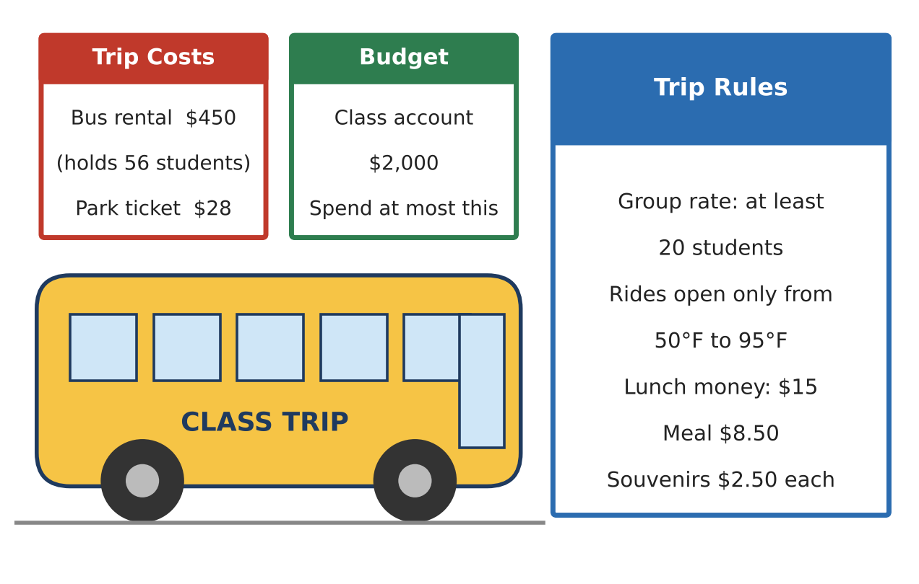
Learning Goals
- I can write and solve multi-step inequalities that model real constraints.
- I can write, solve, and graph compound inequalities using "and" and "or".
- I can decide which constraint limits the plan the most.
Project Timeline
When | What you will do
Day 1 | Budget & Fundraising
Day 2 | Compound Conditions
Day 3 | Plan Your Own Trip
Final | Trip Proposal + reflection

Part 1: Budget & Fundraising
Day 1 · Use the Trip Costs and Budget cards.
1. Write and solve an inequality to find the greatest number of students who can go on a $2,000 budget.

2. The class account actually has only $1,200 right now. The class will sell snacks for $1.50 profit each. How many snacks must be sold so that 45 students can go?

3. Riley solved 2000 − 28n ≥ 450 and wrote: −28n ≥ −1550, so n ≥ 55.36. Explain the mistake and give the correct solution.

4. Show the correct solution for the number of students on the number line.
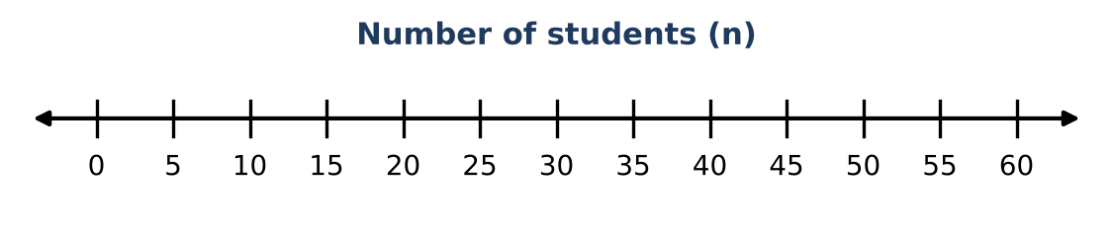

Part 2: Compound Conditions
Day 2 · Use the Trip Rules card.
5. Write a compound inequality for the number of students n that satisfies the group-rate rule, the budget, and the bus size.

6. The weather app shows Celsius. Rides are open when 50 ≤ F ≤ 95, and F = 1.8C + 32. Write and solve a compound inequality to find the Celsius temperatures when rides are open.

7. The trip includes 2 hours of bus travel plus h hours at the park. The bus company adds a fee if the trip is shorter than 4 hours or longer than 10 hours. Write and solve a compound inequality for the values of h that cause a fee. Graph it.

8. Write and solve an inequality for the number of souvenirs a student can buy with $15 if lunch costs $8.50 and souvenirs cost $2.50 each.

Part 3: Plan Your Own Trip
Day 3 · Choose a destination card. Budget: $2,000. Current savings: $1,200. Snacks earn $1.50 profit each.
9. Write and solve an inequality for the greatest number of students who can go. Remember the bus limit.
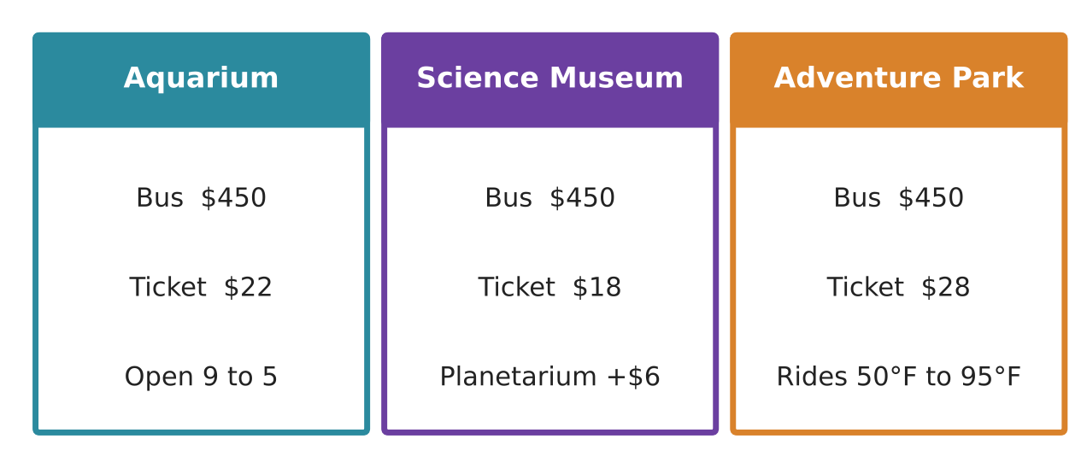

10. Choose a realistic group size. Write and solve an inequality to find how many snacks must be sold to pay for that group.

11. Write at least two more constraints for your trip (time, temperature, lunch, chaperones) as inequalities and solve them. Which constraint limits your plan the most?

Final Product: Trip Proposal
Your final product must include:
- Destination and group size
- Budget and fundraising inequalities, solved and graphed
- At least one 'and' and one 'or' compound inequality
- A statement of which constraint is the most limiting and why
- A persuasive proposal to the principal
Reflection
R1. Explain why the inequality sign flips when you multiply or divide by a negative number. Use a numeric example.

R2. How did you decide whether to round up or round down in each problem?

Scoring Rubric
Criteria | 4 – Exceeds | 3 – Meets | 2 – Approaching | 1 – Beginning
Mathematical Accuracy | All calculations and solutions are correct; answers include units and are checked. | Nearly all work is correct; minor errors do not change conclusions. | Several errors; some conclusions are affected. | Many errors or missing work.
Reasoning & Justification | Clear, complete explanations connect every answer to the situation; uses precise vocabulary. | Explanations are mostly clear and connected to the situation. | Explanations are brief or partly unclear. | Little or no explanation.
Application & Design | Every constraint is written and solved correctly, and the final group size satisfies all of them. Goes beyond the minimum with a creative, realistic choice. | Every constraint is written and solved correctly, and the final group size satisfies all of them. | Design is incomplete or only partly uses the math from the unit. | Design is missing or unrelated to the unit math.
Communication & Presentation | Proposal shows the destination, every constraint as an inequality, graphs, and a final recommendation. Polished, organized, and visually engaging. | Proposal shows the destination, every constraint as an inequality, graphs, and a final recommendation. Organized and easy to follow. | Product is missing required parts or is hard to follow. | Product is mostly missing.

