ALGEBRA 1 · UNIT 3: LINEAR INEQUALITIES  Class Trip Planner  Use inequalities to plan a field trip that fits the budget and the rules. | CP2  2–3 class periods

Name: ________________________________ Date: ______________ Period: ______
The Scenario
Your class gets to take an end-of-year trip, but the principal will approve it only if the plan follows every rule and stays within the class budget.
You must figure out how many students can go, how much fundraising is needed, and when the trip can happen. Each rule is a constraint, and each constraint is an inequality.
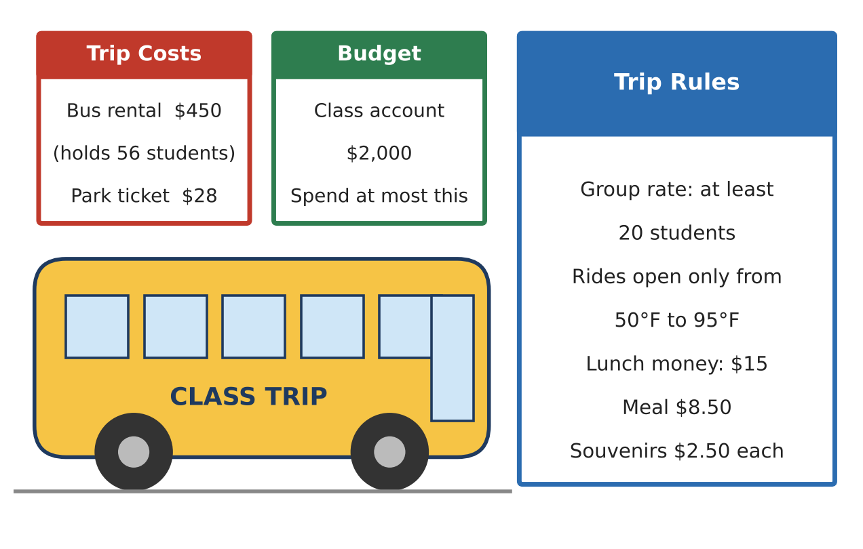
Learning Goals
- I can write an inequality from a real rule.
- I can solve and graph inequalities and explain my answer.
- I can use a compound inequality to describe a range of values.
Project Timeline
When | What you will do
Day 1 | Stay Within the Budget
Day 2 | Follow the Rules
Day 3 | Plan Your Own Trip
Final | Trip Proposal + reflection

Part 1: Stay Within the Budget
Day 1 · Use the Trip Costs and Budget cards.
1. Write an expression for the total cost of the trip if n students go.
Starter: Total cost = bus + ____ · n

2. The class can spend at most $2,000. Write an inequality using your expression.
Starter: "At most" means ≤.

3. Solve your inequality. What is the greatest number of students who can go? Explain why you round down.

4. Show your solution on the number line.
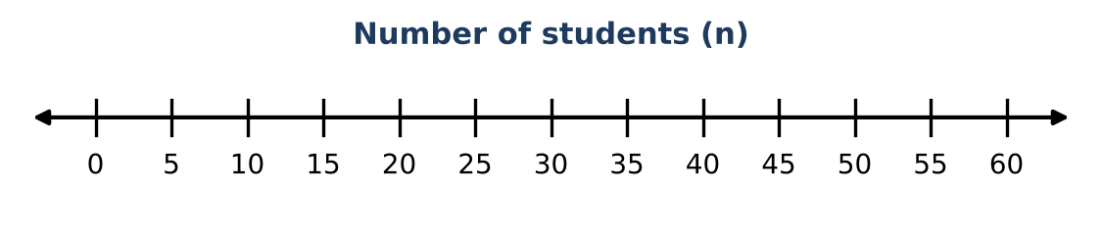
5. Check: find the total cost for 55 students and for 56 students. Which one is over budget?

Part 2: Follow the Rules
Day 2 · Use the Trip Rules card.
6. The group rate needs at least 20 students. Combine this with your budget answer to write a compound inequality for n.
Starter: ___ ≤ n ≤ ___

7. Rides are open only from 50°F to 95°F. Write a compound inequality for the temperature T when rides are open, and graph it.
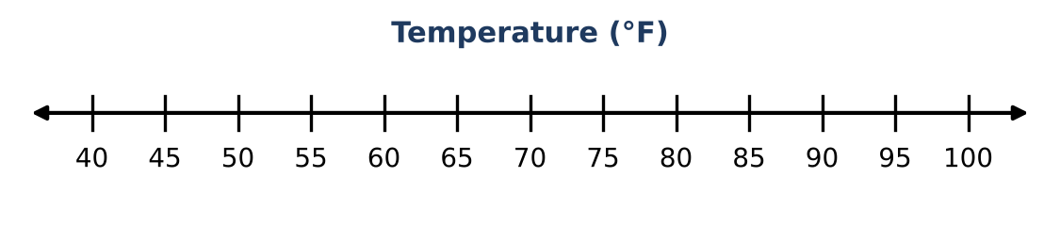

8. Write an inequality for the temperatures when rides are closed.
Starter: T < ___ or T > ___

9. Each student has $15 for lunch. The meal costs $8.50 and souvenirs cost $2.50 each. Write and solve an inequality for the number of souvenirs s a student can buy.

Part 3: Plan Your Own Trip
Day 3 · Choose a destination card. The budget is still $2,000.
10. Which destination did you choose? Write an inequality for the number of students who can go, and solve it.
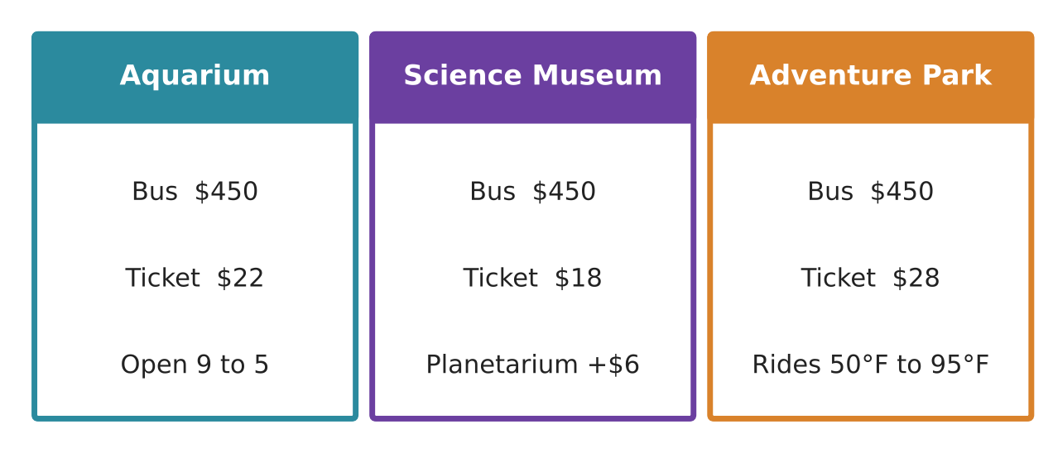

11. Write a compound inequality that includes the group-rate rule (at least 20) and your budget answer.

12. Write 2–3 sentences to the principal explaining why your trip should be approved.

Final Product: Trip Proposal
Your final product must include:
- Destination name and picture
- The budget inequality, solved, with a number line
- The compound inequality for group size
- One more rule (temperature, lunch, or time) written as an inequality
- Your message to the principal
Reflection
R1. Why did we round down for the budget but would round up for a minimum, like "at least 20"?

R2. What is one inequality you see in your own life (phone data, money, time)?

Scoring Rubric
Criteria | 4 – Exceeds | 3 – Meets | 2 – Approaching | 1 – Beginning
Mathematical Accuracy | All calculations and solutions are correct; answers include units and are checked. | Nearly all work is correct; minor errors do not change conclusions. | Several errors; some conclusions are affected. | Many errors or missing work.
Reasoning & Justification | Clear, complete explanations connect every answer to the situation; uses precise vocabulary. | Explanations are mostly clear and connected to the situation. | Explanations are brief or partly unclear. | Little or no explanation.
Application & Design | Every constraint is written and solved correctly, and the final group size satisfies all of them. Goes beyond the minimum with a creative, realistic choice. | Every constraint is written and solved correctly, and the final group size satisfies all of them. | Design is incomplete or only partly uses the math from the unit. | Design is missing or unrelated to the unit math.
Communication & Presentation | Proposal shows the destination, every constraint as an inequality, graphs, and a final recommendation. Polished, organized, and visually engaging. | Proposal shows the destination, every constraint as an inequality, graphs, and a final recommendation. Organized and easy to follow. | Product is missing required parts or is hard to follow. | Product is mostly missing.

