ALGEBRA 1 · UNIT 3: LINEAR INEQUALITIES  Class Trip Planner  Use inequalities to plan a field trip that fits the budget and the rules. | Honors  2–3 class periods

Name: ________________________________ Date: ______________ Period: ______
The Scenario
Your class gets to take an end-of-year trip, but the principal will approve it only if the plan follows every rule and stays within the class budget.
You must figure out how many students can go, how much fundraising is needed, and when the trip can happen. Each rule is a constraint, and each constraint is an inequality.
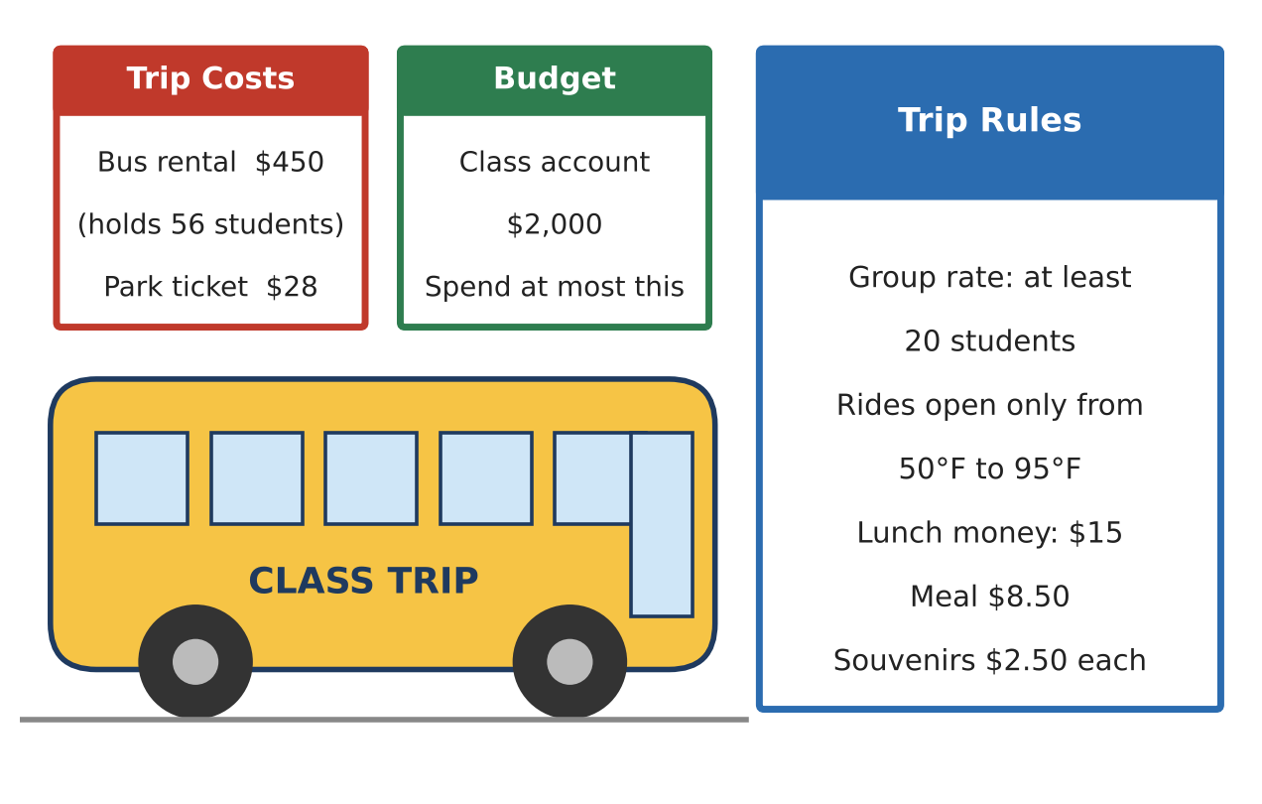
Learning Goals
- I can generalize a constraint into a formula and solve literal inequalities.
- I can use compound and absolute value inequalities to describe ranges.
- I can analyze which constraint is binding when the situation changes.
Project Timeline
When | What you will do
Day 1 | Budget, Buses & Fundraising
Day 2 | Ranges & Absolute Value
Day 3 | Compare & Recommend
Final | Trip Proposal + reflection

Part 1: Budget, Buses & Fundraising
Day 1 · Use the Trip Costs and Budget cards. Each bus holds 56 students and costs $450.
1. Let B = bus cost, p = ticket price, and M = budget. Write an inequality for the number of students n, and solve it for n.

2. Use your formula to find the most students that can go with one bus on a $2,000 budget.

3. The principal offers $3,000 if the whole grade goes, which needs two buses. Write and solve an inequality for n. Then write a compound inequality for the group sizes that need two buses and fit the budget.

4. The class has $1,200 saved and earns $1.50 profit per snack. How many snacks must be sold to take 70 students (two buses)?

Part 2: Ranges & Absolute Value
Day 2 · Use the Trip Rules card.
5. Rides open when 50 ≤ F ≤ 95. Using F = 1.8C + 32, find the open range in Celsius.

6. Write the Fahrenheit range 50 ≤ F ≤ 95 as one absolute value inequality. Explain the meaning of each number.

7. The trip is 2 hours of bus travel plus h hours at the park. A fee is charged if the total is under 4 hours or over 10 hours. Solve for h, then write your answer as a single absolute value inequality.

8. The park gives a 15% ticket discount to groups of 40 or more. With one bus and $2,000, find every group size that is affordable (group rate requires at least 20). Explain which constraint now limits the group.

Part 3: Compare & Recommend
Day 3 · Compare two destination cards for a grade of 110 students, a $3,000 budget, and $1,200 saved.
9. For each of two destinations, write and solve the inequalities for group size and buses needed. Which destinations can take the whole grade?
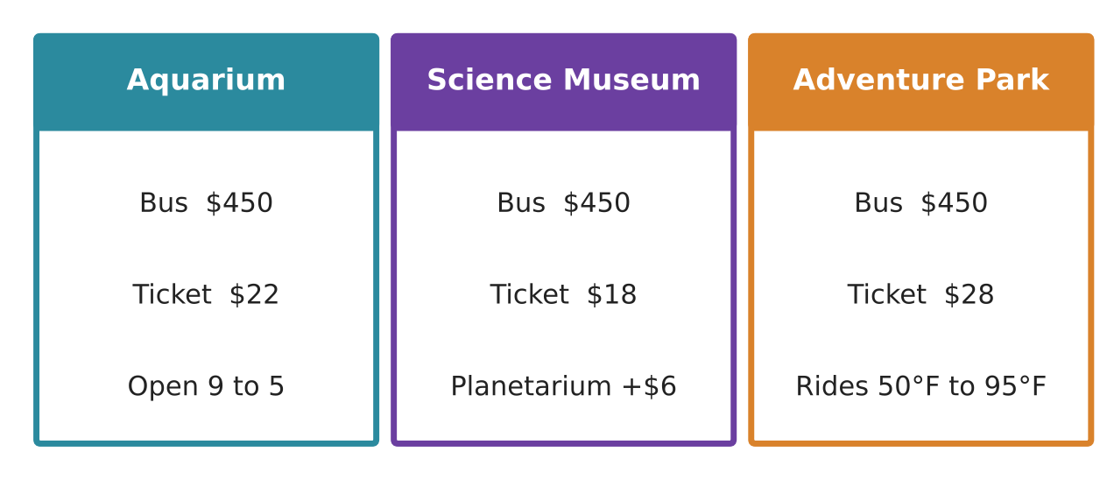

10. For your chosen destination, write the fundraising inequality and find the snacks needed for the largest affordable group.

11. Write a recommendation that names the binding constraint (the one that limits the plan) and explains how the plan would change if that constraint changed.

Final Product: Trip Proposal
Your final product must include:
- General budget formula and solved literal inequality
- Two-bus analysis with a compound inequality
- Absolute value forms of two ranges
- Discount analysis identifying the binding constraint
- Comparison of two destinations and a recommendation
Reflection
R1. How does an absolute value inequality describe a 'distance from a center' in this project?

R2. When the discount was added, the binding constraint changed. Explain what that means for decision makers.

Scoring Rubric
Criteria | 4 – Exceeds | 3 – Meets | 2 – Approaching | 1 – Beginning
Mathematical Accuracy | All calculations and solutions are correct; answers include units and are checked. | Nearly all work is correct; minor errors do not change conclusions. | Several errors; some conclusions are affected. | Many errors or missing work.
Reasoning & Justification | Clear, complete explanations connect every answer to the situation; uses precise vocabulary. | Explanations are mostly clear and connected to the situation. | Explanations are brief or partly unclear. | Little or no explanation.
Application & Design | Every constraint is written and solved correctly, and the final group size satisfies all of them. Goes beyond the minimum with a creative, realistic choice. | Every constraint is written and solved correctly, and the final group size satisfies all of them. | Design is incomplete or only partly uses the math from the unit. | Design is missing or unrelated to the unit math.
Communication & Presentation | Proposal shows the destination, every constraint as an inequality, graphs, and a final recommendation. Polished, organized, and visually engaging. | Proposal shows the destination, every constraint as an inequality, graphs, and a final recommendation. Organized and easy to follow. | Product is missing required parts or is hard to follow. | Product is mostly missing.

