6TH GRADE MATH · UNIT 7: DATA DISPLAYS  Lunch Menu Survey  Survey classmates and use data displays to recommend a new lunch menu. | CP1  2–3 class periods

Name: ________________________________ Date: ______________ Period: ______
The Scenario
The cafeteria wants to add a new lunch and asked the student council for advice. Your team surveyed students about their favorite foods, how long the lunch line takes, and how many items they buy.
You will organize the data with displays, find the center and spread, and recommend a menu that the data supports.
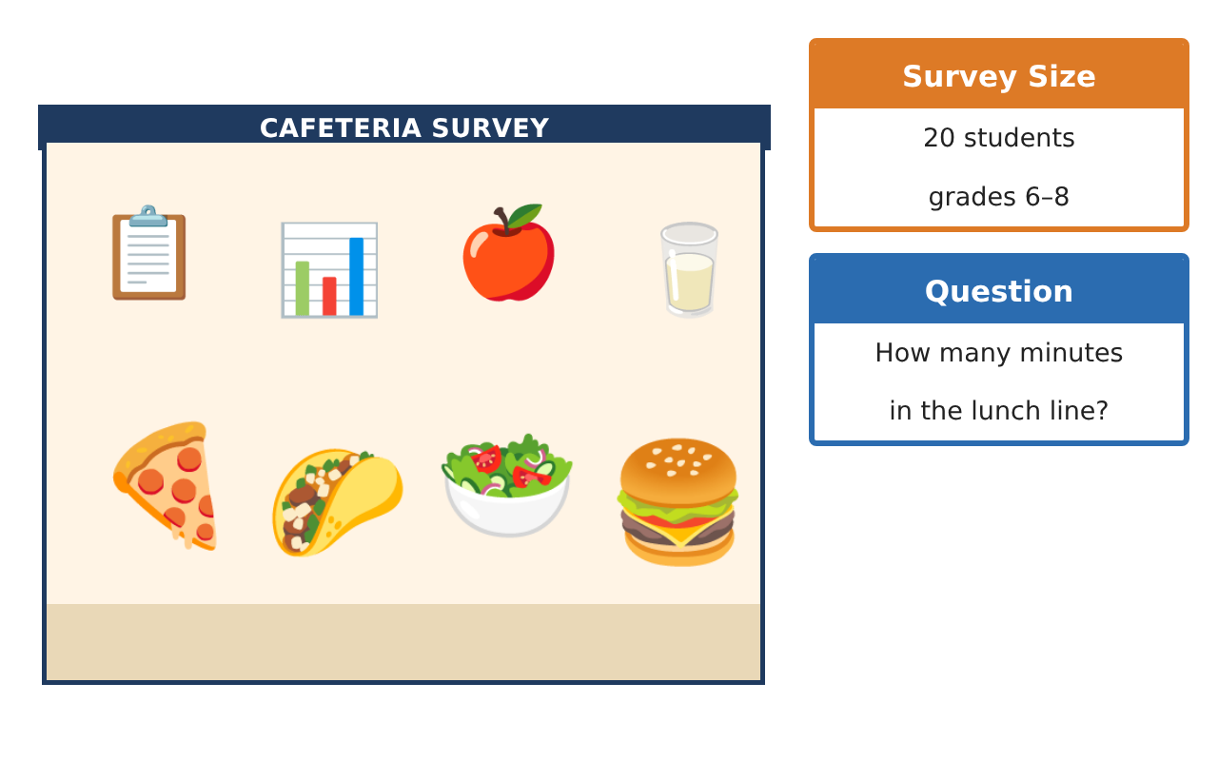
Learning Goals
- I can display numerical data in dot plots, histograms, and box plots.
- I can find and interpret measures of center and variability.
- I can choose the best measure to summarize data.
Project Timeline
When | What you will do
Day 1 | Display the Data
Day 2 | Measure It
Day 3 | Menu Recommendation
Final | Menu Recommendation Report + reflection
Part 1: Display the Data
Day 1 · Use the Survey Data card.
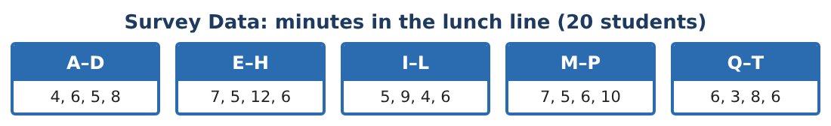
1. Make a dot plot and describe the shape of the data.
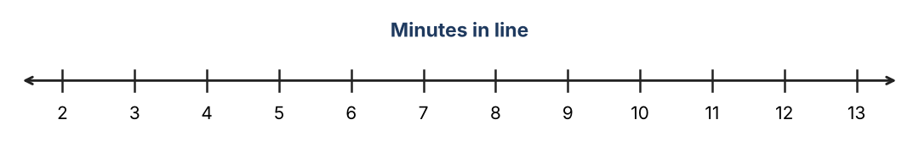

2. Make a histogram with intervals 2–3, 4–5, 6–7, 8–9, 10–11, 12–13.

3. Find the five-number summary.

4. Draw a box plot. Is 12 an outlier by the 1.5 × IQR rule?

Part 2: Measure It
Day 2 · Compare center and spread.
5. Find the mean and median. Which better describes a typical wait? Why?

6. Find the mean absolute deviation (MAD). Round to the nearest tenth.

7. After a second register opened, the times were: 3, 4, 4, 5, 5, 5, 4, 6, 3, 4, 5, 5, 4, 6, 5, 4, 3, 5, 4, 6. Find the new median and IQR.

8. Compare the two data sets in two sentences using center and spread.

Part 3: Menu Recommendation
Day 3 · Favorite-food survey: pizza 7, tacos 5, salad bar 3, burgers 4, other 1.
9. What percent chose each option? Make a display.

10. The cafeteria can serve one new lunch only if at least 20% want it and it does not raise the typical wait above 6 minutes. Which options qualify?

11. Write your recommendation with at least one display and two statistics.

Final Product: Menu Recommendation Report
Your final product must include:
- Dot plot, histogram, and box plot
- Five-number summary, mean, and MAD
- Before-and-after comparison of wait times
- Percent display of favorite foods
- Recommendation with statistics
Reflection
R1. When is the median a better summary than the mean?

R2. What does a small IQR or MAD tell you about the wait times?

Scoring Rubric
Criteria | 4 – Exceeds | 3 – Meets | 2 – Approaching | 1 – Beginning
Mathematical Accuracy | All calculations and solutions are correct; answers include units and are checked. | Nearly all work is correct; minor errors do not change conclusions. | Several errors; some conclusions are affected. | Many errors or missing work.
Reasoning & Justification | Clear, complete explanations connect every answer to the situation; uses precise vocabulary. | Explanations are mostly clear and connected to the situation. | Explanations are brief or partly unclear. | Little or no explanation.
Application & Design | Displays and statistics are correct and are used to support the lunch recommendation. Goes beyond the minimum with a creative, realistic choice. | Displays and statistics are correct and are used to support the lunch recommendation. | Design is incomplete or only partly uses the math from the unit. | Design is missing or unrelated to the unit math.
Communication & Presentation | Report includes displays, statistics, comparison, and a clear recommendation. Polished, organized, and visually engaging. | Report includes displays, statistics, comparison, and a clear recommendation. Organized and easy to follow. | Product is missing required parts or is hard to follow. | Product is mostly missing.

