6TH GRADE MATH · UNIT 7: DATA DISPLAYS  Lunch Menu Survey  Survey classmates and use data displays to recommend a new lunch menu. | CP2  2–3 class periods

Name: ________________________________ Date: ______________ Period: ______
The Scenario
The cafeteria wants to add a new lunch and asked the student council for advice. Your team surveyed students about their favorite foods, how long the lunch line takes, and how many items they buy.
You will organize the data with displays, find the center and spread, and recommend a menu that the data supports.
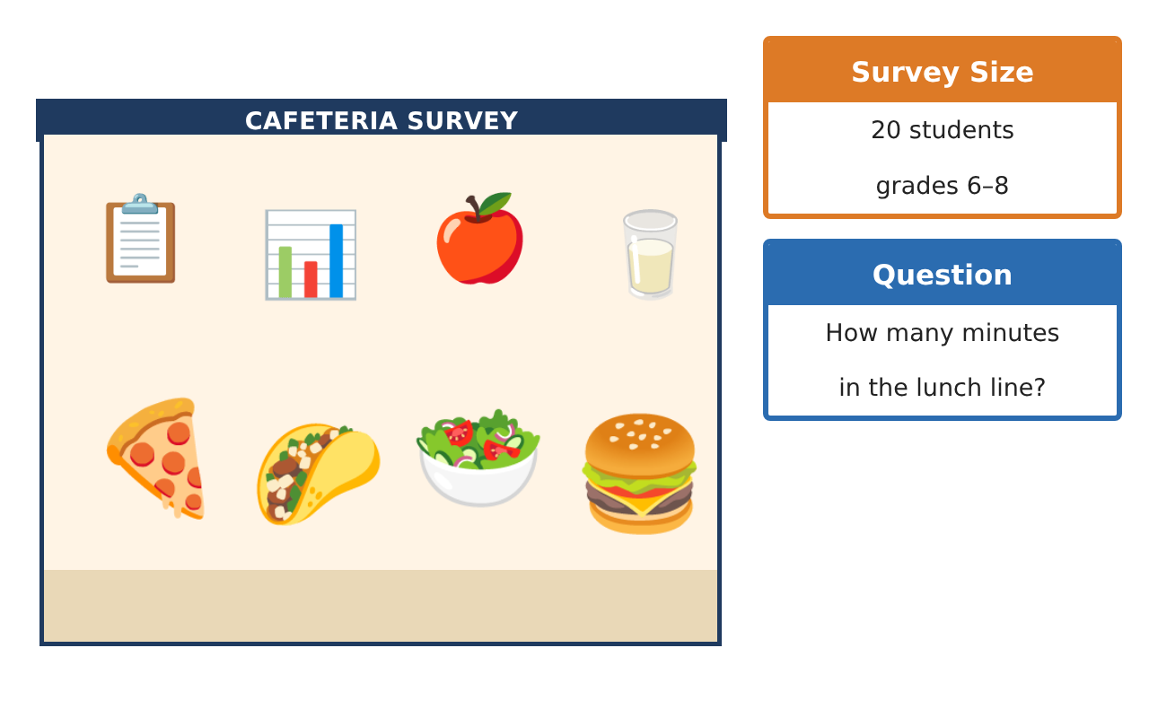
Learning Goals
- I can tell a statistical question from a regular question.
- I can make a dot plot and a frequency table.
- I can find the mean, median, mode, and range.
Project Timeline
When | What you will do
Day 1 | Ask the Question
Day 2 | Center and Spread
Day 3 | Recommend a Menu
Final | Menu Recommendation Report + reflection
Part 1: Ask the Question
Day 1 · Use the Survey Data card.
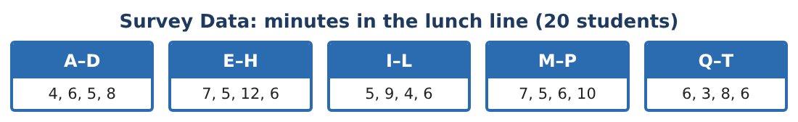
1. Which is a statistical question: "How long did you wait in line today?" or "How long do students wait in the lunch line?" Explain.

2. Make a frequency table for the 20 wait times.

3. Make a dot plot of the wait times.
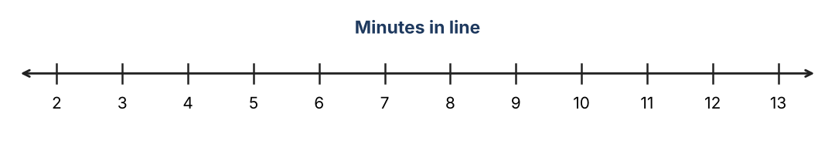

4. What is the mode? What does it tell you?

Part 2: Center and Spread
Day 2 · Use your dot plot.
5. Find the median wait time.
Starter: Put the 20 numbers in order. The median is between the 10th and 11th numbers.

6. Find the mean wait time.

7. Find the range.

8. Which value is an outlier? How does it change the mean?

Part 3: Recommend a Menu
Day 3 · The favorite-food survey: pizza 7, tacos 5, salad bar 3, burgers 4, other 1.
9. Make a bar graph of the favorite foods.

10. What fraction of students chose tacos? What percent?

11. Which new lunch would you recommend? Use two facts from the data.

Final Product: Menu Recommendation Report
Your final product must include:
- Your statistical question
- Frequency table and dot plot
- Mean, median, mode, and range
- Bar graph of favorite foods
- Your menu recommendation with two data facts
Reflection
R1. Why did the outlier change the mean more than the median?

R2. What makes a question statistical?

Scoring Rubric
Criteria | 4 – Exceeds | 3 – Meets | 2 – Approaching | 1 – Beginning
Mathematical Accuracy | All calculations and solutions are correct; answers include units and are checked. | Nearly all work is correct; minor errors do not change conclusions. | Several errors; some conclusions are affected. | Many errors or missing work.
Reasoning & Justification | Clear, complete explanations connect every answer to the situation; uses precise vocabulary. | Explanations are mostly clear and connected to the situation. | Explanations are brief or partly unclear. | Little or no explanation.
Application & Design | Displays and statistics are correct and are used to support the lunch recommendation. Goes beyond the minimum with a creative, realistic choice. | Displays and statistics are correct and are used to support the lunch recommendation. | Design is incomplete or only partly uses the math from the unit. | Design is missing or unrelated to the unit math.
Communication & Presentation | Report includes displays, statistics, comparison, and a clear recommendation. Polished, organized, and visually engaging. | Report includes displays, statistics, comparison, and a clear recommendation. Organized and easy to follow. | Product is missing required parts or is hard to follow. | Product is mostly missing.

