6TH GRADE MATH · UNIT 2: OPERATIONS OF FRACTIONS AND DECIMALS  Quilt Shop Makers  Measure, cut, and price fabric to sew a class quilt. | CP1  2–3 class periods

Name: ________________________________ Date: ______________ Period: ______
The Scenario
The art club is sewing a quilt to sell at the school auction. Fabric is sold by the yard in fractions of a yard, squares must be cut to exact sizes, and every material has a price in dollars and cents.
You will use fraction and decimal operations to plan the cutting, figure out how much fabric to buy, and find the total cost of your quilt.
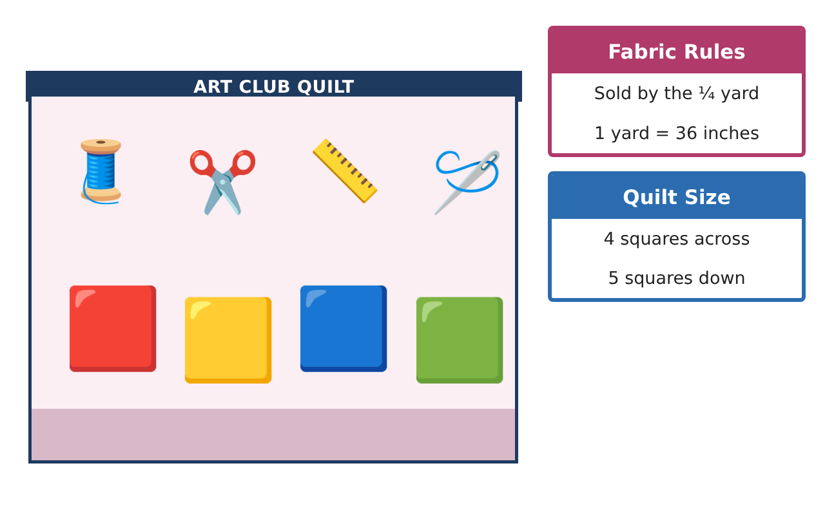
Learning Goals
- I can add and subtract mixed numbers with unlike denominators.
- I can multiply and divide fractions and mixed numbers to plan cuts.
- I can compute with decimals to find costs and change.
Project Timeline
When | What you will do
Day 1 | Fabric Math
Day 2 | Cutting Plan
Day 3 | Cost & Change
Final | Quilt Plan & Price Sheet + reflection
Part 1: Fabric Math
Day 1 · Fabric is sold in quarter yards. 1 yard = 36 inches.
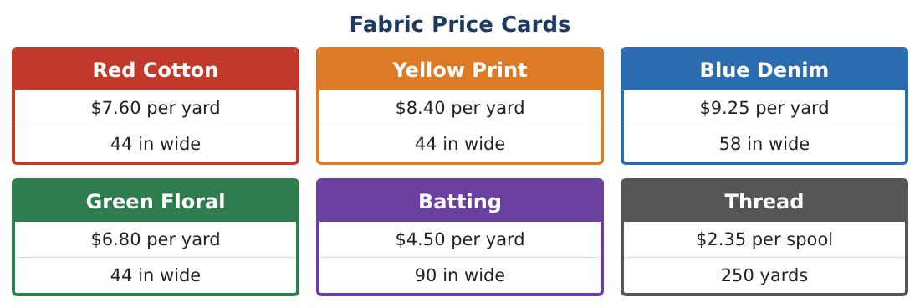
1. You need 1$\frac{2}{3}$ yards of red and 2$\frac{3}{4}$ yards of blue. How much fabric is that in all? What is the smallest amount you can buy if fabric is sold by the $\frac{1}{4}$ yard?

2. A $\frac{7}{8}$ yard strip is cut into a $\frac{1}{3}$ yard piece and the rest. How long is the rest, in yards and in inches?

3. Write $\frac{5}{8}$ yard, 0.6 yard, and $\frac{2}{3}$ yard in order from least to greatest.

4. How many inches is 2$\frac{3}{8}$ yards?

Part 2: Cutting Plan
Day 2 · Each finished square is 6 inches, but you cut 6$\frac{1}{2}$ inches to allow for seams.
5. How many 6$\frac{1}{2}$-inch squares fit across a 44-inch width of fabric? How much is left over?

6. A strip 6$\frac{1}{2}$ inches tall gives 6 squares. How many strips (and how many yards of fabric) do you need for 20 squares?

7. The finished quilt is 4 squares across and 5 down. What are its finished length and width in feet? (12 inches = 1 foot)

8. $\frac{2}{5}$ of the squares are blue and $\frac{1}{4}$ are yellow. How many squares is each? What fraction is left for other colors?

Part 3: Cost & Change
Day 3 · Use the Fabric Price Cards. The art club has $60.
9. Find the cost of $\frac{3}{4}$ yard red, $\frac{3}{4}$ yard yellow, 1$\frac{1}{4}$ yards blue, and 1 yard batting.

10. Add 2 spools of thread. How much change is left from $60?

11. Design your own quilt (at least 3 colors). Find the yards to buy (in quarter yards) and the total cost, and show it is under $60.

Final Product: Quilt Plan & Price Sheet
Your final product must include:
- Quilt diagram with the fraction of each color
- Cutting plan with strips and leftover fabric
- Shopping list in quarter yards
- Price sheet with total and change
- Explanation of one rounding decision
Reflection
R1. Why do you round fabric amounts UP to the next quarter yard?

R2. Explain how you knew whether to multiply or divide in the cutting plan.

Scoring Rubric
Criteria | 4 – Exceeds | 3 – Meets | 2 – Approaching | 1 – Beginning
Mathematical Accuracy | All calculations and solutions are correct; answers include units and are checked. | Nearly all work is correct; minor errors do not change conclusions. | Several errors; some conclusions are affected. | Many errors or missing work.
Reasoning & Justification | Clear, complete explanations connect every answer to the situation; uses precise vocabulary. | Explanations are mostly clear and connected to the situation. | Explanations are brief or partly unclear. | Little or no explanation.
Application & Design | Fabric amounts, cuts, and costs are computed with correct fraction and decimal operations and match the quilt design. Goes beyond the minimum with a creative, realistic choice. | Fabric amounts, cuts, and costs are computed with correct fraction and decimal operations and match the quilt design. | Design is incomplete or only partly uses the math from the unit. | Design is missing or unrelated to the unit math.
Communication & Presentation | Quilt plan shows the diagram, fabric amounts, cutting plan, and price sheet. Polished, organized, and visually engaging. | Quilt plan shows the diagram, fabric amounts, cutting plan, and price sheet. Organized and easy to follow. | Product is missing required parts or is hard to follow. | Product is mostly missing.

