6TH GRADE MATH · UNIT 2: OPERATIONS OF FRACTIONS AND DECIMALS  Quilt Shop Makers  Measure, cut, and price fabric to sew a class quilt. | Honors  2–3 class periods

Name: ________________________________ Date: ______________ Period: ______
The Scenario
The art club is sewing a quilt to sell at the school auction. Fabric is sold by the yard in fractions of a yard, squares must be cut to exact sizes, and every material has a price in dollars and cents.
You will use fraction and decimal operations to plan the cutting, figure out how much fabric to buy, and find the total cost of your quilt.
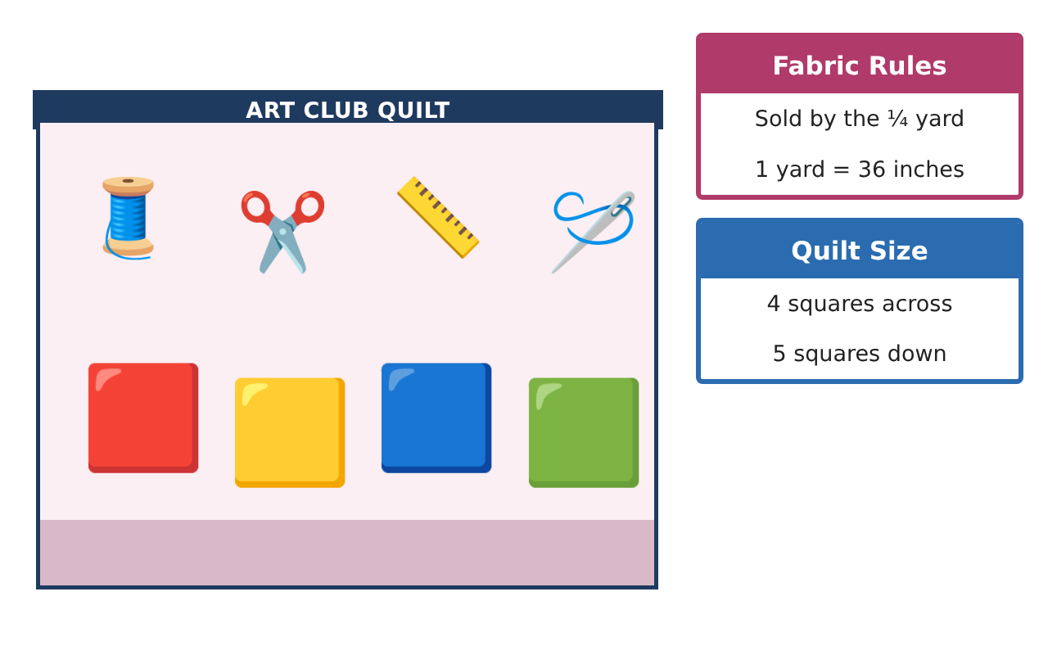
Learning Goals
- I can solve multi-step problems with mixed numbers and decimals.
- I can use division of fractions to plan efficient cuts and minimize waste.
- I can compare costs and justify a design within a budget.
Project Timeline
When | What you will do
Day 1 | Yardage
Day 2 | Efficient Cutting
Day 3 | Budget Design
Final | Quilt Plan & Price Sheet + reflection
Part 1: Yardage
Day 1 · Fabric is sold in eighths of a yard. 1 yard = 36 inches.
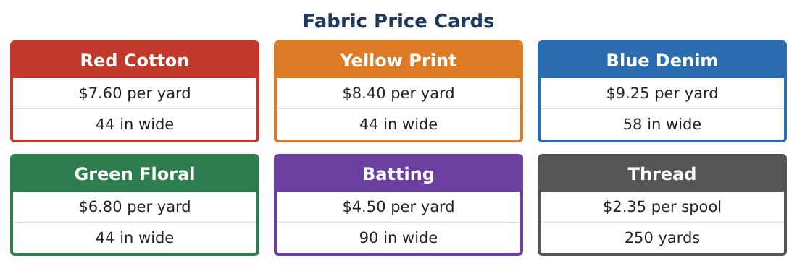
1. A pattern needs 1$\frac{5}{6}$ yd of red, 2$\frac{3}{8}$ yd of blue, and $\frac{11}{12}$ yd of yellow. Find the total and the least amount you must buy if fabric is sold by the $\frac{1}{8}$ yard (each color separately).

2. How much fabric (in inches) is wasted by rounding each color up?

3. A $\frac{5}{6}$ yd strip is cut into pieces of $\frac{5}{36}$ yd. How many pieces, and how many inches long is each?

4. Is $\frac{7}{12}$ yd more or less than 0.58 yd? By how many inches?

Part 2: Efficient Cutting
Day 2 · Squares are cut 6$\frac{1}{2}$ in. Fabric is 44 in wide, denim is 58 in wide.
5. How many squares fit across each width, and what percent of the width is wasted on each?

6. For 30 squares, compare the inches of fabric length needed from cotton and from denim.

7. Using the Price Cards, which fabric costs less per square for 30 squares if you must buy in eighths of a yard?

8. A triangle piece is half of a square cut on the diagonal. How many triangles come from $\frac{3}{4}$ yard of 44-inch cotton?

Part 3: Budget Design
Day 3 · The art club has $75. The quilt must have 30 squares in at least 3 fabrics, plus batting (1$\frac{1}{2}$ yd) and 2 spools of thread.
9. What is the fixed cost of batting and thread? How much is left for fabric?

10. Design your quilt: give the fraction of squares in each fabric, the yardage to buy (in eighths), the cost of each, and the total.

11. The auction sells the quilt for 3$\frac{1}{2}$ times the material cost. What is the expected profit for your design?

Final Product: Quilt Plan & Price Sheet
Your final product must include:
- Scaled quilt diagram with the fraction for each fabric
- Cutting plan comparing widths and waste
- Shopping list in eighths of a yard with costs
- Total cost within $75 and expected auction profit
- Justification of your fabric choices
Reflection
R1. When can rounding up fabric amounts cost more than the extra fabric is worth? How would you reduce waste?

R2. Explain why a wider, more expensive fabric can be cheaper per square.

Scoring Rubric
Criteria | 4 – Exceeds | 3 – Meets | 2 – Approaching | 1 – Beginning
Mathematical Accuracy | All calculations and solutions are correct; answers include units and are checked. | Nearly all work is correct; minor errors do not change conclusions. | Several errors; some conclusions are affected. | Many errors or missing work.
Reasoning & Justification | Clear, complete explanations connect every answer to the situation; uses precise vocabulary. | Explanations are mostly clear and connected to the situation. | Explanations are brief or partly unclear. | Little or no explanation.
Application & Design | Fabric amounts, cuts, and costs are computed with correct fraction and decimal operations and match the quilt design. Goes beyond the minimum with a creative, realistic choice. | Fabric amounts, cuts, and costs are computed with correct fraction and decimal operations and match the quilt design. | Design is incomplete or only partly uses the math from the unit. | Design is missing or unrelated to the unit math.
Communication & Presentation | Quilt plan shows the diagram, fabric amounts, cutting plan, and price sheet. Polished, organized, and visually engaging. | Quilt plan shows the diagram, fabric amounts, cutting plan, and price sheet. Organized and easy to follow. | Product is missing required parts or is hard to follow. | Product is mostly missing.

