6TH GRADE MATH · UNIT 5: INEQUALITIES  Theme Park Rules  Use inequalities to check ride rules, budgets, and wait times at a theme park. | CP2  2–3 class periods

Name: ________________________________ Date: ______________ Period: ______
The Scenario
Your class is visiting Thunder Valley Theme Park. Every ride has a rule: you must be at least a certain height, some rides have weight or age limits, and your group has a budget for food and games.
You will write, solve, and graph inequalities to decide who can ride what and to plan the best day possible.
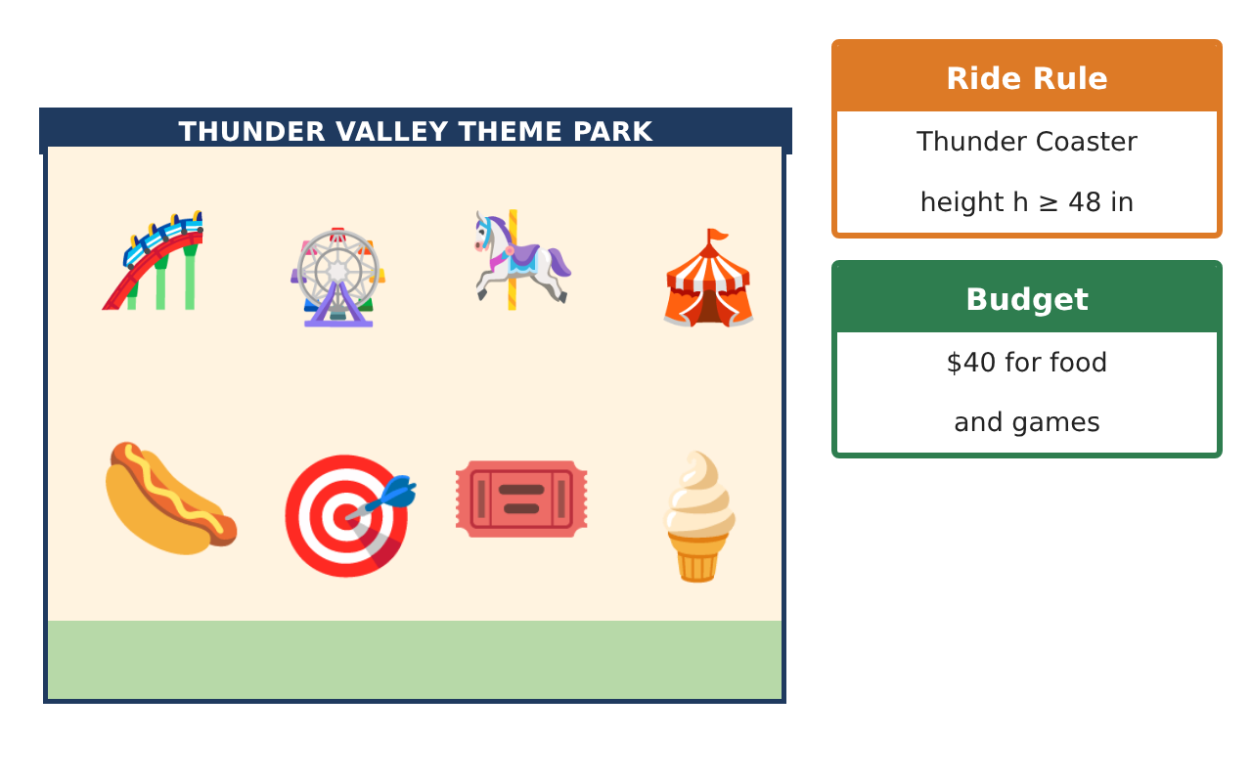
Learning Goals
- I can write an inequality for a rule.
- I can graph an inequality on a number line.
- I can solve one-step inequalities.
Project Timeline
When | What you will do
Day 1 | Ride Rules
Day 2 | Budget Check
Day 3 | Plan Your Day
Final | Theme Park Day Plan + reflection
Part 1: Ride Rules
Day 1 · Use the Ride Rule Cards. Let h be height in inches.
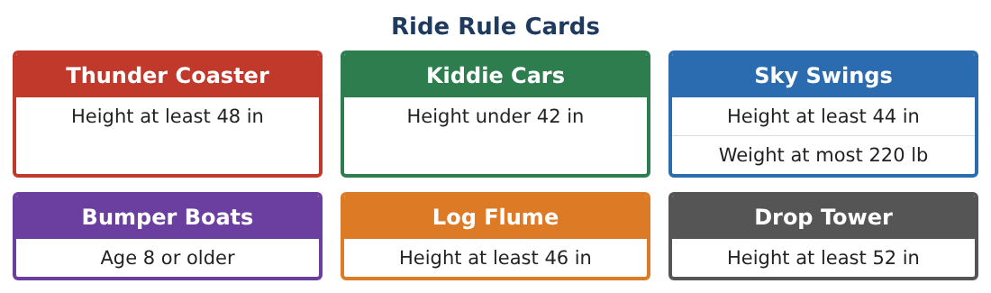
1. Write an inequality for the Thunder Coaster rule.
Starter: h ___ 48

2. Graph the Thunder Coaster rule on a number line. Use a closed circle or an open circle?
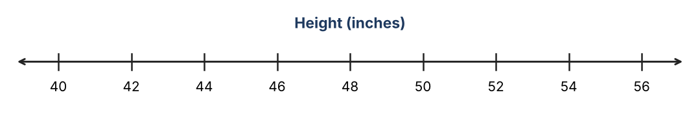

3. Write and graph the Kiddie Cars rule.

4. Maya is 47 inches tall. Which rides can she go on?

Part 2: Budget Check
Day 2 · Write an inequality and solve it.
5. Game tickets cost $3 each. You can spend at most $24. How many tickets t can you buy?
Starter: 3t ≤ 24, so t ≤ ___

6. You have $40. After lunch you have to keep at least $15. Lunch costs x dollars. Write an inequality.

7. A ride takes 5 minutes. You have 45 minutes. How many times r can you ride?

8. Is 10 a solution of 3t ≤ 24? Explain.

Part 3: Plan Your Day
Day 3 · Plan a day for your group.
9. Pick three rides. List the height rule for each and say who in a group of heights 43, 46, 49, and 53 inches can ride.

10. Write an inequality for how much you can spend on snacks if snacks cost $4 each and your snack budget is $16.

11. Make a schedule for your day. Show that your total time on rides is at most 3 hours (180 minutes).

Final Product: Theme Park Day Plan
Your final product must include:
- Each ride rule as an inequality and a graph
- Which riders can go on each ride
- Your budget inequality and solution
- Your day schedule
- A poster of your favorite ride rule
Reflection
R1. When do you use a closed circle, and when do you use an open circle?

R2. Why does an inequality have many solutions?

Scoring Rubric
Criteria | 4 – Exceeds | 3 – Meets | 2 – Approaching | 1 – Beginning
Mathematical Accuracy | All calculations and solutions are correct; answers include units and are checked. | Nearly all work is correct; minor errors do not change conclusions. | Several errors; some conclusions are affected. | Many errors or missing work.
Reasoning & Justification | Clear, complete explanations connect every answer to the situation; uses precise vocabulary. | Explanations are mostly clear and connected to the situation. | Explanations are brief or partly unclear. | Little or no explanation.
Application & Design | Ride rules, budgets, and times are written, solved, and graphed as inequalities and used to make decisions. Goes beyond the minimum with a creative, realistic choice. | Ride rules, budgets, and times are written, solved, and graphed as inequalities and used to make decisions. | Design is incomplete or only partly uses the math from the unit. | Design is missing or unrelated to the unit math.
Communication & Presentation | Day plan includes rules, graphs, solved inequalities, and a schedule. Polished, organized, and visually engaging. | Day plan includes rules, graphs, solved inequalities, and a schedule. Organized and easy to follow. | Product is missing required parts or is hard to follow. | Product is mostly missing.

