6TH GRADE MATH · UNIT 3: RATIONAL NUMBERS  Weather Station Watch  Track below-zero temperatures, elevations, and locations with rational numbers. | CP1  2–3 class periods

Name: ________________________________ Date: ______________ Period: ______
The Scenario
Your class runs the school weather station for the winter. Temperatures drop below zero, nearby stations sit above and below sea level, and the storm tracker shows every station on a coordinate map.
You will use positive and negative numbers, absolute value, and the coordinate plane to report the weather to the school.
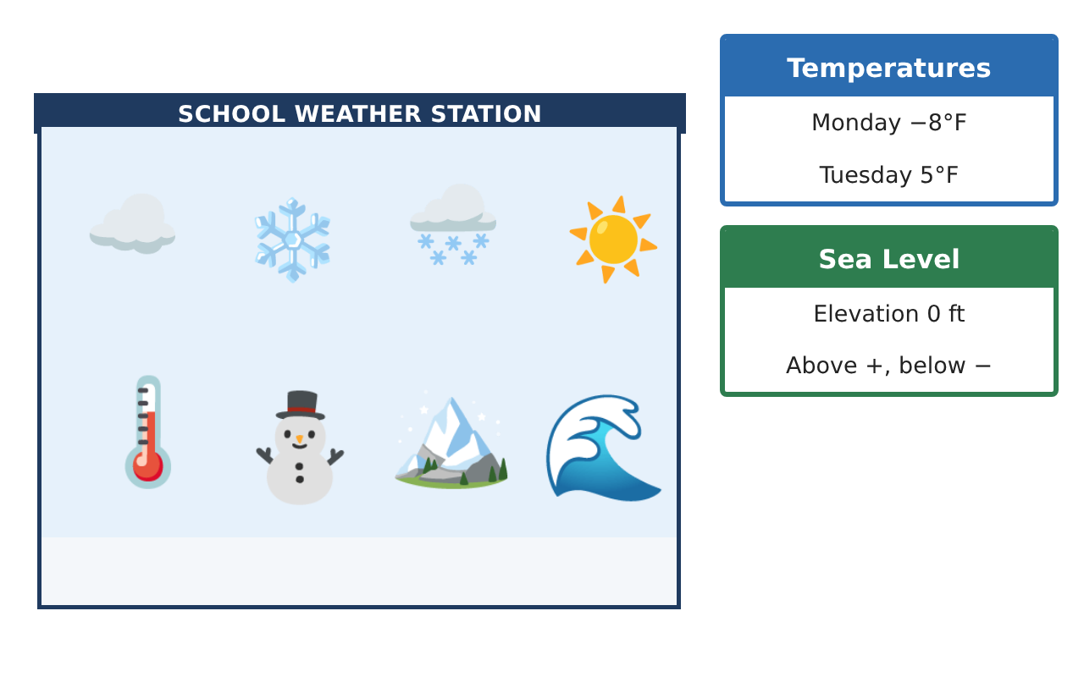
Learning Goals
- I can compare, order, and interpret rational numbers in context.
- I can use absolute value to find distances and changes.
- I can find distances between points with the same x- or y-coordinate.
Project Timeline
When | What you will do
Day 1 | Temperature Log
Day 2 | Elevation & Change
Day 3 | Storm Tracker
Final | Weather Station Report + reflection
Part 1: Temperature Log
Day 1 · This week the School station recorded −3.5, 2.25, −$\frac{3}{4}$, 0, −5.5, and 1$\frac{1}{2}$ degrees Fahrenheit.
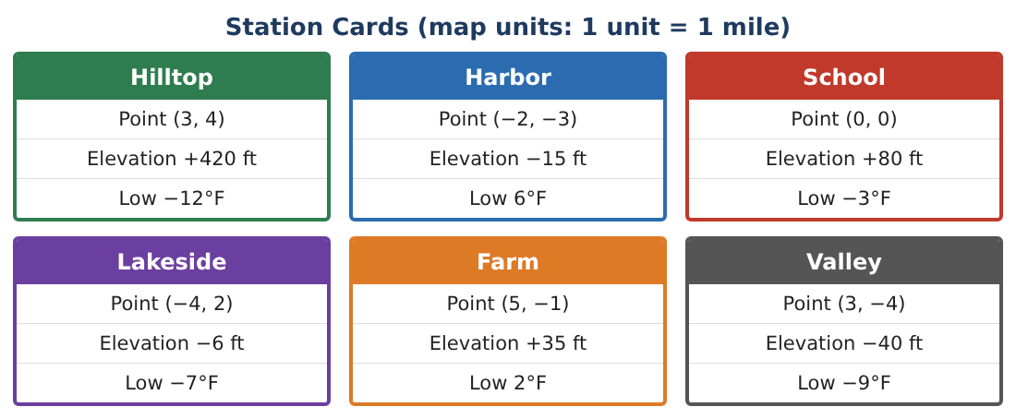
1. Order the readings from least to greatest.

2. Which reading is closest to 0? Which is farthest? Use absolute value.

3. Write an inequality that compares −3.5 and −$\frac{3}{4}$, and explain it in words.

4. How many degrees warmer was the warmest reading than the coldest?

Part 2: Elevation & Change
Day 2 · Use the Station Cards.
5. Order the stations by elevation from lowest to highest.

6. How many feet higher is Hilltop than Valley?

7. A weather balloon starts at Harbor and rises 115 ft. What is its elevation? Is it above or below School?

8. Explain why "Lakeside is at −6 ft" and "Lakeside is 6 ft below sea level" mean the same thing.

Part 3: Storm Tracker
Day 3 · A storm moves across the station map. 1 unit = 1 mile.
9. Plot the stations. Find the distance from Hilltop (3, 4) to Valley (3, −4). Why can you NOT find the distance from Lakeside (−4, 2) to Hilltop by counting along one grid line?
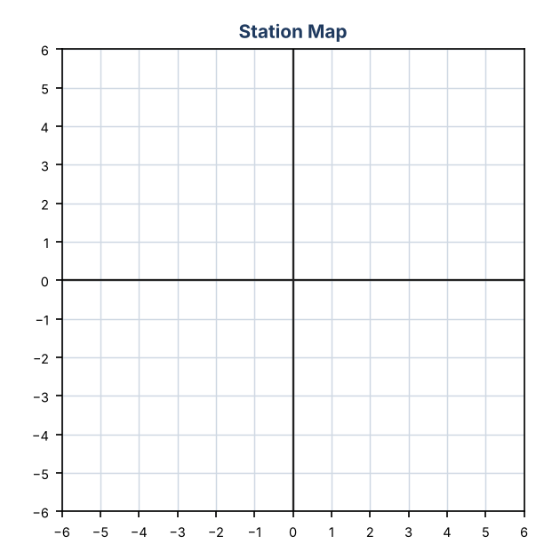

10. The storm starts at (−5, 2), moves 9 miles east, then 6 miles south. Where does it end? Which station is it closest to?

11. Reflect Farm (5, −1) across the x-axis and across the y-axis. Name the new points and their quadrants.

Final Product: Weather Station Report
Your final product must include:
- Station map with the storm path
- Ordered temperature and elevation lists
- Three distance or change calculations using absolute value
- A forecast: which station gets the storm and why
- A clear weather report for families
Reflection
R1. How is finding a change in temperature like finding a distance on a number line?

R2. Why can you count units to find distance only when two points share a coordinate?

Scoring Rubric
Criteria | 4 – Exceeds | 3 – Meets | 2 – Approaching | 1 – Beginning
Mathematical Accuracy | All calculations and solutions are correct; answers include units and are checked. | Nearly all work is correct; minor errors do not change conclusions. | Several errors; some conclusions are affected. | Many errors or missing work.
Reasoning & Justification | Clear, complete explanations connect every answer to the situation; uses precise vocabulary. | Explanations are mostly clear and connected to the situation. | Explanations are brief or partly unclear. | Little or no explanation.
Application & Design | Temperatures, elevations, and stations are ordered, compared, and mapped correctly with absolute value used for distances. Goes beyond the minimum with a creative, realistic choice. | Temperatures, elevations, and stations are ordered, compared, and mapped correctly with absolute value used for distances. | Design is incomplete or only partly uses the math from the unit. | Design is missing or unrelated to the unit math.
Communication & Presentation | Report includes the station map, ordered data, distance calculations, and a forecast. Polished, organized, and visually engaging. | Report includes the station map, ordered data, distance calculations, and a forecast. Organized and easy to follow. | Product is missing required parts or is hard to follow. | Product is mostly missing.

