6TH GRADE MATH · UNIT 3: RATIONAL NUMBERS  Weather Station Watch  Track below-zero temperatures, elevations, and locations with rational numbers. | CP2  2–3 class periods

Name: ________________________________ Date: ______________ Period: ______
The Scenario
Your class runs the school weather station for the winter. Temperatures drop below zero, nearby stations sit above and below sea level, and the storm tracker shows every station on a coordinate map.
You will use positive and negative numbers, absolute value, and the coordinate plane to report the weather to the school.
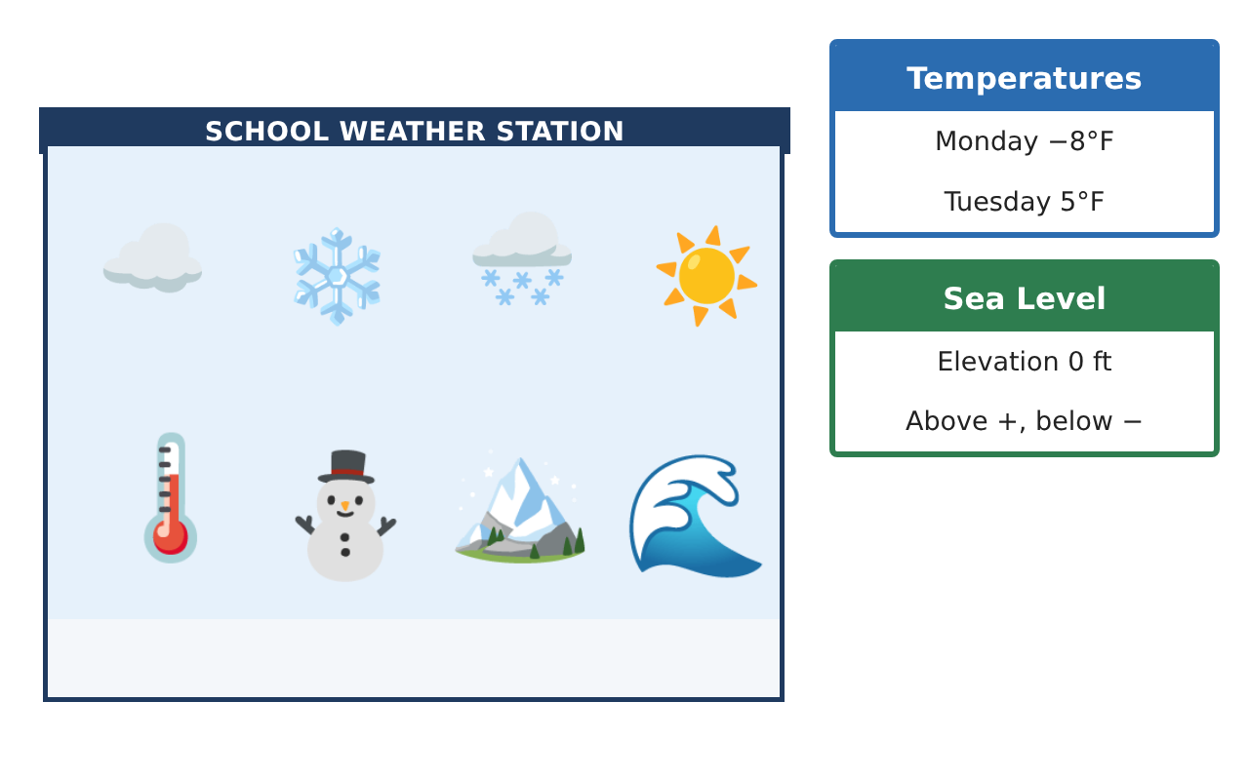
Learning Goals
- I can use positive and negative numbers to describe temperatures and elevations.
- I can compare and order rational numbers on a number line.
- I can plot points in all four quadrants.
Project Timeline
When | What you will do
Day 1 | Read the Weather
Day 2 | Distance from Zero
Day 3 | Map the Stations
Final | Weather Station Report + reflection
Part 1: Read the Weather
Day 1 · Use the Station Cards.
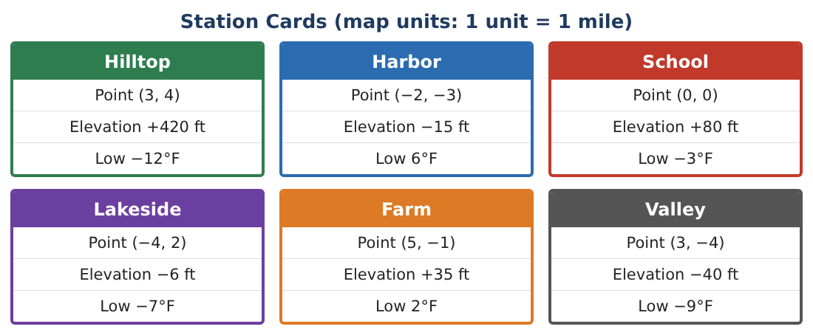
1. Write the low temperature of each station. Which station was coldest?

2. Order the six low temperatures from least to greatest.
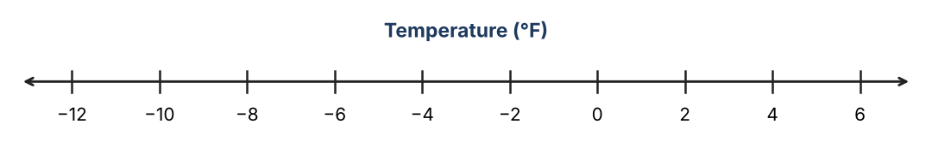

3. Which stations are below sea level? How do you know?

4. What is the opposite of −7? Of 6?

Part 2: Distance from Zero
Day 2 · Absolute value is the distance from 0.
5. Find |−12|, |6|, and |−40|.
Starter: |−12| = ___ because −12 is ___ units from 0.

6. Which station is farthest from sea level, up or down?

7. Valley is at −40 ft and Harbor is at −15 ft. Which is lower? How many feet apart are they?

8. The temperature went from −3°F to 5°F. How many degrees did it rise?

Part 3: Map the Stations
Day 3 · Plot each station on the grid.
9. Plot all six stations on a coordinate grid. Label each one.
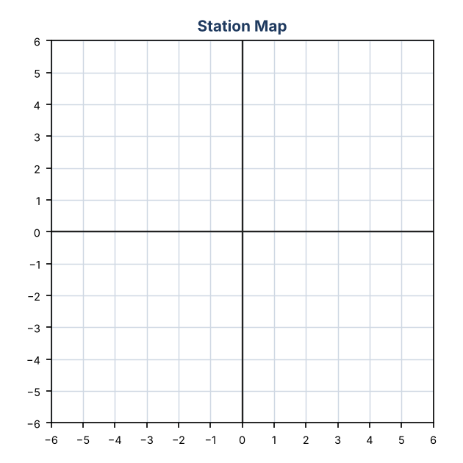

10. Which quadrant is each station in? (School is at the origin.)

11. Hilltop (3, 4) and Valley (3, −4) are on the same line. How many miles apart are they?

Final Product: Weather Station Report
Your final product must include:
- Your station map with all six stations
- A number line of the low temperatures
- The coldest and warmest stations
- One distance found with absolute value
- A short weather report for the morning announcements
Reflection
R1. Why is −12 less than −3 even though 12 is greater than 3?

R2. How does absolute value help describe distance?

Scoring Rubric
Criteria | 4 – Exceeds | 3 – Meets | 2 – Approaching | 1 – Beginning
Mathematical Accuracy | All calculations and solutions are correct; answers include units and are checked. | Nearly all work is correct; minor errors do not change conclusions. | Several errors; some conclusions are affected. | Many errors or missing work.
Reasoning & Justification | Clear, complete explanations connect every answer to the situation; uses precise vocabulary. | Explanations are mostly clear and connected to the situation. | Explanations are brief or partly unclear. | Little or no explanation.
Application & Design | Temperatures, elevations, and stations are ordered, compared, and mapped correctly with absolute value used for distances. Goes beyond the minimum with a creative, realistic choice. | Temperatures, elevations, and stations are ordered, compared, and mapped correctly with absolute value used for distances. | Design is incomplete or only partly uses the math from the unit. | Design is missing or unrelated to the unit math.
Communication & Presentation | Report includes the station map, ordered data, distance calculations, and a forecast. Polished, organized, and visually engaging. | Report includes the station map, ordered data, distance calculations, and a forecast. Organized and easy to follow. | Product is missing required parts or is hard to follow. | Product is mostly missing.

