PRECALCULUS · UNIT 1: EQUATIONS AND INEQUALITIES  Concert Venue Planner  Use equations and inequalities to set ticket prices, tolerances, and capacity for a concert. | CP2  2–3 class periods

Name: ________________________________ Date: ______________ Period: ______
The Scenario
Your team is running a summer concert at Riverside Amphitheater. Ticket price affects how many people come, the sound system must stay within safe levels, and the venue has fixed costs no matter how many tickets are sold.
You will solve equations and inequalities to set the price, plan the budget, and keep the crowd safe.
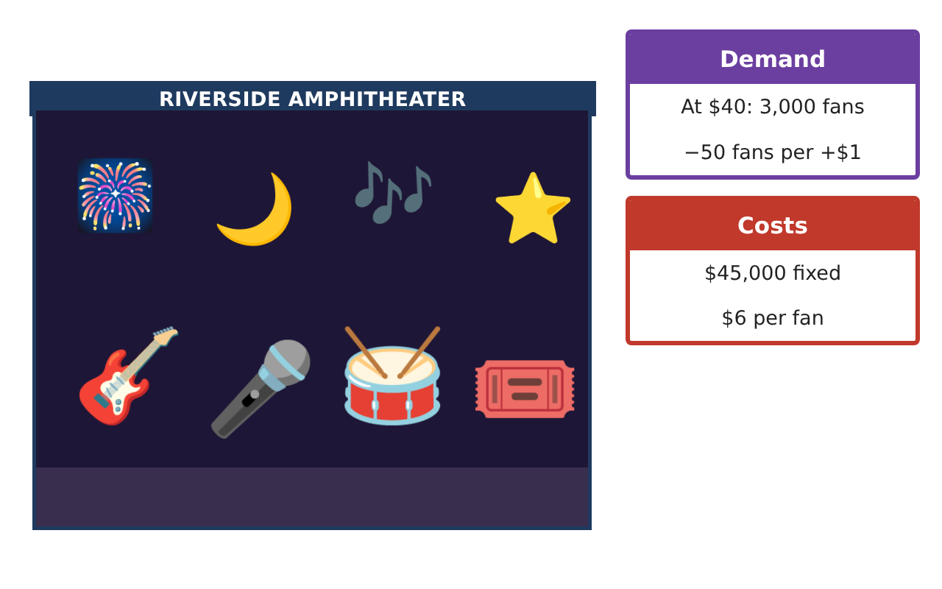
Learning Goals
- I can solve linear and absolute value equations and inequalities.
- I can solve quadratic equations by factoring or the quadratic formula.
- I can interpret solutions in context.
Project Timeline
When | What you will do
Day 1 | Tolerances
Day 2 | Ticket Demand
Day 3 | Break Even
Final | Venue Operations Plan + reflection
Part 1: Tolerances
Day 1 · Use the Venue Fact Cards.
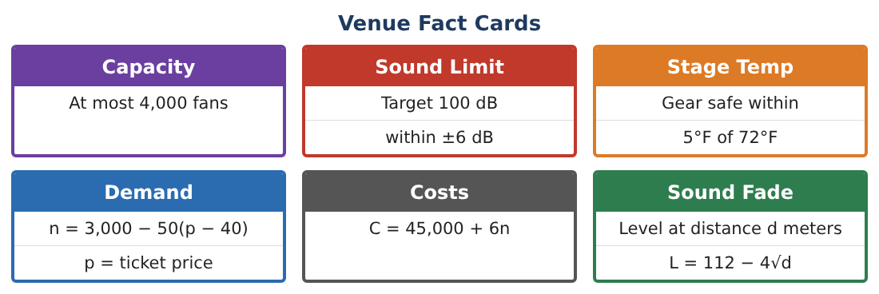
1. Write an absolute value inequality for the safe sound level L.
Starter: |L − ___| ≤ ___

2. Solve it. What is the safe range?

3. Write and solve an inequality for the safe stage temperature T.

4. The temperature is 79°F. By how much is it outside the safe range?

Part 2: Ticket Demand
Day 2 · n = 3,000 − 50(p − 40).
5. Simplify the demand equation.

6. How many fans come if tickets cost $50? $30?

7. Revenue is R = p · n = p(5,000 − 50p). Find R for p = $50.

8. Solve 5,000 − 50p = 4,000 to find the price that exactly fills the venue.

Part 3: Break Even
Day 3 · Profit = revenue − cost.
9. Write the cost when the price is p (use n = 5,000 − 50p).

10. Profit P = −50p² + 5,300p − 75,000. Use the quadratic formula to find the break-even prices.

11. Recommend a ticket price and explain using your work.

Final Product: Venue Operations Plan
Your final product must include:
- Safe sound and temperature ranges
- Demand and revenue calculations
- Break-even prices
- Recommended ticket price
- Operations plan
Reflection
R1. Why is absolute value a good way to describe a tolerance?

R2. What do the two break-even prices mean?

Scoring Rubric
Criteria | 4 – Exceeds | 3 – Meets | 2 – Approaching | 1 – Beginning
Mathematical Accuracy | All calculations and solutions are correct; answers include units and are checked. | Nearly all work is correct; minor errors do not change conclusions. | Several errors; some conclusions are affected. | Many errors or missing work.
Reasoning & Justification | Clear, complete explanations connect every answer to the situation; uses precise vocabulary. | Explanations are mostly clear and connected to the situation. | Explanations are brief or partly unclear. | Little or no explanation.
Application & Design | Equations and inequalities model price, cost, safety, and sound correctly and support the plan. Goes beyond the minimum with a creative, realistic choice. | Equations and inequalities model price, cost, safety, and sound correctly and support the plan. | Design is incomplete or only partly uses the math from the unit. | Design is missing or unrelated to the unit math.
Communication & Presentation | Plan includes models, solution sets, a recommended price, and seating zones. Polished, organized, and visually engaging. | Plan includes models, solution sets, a recommended price, and seating zones. Organized and easy to follow. | Product is missing required parts or is hard to follow. | Product is mostly missing.

