PRECALCULUS · UNIT 1: EQUATIONS AND INEQUALITIES  Concert Venue Planner  Use equations and inequalities to set ticket prices, tolerances, and capacity for a concert. | Honors  2–3 class periods

Name: ________________________________ Date: ______________ Period: ______
The Scenario
Your team is running a summer concert at Riverside Amphitheater. Ticket price affects how many people come, the sound system must stay within safe levels, and the venue has fixed costs no matter how many tickets are sold.
You will solve equations and inequalities to set the price, plan the budget, and keep the crowd safe.
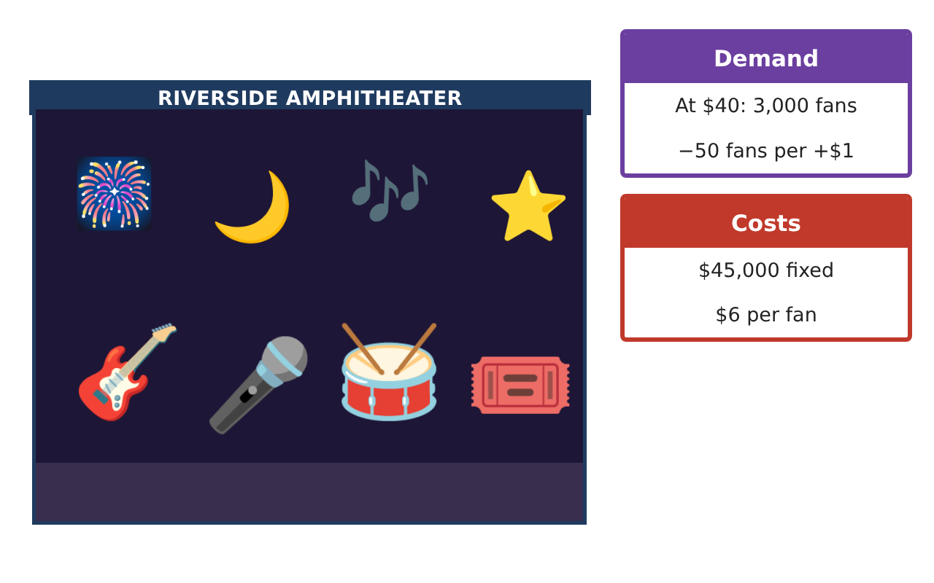
Learning Goals
- I can model a situation with polynomial and rational functions and solve related inequalities.
- I can solve radical and absolute value equations and check for extraneous roots.
- I can justify an optimal plan with algebra.
Project Timeline
When | What you will do
Day 1 | Optimal Pricing
Day 2 | Average Cost & Rational Inequalities
Day 3 | Sound Engineering
Final | Venue Operations Plan + reflection
Part 1: Optimal Pricing
Day 1 · n = 5,000 − 50p, cost 45,000 + 6n, capacity 4,000.
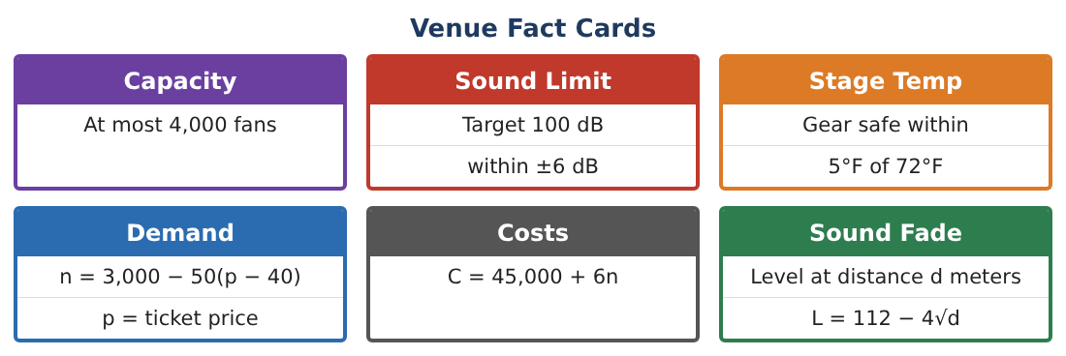
1. Find the profit function and the price that maximizes profit by completing the square.

2. A sponsor adds $2 per fan. Find the new profit function and optimal price.

3. Solve P(p) > 50,000 for the original model.

4. Explain why the capacity constraint (p ≥ 20) does not change the optimal price.

Part 2: Average Cost & Rational Inequalities
Day 2 · Average cost per fan A(n) = $\frac{45,000 + 6n}{n}$.
5. Solve A(n) < p for the optimal price p = 53 and interpret.

6. Solve $\frac{n − 2,000}{n − 4,000}$ ≤ 0 and give a venue meaning (e.g., comparing attendance to thresholds).

7. For which n is A(n) within $1 of its long-run value $6? Solve |A(n) − 6| ≤ 1.

8. Sketch A(n) and describe its asymptotes.

Part 3: Sound Engineering
Day 3 · Model: L = 112 − 4√d.
9. Solve 112 − 4√(d + 5) = 96 and check for extraneous solutions.

10. Solve √(d + 7) = d − 5 and check. Interpret one solution.

11. Design a seating chart: VIP (≥ 100 dB), general (94–100 dB), family (≤ 94 dB). Give each zone’s distance range.

Final Product: Venue Operations Plan
Your final product must include:
- Profit function in vertex form and sponsor analysis
- Profit threshold interval
- Rational inequalities with asymptotes
- Radical equations with checks
- Seating zones and the operations plan
Reflection
R1. How does vertex form reveal the optimal price immediately?

R2. Why can squaring both sides create an extraneous solution?

Scoring Rubric
Criteria | 4 – Exceeds | 3 – Meets | 2 – Approaching | 1 – Beginning
Mathematical Accuracy | All calculations and solutions are correct; answers include units and are checked. | Nearly all work is correct; minor errors do not change conclusions. | Several errors; some conclusions are affected. | Many errors or missing work.
Reasoning & Justification | Clear, complete explanations connect every answer to the situation; uses precise vocabulary. | Explanations are mostly clear and connected to the situation. | Explanations are brief or partly unclear. | Little or no explanation.
Application & Design | Equations and inequalities model price, cost, safety, and sound correctly and support the plan. Goes beyond the minimum with a creative, realistic choice. | Equations and inequalities model price, cost, safety, and sound correctly and support the plan. | Design is incomplete or only partly uses the math from the unit. | Design is missing or unrelated to the unit math.
Communication & Presentation | Plan includes models, solution sets, a recommended price, and seating zones. Polished, organized, and visually engaging. | Plan includes models, solution sets, a recommended price, and seating zones. Organized and easy to follow. | Product is missing required parts or is hard to follow. | Product is mostly missing.

