PRE-ALGEBRA (7TH) · UNIT 4: FACTORS, FRACTIONS, AND EXPONENTS  Space Mission Packer  Use factors, fractions, exponents, and scientific notation to pack a mission to Mars. | CP2  2–3 class periods

Name: ________________________________ Date: ______________ Period: ______
The Scenario
Mission control has chosen your team to pack the cargo bay for a crewed mission to Mars. Supplies must be split into identical kits, cargo space is measured in fractions of the bay, and distances in space are huge.
You will use factors, fractions, exponents, and scientific notation to pack the ship and plan the journey.
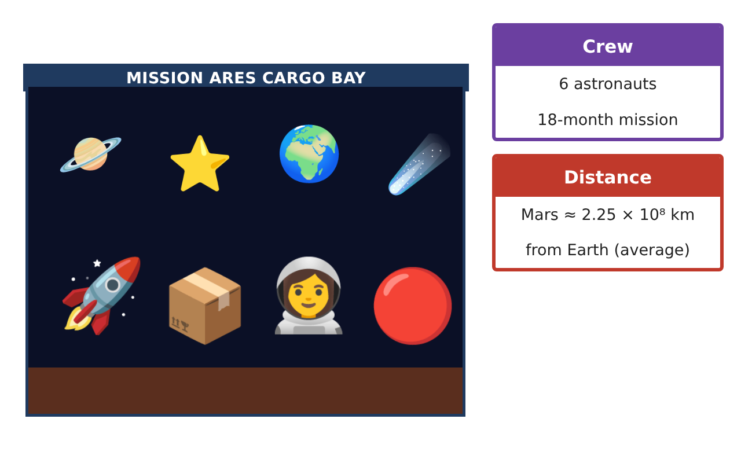
Learning Goals
- I can use divisibility rules and the GCF to make equal groups.
- I can simplify fractions.
- I can use exponents and scientific notation for large numbers.
Project Timeline
When | What you will do
Day 1 | Equal Kits
Day 2 | Cargo Fractions
Day 3 | Space Numbers
Final | Mission Packing Manifest + reflection
Part 1: Equal Kits
Day 1 · Use the Supply Cards.
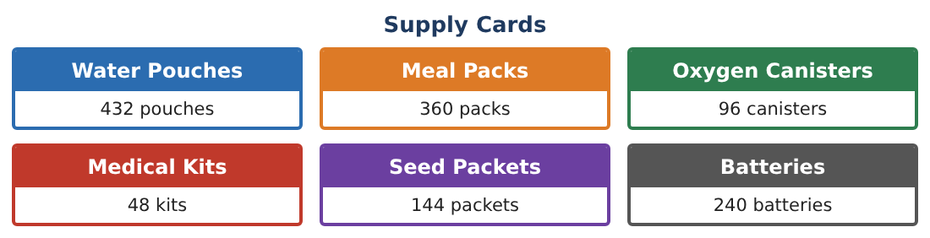
1. Is 432 divisible by 2, 3, 6, and 9? Use divisibility rules.

2. Write the prime factorization of 96 using exponents.
Starter: 96 = 2 × 48 = 2 × 2 × 24 = …

3. Find the GCF of 96 and 48. What does it tell you about packing kits?

4. Find the GCF of 360 and 240. How many identical kits of meals and batteries can be made? What is in each?

Part 2: Cargo Fractions
Day 2 · The cargo bay is divided into sections.
5. Water fills 18 of the 24 cargo sections. Write this as a fraction in simplest form.

6. Food fills $\frac{12}{32}$ of the freezer. Simplify.

7. Which is larger, $\frac{3}{8}$ or $\frac{2}{5}$? Explain.

8. Write $\frac{3}{4}$ as a decimal and a percent.

Part 3: Space Numbers
Day 3 · Use exponents and scientific notation.
9. Write 10⁸ in standard form. How many zeros does it have?

10. Write 2.25 × 10⁸ km in standard form.

11. The Moon is about 384,000 km away. Write this in scientific notation.

Final Product: Mission Packing Manifest
Your final product must include:
- Kit plan with the GCF
- Prime factorizations of two supply amounts
- Cargo fractions in simplest form
- Distances in scientific notation
- Your packing manifest
Reflection
R1. Why does the GCF give the greatest number of identical kits?

R2. Why do scientists use scientific notation?

Scoring Rubric
Criteria | 4 – Exceeds | 3 – Meets | 2 – Approaching | 1 – Beginning
Mathematical Accuracy | All calculations and solutions are correct; answers include units and are checked. | Nearly all work is correct; minor errors do not change conclusions. | Several errors; some conclusions are affected. | Many errors or missing work.
Reasoning & Justification | Clear, complete explanations connect every answer to the situation; uses precise vocabulary. | Explanations are mostly clear and connected to the situation. | Explanations are brief or partly unclear. | Little or no explanation.
Application & Design | Kits, cargo fractions, and space calculations use factors, fractions, and exponents correctly. Goes beyond the minimum with a creative, realistic choice. | Kits, cargo fractions, and space calculations use factors, fractions, and exponents correctly. | Design is incomplete or only partly uses the math from the unit. | Design is missing or unrelated to the unit math.
Communication & Presentation | Manifest includes kit contents, cargo fractions, calculations, and a mission fact sheet. Polished, organized, and visually engaging. | Manifest includes kit contents, cargo fractions, calculations, and a mission fact sheet. Organized and easy to follow. | Product is missing required parts or is hard to follow. | Product is mostly missing.

