PRE-ALGEBRA (7TH) · UNIT 7: SOLVING EQUATIONS AND INEQUALITIES  Summer Job Savings  Compare summer jobs and savings plans with multi-step equations, inequalities, and interest. | CP1  2–3 class periods

Name: ________________________________ Date: ______________ Period: ______
The Scenario
You want to buy a $650 laptop by the end of the summer. You can mow lawns, babysit, or work at the snack stand at the town pool, and you can put your money in a savings account that earns interest.
You will write and solve equations and inequalities to compare jobs, reach your goal, and plan your savings.

Learning Goals
- I can solve multi-step equations, including variables on both sides.
- I can solve two-step inequalities and interpret the solutions.
- I can transform formulas and compute simple and compound interest.
Project Timeline
When | What you will do
Day 1 | Compare Jobs
Day 2 | Savings Goal
Day 3 | Interest
Final | Summer Savings Plan + reflection
Part 1: Compare Jobs
Day 1 · Use the Job Offer Cards.
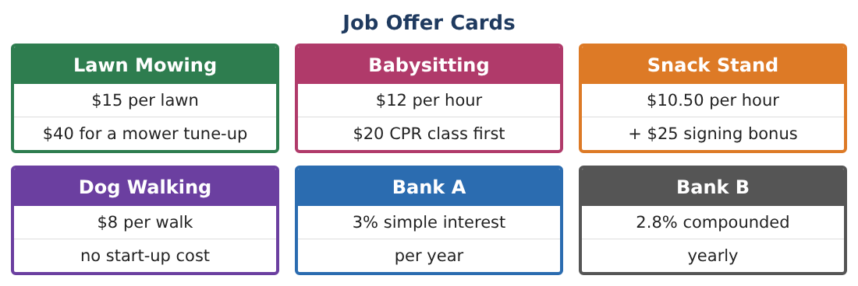
1. After how many hours do babysitting and the snack stand pay the same total? Solve 12h − 20 = 10.50h + 25.

2. Which job pays more for 20 hours? For 40 hours?

3. A mowing weekend: you mow l lawns on Saturday and 3 more on Sunday, earning 15(l + l + 3) − 40 = 365. Solve for l.

4. Solve $\frac{2}{3}$(h − 6) = 18 and explain a babysitting situation it could model.

Part 2: Savings Goal
Day 2 · Goal $650. You have $85.
5. Write and solve an inequality for the number of babysitting hours needed.

6. You can work at most 10 hours a week at the snack stand. Write an inequality for the number of weeks to reach $650 and solve it.

7. You will spend $15 per week on snacks while working. Rewrite and solve the inequality from the last question.

8. Explain how you knew whether to round up or down in each answer.

Part 3: Interest
Day 3 · Simple interest: I = Prt. Compound interest: A = P(1 + r)ᵗ.
9. Solve I = Prt for r. What rate gives $24 interest on $400 in 2 years?

10. Compare $650 for 3 years in Bank A (3% simple) and Bank B (2.8% compounded yearly).

11. Write your summer plan: job(s), hours or lawns, weeks, and where to save the extra money. Support each choice with an equation or inequality.

Final Product: Summer Savings Plan
Your final product must include:
- Job comparison using variables on both sides
- Savings inequality with rounding decisions
- Transformed interest formula
- Bank comparison
- Complete summer plan
Reflection
R1. What does the solution h = 30 mean when comparing two jobs?

R2. Why might compound interest beat simple interest over many years even with a lower rate?

Scoring Rubric
Criteria | 4 – Exceeds | 3 – Meets | 2 – Approaching | 1 – Beginning
Mathematical Accuracy | All calculations and solutions are correct; answers include units and are checked. | Nearly all work is correct; minor errors do not change conclusions. | Several errors; some conclusions are affected. | Many errors or missing work.
Reasoning & Justification | Clear, complete explanations connect every answer to the situation; uses precise vocabulary. | Explanations are mostly clear and connected to the situation. | Explanations are brief or partly unclear. | Little or no explanation.
Application & Design | Equations and inequalities model each job and goal correctly and support a realistic savings plan. Goes beyond the minimum with a creative, realistic choice. | Equations and inequalities model each job and goal correctly and support a realistic savings plan. | Design is incomplete or only partly uses the math from the unit. | Design is missing or unrelated to the unit math.
Communication & Presentation | Plan includes the job choice, solved equations and inequalities, interest comparison, and a calendar. Polished, organized, and visually engaging. | Plan includes the job choice, solved equations and inequalities, interest comparison, and a calendar. Organized and easy to follow. | Product is missing required parts or is hard to follow. | Product is mostly missing.

